western State water program Capabilities assessment survey report

  - A survey issued as part of the WSWC’s Water Data Exchange (WaDE) effort

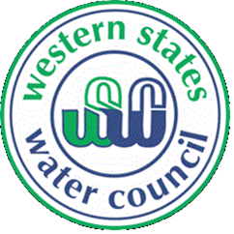
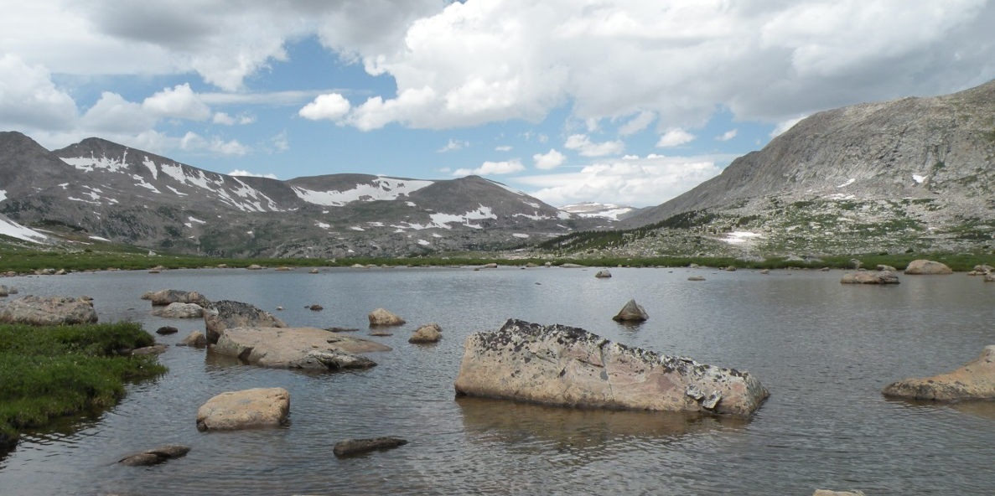

Executive Summary
Whether addressing population growth, national security, drought, climate change, or meeting our growing energy needs, questions surrounding water availability in the West will only increase and become more important in the coming years. In 2011, the Western States Water Council (WSWC), in coordination with the Western Governors’ Association (WGA), the Department of Energy (DOE) National Laboratories, and the Western States Federal Agency Support Team (WestFAST), initiated the Water Data Exchange (WaDE) project to enable the exchange of water planning, water use and water allocation data between state water agencies, federal agencies, tribal and local governments and the public. The goals of the project involve establishing a governance structure, evaluating current capabilities and methods used by state water agencies, and designing a common format that specifically targets the desired data. The Water Information and Data Subcommittee, which directly oversees the WaDE project, agreed to create four workgroups to lay the groundwork for the development of the data exchange. The State Capabilities Assessment Workgroup was charged with the task of evaluating the current mechanisms and tools used by the state agencies charged with overseeing the allocation and administration of water within their state , regarding their water planning and water rights/permitting programs. This report is the culmination of the workgroup’s efforts.
In order to build the framework for the data exchange effectively, a better understanding of how the states collect, generate, manage and share data was needed. To asses this, a survey was sent to each of the states. Some questions addressed policy and planning tasks, while others covered data management. The survey was divided into questions addressing four topics: surface water data, groundwater data, data management, and methodology. The survey was distributed in February of 2012 and collected through the fall of 2013. All eighteen WSWC member states responded. Some states described their programs in great detail, while others were more succinct. This document summarizes the responses and explores the similarities between state water planning programs, finding common points. It also serves to highlight several differences in program approach that may pose a challenge to regional analyses and the comparison of planning and permitting data across state borders. To illustrate these similarities and differences, a table of the primary available data from each state program was generated (see Table 1). Common elements between the state programs include the following:
- Most of the states are managing and maintaining streamgages and streamgage data. Most also rely on the U.S. Geological Survey’s (USGS) streamgage network as an important component to their water supply and availability planning and permitting processes.
- Many are managing and maintaining some groundwater monitoring/elevation data.
- Most states manage their water rights using an enterprise-level database management system, with some information available in a geospatial format (such as points of diversion or places of use).
- Generally withdrawals/diversions (and some consumptive use) are tracked, and some states have the ability to summarize these sets of data by a geospatial unit and/or by beneficial use category.
- Most states that have basins, aquifers, or regions that require special management or have institutional/legal restrictions are maintaining these in a database/geospatial format as well.
The table also reveals differences in the state planning program data and identifies data gaps that pose a challenge:
- Some states have physical water supply, water availability, and water use information programs for specific regions. However, these analyses are typically not generated for the entire state on a repeating basis. Also, some of the targeted data generated by state programs are only published in an analog format or as a report on the state’s website. These are not yet captured and stored in a database or published digitally.
- Most states analyze physical water supply (establish that water is indeed present at the proposed point of diversion, etc.) and legal and institutional water availability (i.e. determine if water is appropriable within the basin) as part of their permitting processes, but these are generated on an ad hoc and site specific basis. They generally do not summarize the information by watershed, basin, planning area or jurisdictional region. Summary-level information on water availability by basin/aquifer is one of the desired datasets for future decision support; therefore, the lack of data and even a standard and specific definition of the term “water availability” constitutes a challenge for regional comparisons.
Consumptive Use: Various water stakeholders may use different definitions for the term “consumptive use.” For the purposes of the WaDE project and this document, consumptive use is defined as the portion of water withdrawn from the natural system for a particular use that is evaporated, transpired, incorporated by products or crops, consumed by humans or livestock, or otherwise removed from the hydrologic cycle, i.e., water not returned to the natural system.
- Most states track allocations and diversions of their waters, but do not have a statewide program for tracking consumptive uses or return flows. Some states do have extensive programs for estimating consumptive use, especially in areas that require additional oversight or data specific to a beneficial use category. For example, they may have robust estimates for agriculture and/or municipal/industrial use, but track self-supplied domestic use to a lesser degree, if at all. Very few states have more comprehensive programs. This adds a degree of uncertainty for estimating current and future demands for water, as well as future availability.

Another challenge to synthesis of state water information is variability in spatial and temporal scale used to estimate and publish data products. Some states have the ability to summarize data by large watershed, while others use a much finer resolution. Some states even use customized delineations that account for administrative functions, such as a basin that ends on a county boundary. This is a significant barrier to those who need a regional synthesis of comparable water data, such as is proposed for the USGS’ National Water Census Program (see side note). WaDE will dovetail with this and other ongoing national water efforts, positioning the states to proactively provide water use estimates and other necessary data when requested.
The Consumptive Use Data Gap: Withdrawals of water from the natural environment has been easier to quantify than its consumptive use. Standardized estimates have been lacking since 1995, when USGS ceased its consumptive use reporting. However, it is a significant component to water budget assessments and has been identified as a primary objective of the National Water Census Program. USGS would like to have more frequent compilations of water withdrawn and consumptive use – ultimately tracking water from its point of diversion to its place(s) of use, and thence to its point of return to the hydrologic cycle.
In addition, some states gather and publish their data by month, some by water year (Oct. 1st – Sep. 31st), and some by calendar year. WaDE supports a wide variety of reporting for both spatial and temporal scales, including custom delineations. However, a regional analysis of similar types of data will remain disjointed until the states incorporate a common spatial/temporal scale into their current workflows, or develop a translation mechanism for the desired output. Similar issues exist with comparison of data products between states that use distinctly different methodologies. An example would be a comparison of Utah and Idaho consumptive use data, where one uses a statewide agricultural land-use survey and the other uses Landsat remotely-sensed imagery as a basis for calculations.
Regarding data management, all states that were surveyed use (or are transitioning to) an enterprise-level database for storing and manipulating some of their data. About two-thirds of the states use Microsoft SQL Server, almost all others use Oracle. Some relevant data are maintained in Microsoft Access and/or Excel. Most states also use .Net as their preferred software application development platform, and the remainder use Java and Python, or a combination of development environments.
Due to the differences in methods used within member states’ water planning programs described above, and many other spatial, temporal and methodological differences in practice between the states, it is the intention of the WaDE program to portray the data and methods that the states currently use. However, ultimately WaDE also provides a template for their workflows and/or a water data “goal” for the states that will help to create a more uniform and spatially complete picture of water availability and use in the West in the future. This report presents a comprehensive analysis of where the states currently are in their respective planning and administration efforts, but it also contains recommendations and solutions that have the potential to create a setting for cross-boundary analysis and comparison of water availability and use. The following is a short list of the recommendations made by WSWC staff members, workgroup members and also state agency staff that would facilitate WaDE project goals. A more detail description of these recommendations is available in the “Potential Solutions” section of the report.

Recommendation #1 – Expand water withdrawal and water use reporting programs to include regions and sectors/beneficial use categories within the state that not yet assessed or required to report. Implement or expand consumptive use and return flow estimation programs.

Recommendation #2 – Modify or expand the workflow processes states are already using for reviewing physical and legal water availability to basin-level and statewide scales, and seasonal/annual time intervals.

Recommendation #3 – More generally, encourage states to review the WaDE targeted data schema for possible inclusion in future program efforts. Encourage the adoption of a standard spatial scale for the most common workflow products, such as physical water supply and availability analyses and summaries of water diversions, and also the adoption of a preferred timescale for reporting summary and detailed WaDE data – annually or monthly, using either a calendar or water year.

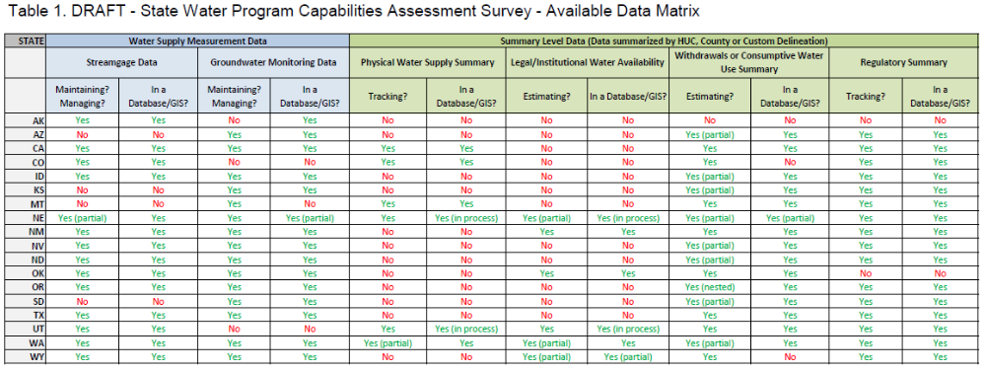
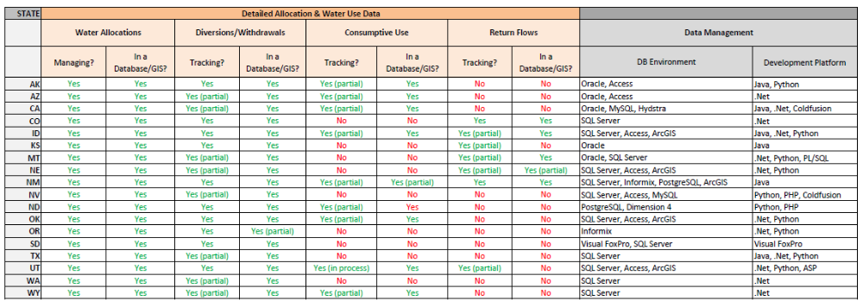
Recommendation #4 – Facilitate a state-by-state dialogue or repository for a glossary of terms relevant to legal processes behind the state’s management of water resources, as well as the physical and environmental reviews.
Table 1. DRAFT - State Water Program Capabilities Assessment Survey - Available Data Matrix
Table of Contents
Executive Summary 1
Introduction 7
Background 7
Governance and Outreach 8
Categories of Data 10
System Design 10
Types of Services 12
Publishing and Discovery via the Central Portal 12
State Capabilities Survey – Summary of Findings 14
Themes and Similarities 14
Potential Data Challenges 16
Spatial/Temporal Scale Differences 17
Methodological Differences 19
Possible Solutions 20
State-by-State Summary 23
Alaska 23
Arizona 24
California 27
Colorado 29
Idaho 31
Kansas 34
Montana 36
Nebraska 38
New Mexico 42
Nevada 45
North Dakota 47
Oklahoma 51
Oregon 53
South Dakota 54
Texas 56
Utah 58
Washington 61
Wyoming 63
Appendix 66
Table 3. Types of Data (Surface Water) 66
Table 4. Types of Data (Groundwater) 69
Table 5. Reporting Requirements (Surface Water) 72
Table 6. Reporting Requirements (Groundwater) 75
Table 7. Data Management and Data Publishing 78

Photo Credit: P. Tyrell, Boulder Lake Drainage, WY

Introduction
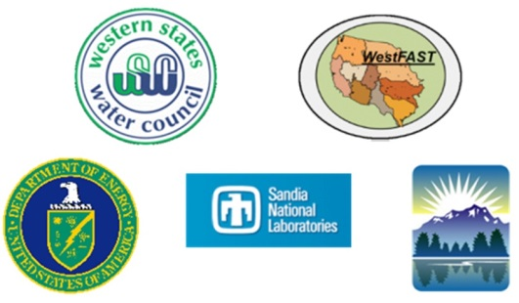
Whether addressing population growth, national security, drought, climate change, or meeting our growing energy needs, questions surrounding water availability in the West will only increase and become more important in the coming years. The Water Data Exchange (WaDE) is a project initiated to assist state water agencies to answer these kinds of local and national water availability questions more easily, more sustainably, and more cost effectively. In 2011, the Western States Water Council (WSWC), in coordination with the Western Governors’ Association (WGA), the Department of Energy (DOE), its affiliated National Laboratories, and the Western States Federal Agency Support Team (WestFAST), initiated the WaDE project to enable the exchange of water planning, water use and water allocation data between state water agencies, federal agencies, and the public. The goals of the project include the establishment of a governance structure, the evaluation of the current capabilities and methods used within the states, the design of a common format (i.e. data schema) that specifically targets derived water data products and/or water-quantity type information, database and web service design and development, and implementation within state information technology (IT) environments.
WaDE employs an innovative, distributed data framework, wherein partners control and maintain datasets locally (ensuring that published data are the best available), while making them discoverable via a centralized web mapping application and web service requests. The data are transferred using platform-independent eXtensible Markup Language (XML), which can be automatically incorporated into other software, models and products. The implementation of WaDE will dramatically increase the availability of water quantity-related information, both from state and eventually federal partners. It will also directly support national water security efforts and better decision-making by agencies pursuing an integrated water resource management approach. The project itself serves as a model for other parties interested in developing and sharing specific datasets using a distributed, real-time retrieval mechanism.

Background
The Western States Water Council (WSWC) is an organization consisting of representatives appointed by the governors of the 18 western states, from North Dakota to Texas and westward, including Alaska, created at the direction of the governors in 1965. Since that time, WSWC has striven to accomplish its chartered purposes, including facilitating effective cooperation among western states in the conservation, development and management of water resources. A tangible step toward such cooperation was defined in “Water Needs and Strategies for a Sustainable Future: Next Steps,” a report published by the Western Governors’ Association (WGA) and co-authored by WSWC in 2008. With the publication of the report, the following was adopted as an action item for the WSWC:
“State and federal water resource agencies should work together to provide universal access to the water-related data collected by all state, local, and federal agencies, as well as tools and models that better enable the synthesis, visualization and evaluation of water-related data, including that to be shared with local governments.”
Similarly, the Western States Federal Agency Support Team (WestFAST), a collaboration between 12 federal agencies with water management responsibilities created to support the WSWC, adopted the objective above as part of its workplan.
Coincident with these efforts was a national shift in focus toward viewing water as an issue of national security, concerning the energy sector’s reliance on water, in competition with food and feed production, recreation and urban needs, and vice versa. As part of a study on water and energy nexus impacts related to energy transmission planning, the Department of Energy (DOE) and its suite of National Laboratories, led primarily by Sandia National Laboratory, began efforts to assess current and future water availability in the West. The analyses included an evaluation of various water supply sources and future demand for water by sector, the results of which could be used to inform and act as an additional constraining parameter in long-range energy transmission planning models.
To create these water availability “metrics”, research teams had to assemble disparate water data from the states concerning water supply, legal and institutional water availability, estimated water uses and future demand. Gathering the data and aggregating them into a comparable dataset was a difficult task, and the study allowed for one “snapshot” of water availability. In order to facilitate the National Labs’ effort and to ensure the sustainability and repeatability of future studies, WSWC proposed to work with its member states to establish a data exchange framework focused on sharing water planning data. The exchange would allow the WSWC, WestFAST and the states to accomplish their action item above, while supporting access to data by the National Laboratories, USGS and other interested stakeholders.

Governance and Outreach
The Water Information and Data Subcommittee (WIDS) was formed under the direction of the Water Resources Committee of the WSWC. WIDS is comprised of representatives from the states and also from federal agencies. The Water Resources Committee approved a proposal sponsored by WIDS to begin building the framework that would eventually become the Water Data Exchange (WaDE) project. They also agreed to create four workgroups under the direction of WIDS. These four workgroups worked to create the initial momentum and lay the groundwork for the development of the data exchange and some continue to function as its primary governance bodies.
1) State Capabilities Assessment Workgroup: To evaluate the current capabilities of the western states with regard to water allocation, supply and demand data, as well as their current methods of publishing data and IT environments. This report is the culmination of efforts by this workgroup.
2) Methods Workgroup: To document existing methods and science for estimating targeted water planning data, such as water supply, availability, consumptive use, etc., and to understand the semantic differences between the states’ use of these terms.
3) Data Exchange Template (Schema Development) Workgroup: To identify and define the data elements necessary for exchanging targeted water data. Using the data elements as a guide, the group can refine the data exchange schema (a standard format proposed for the data using eXtensible Markup Language (XML)) that reflects the hierarchical relationships of the data.
4) Data Exchange Methodology Workgroup: To review the existing field of data exchange technologies, evaluate existing state, federal and academic data exchange collaborations, and make recommendations for technological approaches.
During the first year of WaDE development, Workgroup 3 and 4 members realized that they needed closer collaboration in order to work through their respective tasks. They opted to combine the two groups into one that could address most technology-related issues. During the second year of WaDE development, the Combined Workgroups 3/4 were able to achieve significant milestones with regard to developing a robust schema that most of the states could support, settling on a means of data hosting and also code development. Coincidentally, the WSWC and several states received a partnership grant from the Environmental Protection Agency’s (EPA) National Environmental Information Exchange Network (NEIEN) to assist with WaDE development and deployment by the states. The NEIEN has a governance arrangement already in place that addresses technology-related tasks, akin to Workgroups 3/4, called an Implementation Project Team (IPT). To avoid duplication of effort and to have greater integration with the NEIEN framework, the two groups are in the process of transitioning to the NEIEN IPT format.
5) NEIEN WaDE Schema and Technology Implementation Project Team (IPT): Workgroups 3 and 4 are transitioning to the NEIEN IPT workgroup format. This group will reconvene in early 2014.
6) NEIEN WaDE Grant Partners Steering Committee: After the WaDE NEIEN grant application was accepted for funding, the partner states on the grant – Texas, Oklahoma, Washington, Oregon and Idaho – have organized a steering committee to manage and oversee the distribution of funds and coordinate the WaDE tasks related to the grant.
The activities of the remaining four workgroups and the coordination and reporting for the WaDE project in general are overseen by WSWC staff members. During 2012 and 2013, site visits to 16 of the 18 WSWC member states were conducted to explain the WaDE project to state agency staff, garner support, and to define and refine the data schema originally developed by the Data Exchange Template Workgroup. Several federal agencies, including the Natural Resource Conservation Service (NRCS), the Bureau of Reclamation (BOR) and USGS were also visited to discuss the adoption of a common format for publishing data controlled by their respective agencies, which would greatly improve state access and facilitate state and federal water planning processes. The site visits resulted in broad support of the project and several adjustments to the proposed data schema, such that it would provide a better “fit” for more state and federal agency data. Table 2 provides a timeline for the WaDE project major milestones.
Table 2. WaDE Project Major Milestones
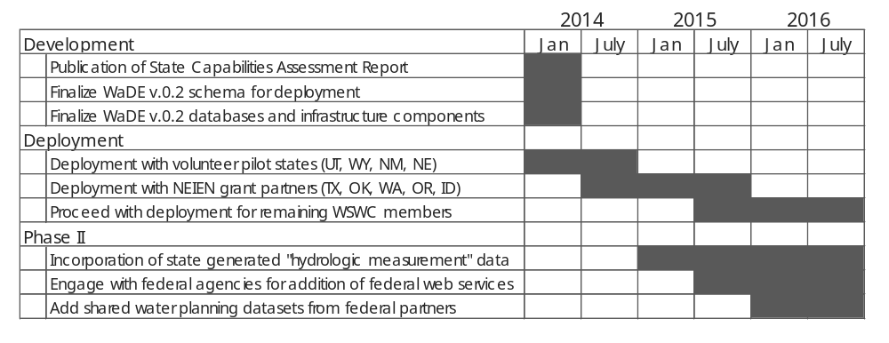

Categories of Data
There are specifically two categories of data targeted for publication under this project. Each category requires a different solution for the implementation of the exchange. Phase I of the WaDE project targets the first category of data, termed “derived” or “value added” data. These can be described as data that are not direct measurements, but rather reflect interpretations, evaluations, modeling or decisions based on other datasets. Examples include water summaries, appropriation summaries, consumptive use estimates, or general water planning data. Each “derived” product is generated from other datasets, such as streamflow measurement, reservoir storage and meteorological data, to arrive at a conclusion. An important piece of information that must be captured for “derived” data is the methodology used by the agency to arrive at their calculation so that others can understand the context of that estimate. WaDE workgroup members determined that this category of data would benefit the states more directly and immediately, and gave it priority over Phase II.
Phase II of the WaDE project involves the incorporation of a second category of data, termed “time-series” or “hydrologic measurement” data, i.e. a dataset containing measurements of some water-related parameter taken over a period of time. Although some measurements may still be derived from other measured values, they can be quantified as a specific measurement at a specific time, which can be evaluated along with other measurements over that same time period. Examples of data that fit within this category include streamgage data, groundwater elevation, snow depth, reservoir elevation, precipitation data, etc.
Recommendations from WaDE workgroup members concerning “time-series” data are based on recent work conducted by the Consortium of Universities for the Advancement of Hydrologic Science, Inc. (CUASHI). CUASHI has established a framework for hydrologic measurement data called Water Mark-up Language, widely known as WaterML, to transfer hydrologic measurement/sensor data using a common format. Recognizing that much of the state and federal data that would be shared within the WaDE framework would be of this category, workgroup members recommended that the WSWC’s state and federal partners be encouraged to adopt the WaterML 2.0 schema – the most recent Open Geospatial Consortium (OGC) approved version - in preparation for Phase II.

System Design
WaDE provides a state-to-state, state-to-fed, fed-to-state, and open publishing data exchange. The design of the system is such that data flows in an automated, computer-to-computer fashion. Requests do not require a manual step to receive data. Data owners or partners control what data are shared and oversee quality control of published estimates. Participants benefit by being able to access other agency data, while having their own published in a common format via web service using a centralized data portal. The portal facilitates data discovery by other states, federal agencies, the public and other interested parties.
Figure 1 is a conceptual diagram of the WaDE system architecture. Partners that supply data to the WaDE interface will include state and federal partners, as well as organizations that house significant datasets dealing with water planning or management. The data exchange design has some key components:
- Each state operates a “node” on the infrastructure that is based on their in-house databases. All WaDE nodes respond in the same manner, when queried with a URL of the same format. This arrangement allows the WaDE retrieval system to query all relevant nodes at once without having to build a custom interface for each node. Nodes also manage security and access to the data. Node databases and software need not be identical as long as the responses are similar.
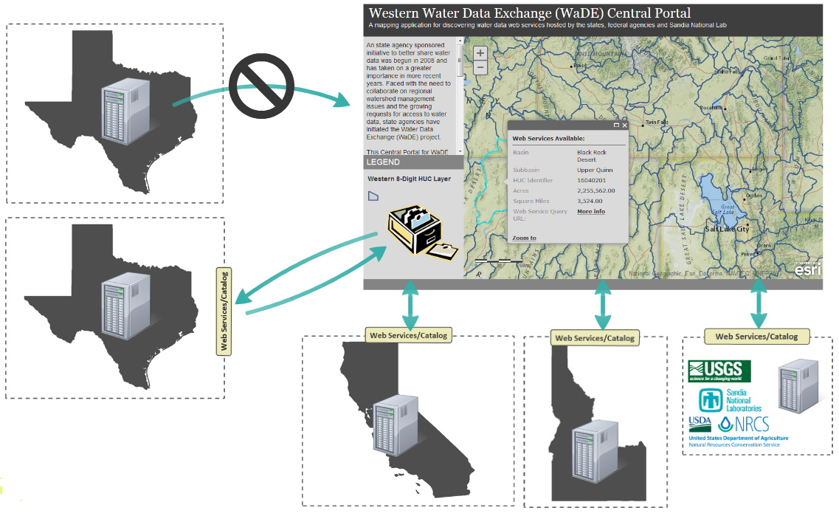
Figure 1. Water Date Exchange (WaDE) Framework Conceptual Diagram
- Each state maintains both a core set of defined web services, such as “authenticate a user,” or “get available services,” as well as a “Catalog” of the data housed within the node. The use of a catalog allows other partners to be able to discover data without having to search through entire data sets. Once a user has narrowed in on the data that they want via a catalog, it can be used as a gateway to retrieve what is available on a particular node.
- A WaDE Central Portal with a corresponding centralized catalog has the ability to consume the summary information available in partner catalogs, display that information on a queryable map interface, compile a user’s request for specific data, request the data from the respective nodes, and return a report or dataset to the user. The portal is a key piece in demonstrating the value of the data flow. The central catalog would allow the portal to perform quickly, for ease-of-use by the client.
Based on feedback gathered during outreach visits and reviews within the workgroups, the WSWC has developed a preliminary draft schema and defined services that their state partners will implement as they plug into the WaDE framework, termed WaDE v.0.2. As the components are deployed by each partner agency, suggested changes to the schema will be documented and then evaluated by the appropriate governance workgroups for incorporation into the next official schema version.

Types of Services
After a careful evaluation of many options and approaches for the sharing in-situ data, WSWC and the workgroups have made the recommendation to use a combination of Representational State Transfer (REST) and Simple Object Access Protocol (SOAP) web services, for the exchange of information between partners. The majority of the web services will be shared using REST, with some SOAP services as needed to gather information about participating nodes and to retrieve information about data available at each node. Both the SOAP and the REST services offered by WaDE are modeled after and adhere to the specifications for services used by the Environmental Protection Agency’s National Environmental Information Exchange Network (NEIEN) program.
Figure 2 provides examples of transactions between nodes, the public and the central catalog that would require either REST or SOAP.
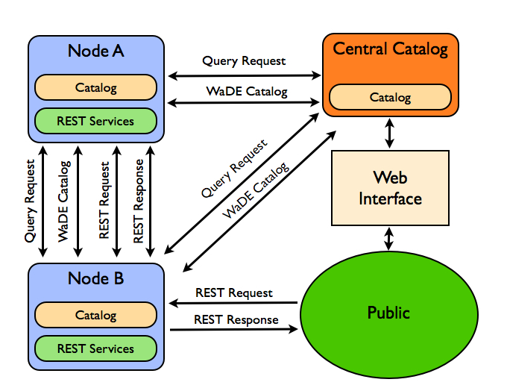
Figure 2. WaDE Web Service Types between Nodes

Publishing and Discovery via the Central Portal
As Sandia prepared to release the preliminary results of their study, WSWC proposed to use these results as sample data in order to demonstrate the capability of the WaDE framework. A prototype web-mapping application was built to access the results from the Sandia study, and other sample data gathered from state agencies. The prototype used REST-based URL requests to query databases residing at an emulated “node.” The queries were returned to the user by super-imposing browser style-sheets over the returned raw XML data summaries for human readability. The Central Portal demonstration was provided to show how the different components that comprise the WaDE system function together to provide the user with an easy-to-navigate and responsive dashboard-like interface. Figure 3 is a screenshot of the prototype application, showing some of the Sandia results and the sample state-hosted data side by side. The WSWC anticipates continued refinement and customization of the interface as more and more states are brought into the data exchange. It is important to note that the high degree of variability between state water planning programs, especially related to the scales of their water planning summaries, make cross-state boundary comparisons difficult at this time and make metadata concerning summary methodologies of paramount importance. Discussion is ongoing within the workgroups concerning the possibility of incorporating an agreed upon series of “west wide metrics” into state agency work plans. This is discussed in greater detail in the “Summary of Findings” chapter.
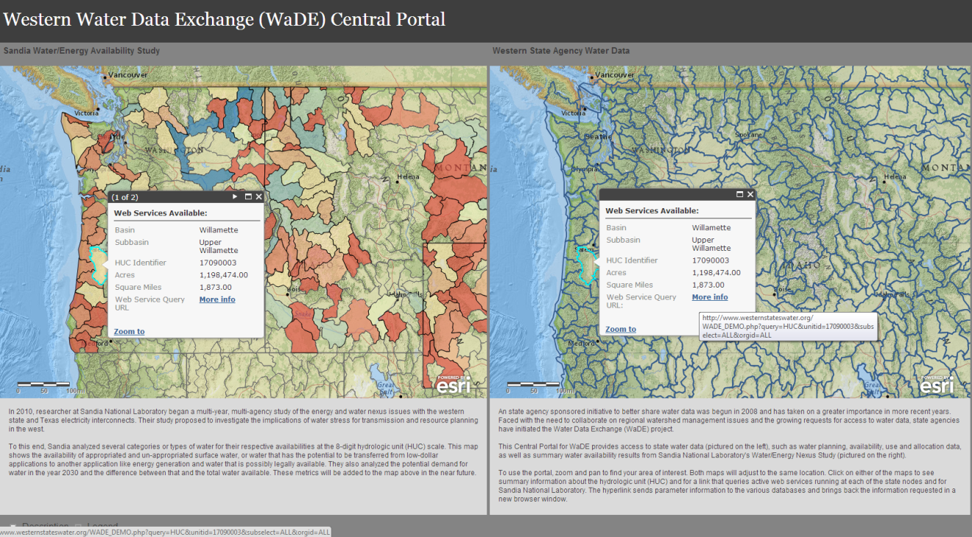
Figure 3. Prototype WaDE Central Portal Application
State agencies and others are continually being called upon to answer national and regional questions about water availability, resiliency and scarcity. WaDE allows its partners to share and publish important water planning and use data and methods to their customers easily, and in a common defined format that minimizes the difficulties and costs of data collection. WaDE will also dovetail with other ongoing national water efforts, such as USGS’ National Water Census, positioning the states to proactively provide water use estimates and other necessary data when requested.
Other potential customers of the data exchange range from large organizations such as the Government Accountability Office (GAO), with their recent water-energy nexus work, and the Environmental Protection Agency, studying the relationship between water quality and quantity, to research institutions, NGOs, water district managers, and even farmers, journalists and politicians concerned about ongoing drought and other water issues. The accomplishment of Phase I of the WaDE project will be a major step toward improved access to “derived” data products like water availability and use summaries, while Phase II will provide greater access and discoverability to “time-series” hydrologic measurement data. Finally, the tangible step of sharing water data and methodologies between state agencies signals a shift in attitude toward more cooperative regional watershed and water resource information management.

State Capabilities Survey – Summary of Findings
The survey was sent by the State Capabilities Assessment Workgroup to the eighteen WSWC member states, which include all states from Texas to North Dakota and westward, including Alaska. The survey was divided into four general categories of inquiry, and data that had the most potential for incorporation into the WaDE portal for publication were targeted specifically. The majority of the questions addressed policy and planning tasks, and the remainder covered data management. Topics covered by the survey included: a general summary of the state’s program, surface water data, groundwater data, data management, and methodologies used for primary estimates. A small number of questions refer to very specific subsets of data, such as community water system populations, instream flow policies, or energy produced by water allocated to the thermoelectric sector. These are the types of data that the original DOE study with Sandia were interested in gathering from the states.
The survey was originally distributed in February of 2012 and then collected throughout the summer. Fourteen of the eighteen WSWC member states responded to the survey initially. After a pause for development of WaDE infrastructure and components, the survey was issued again, with the four remaining member states submitting their surveys back to WSWC. Some states described their programs in great detail, while others were brief, with some essential data lacking. Where the survey data was insufficient, attempts were made to glean the relevant information from the state agency’s website. This document summarizes the responses and any additional information gathered, and explores the similarities between state programs, finding common elements and efforts. It also serves to highlight several differences in program approach that may pose a challenge to regional analyses and comparison of planning and permitting data across state borders. This section explores these similarities and also lists in greater detail the challenges that need to be overcome before a true regional analysis of water availability or use will be possible based on data supplied by state water agencies. Lastly, some potential solutions to these challenges are discussed.

Themes and Similarities
There are many common elements between the state water planning programs. The most common tasks performed by all of the states that returned the survey are tracking, storage and maintenance of water allocation data (water rights/permits). As this is a primary task of administering water, it is not surprising that this segment of complex data has been the first to be adopted into a database management platform. Most allocation data are site-specific and, within the WaDE data schema, fall into the “detailed” category of data, as opposed to the “summarized” category (See side note for definition and Table 1 for a breakdown of detailed and summarized data available from each member state).
Important Definitions: For the purposes of the WaDE project, Phase I target data are divided into two categories, “summarized” and “detailed.” “Summary” data is a set of data that are assembled or aggregated by a spatial area or unit, such as a water availability estimate for a watershed or a water use estimate for a county. “Detailed” data are site-specific and are much more detailed in nature. These include individual water permits, points of diversion, places of use or return flows.
For all WSWC member states, allocation data are tracked and stored in an enterprise-level database management system. High-level information typical to a water right includes the owner of the permit or right holder, legal status, amount (or rate) of water that can be withdrawn, beneficial use category and specific time periods for that withdrawal. Other allocation data that vary more significantly amongst the states include whether the acres irrigated and irrigation method are tracked, energy-related information, population served, etc. All member states are beginning to track the locations of points of diversion, as a subset of data to their allocation administration programs. Those that aren’t tracking this information statewide, are doing so on a limited geographic or temporal basis for the time being. An example would be a state that only required Public Land Survey System (PLSS) location reporting for diversions in the past, but has instituted the requirement for geographic coordinates for newer diversion applications. Related to withdrawals and places of use, are the return flows for water that has not been consumed, and which returns to the natural hydrologic cycle. This also represents an area where states can improve their data gathering efforts, as most states only measure or track a small portion of return flows and their locations.
Allocation data and its associated points of diversion and places of use are usually site-specific in nature, such that when spatial data are available they are typically shown using geographic coordinates or polygons of the fields for the designated use. Other data targeted specifically for the WaDE project include energy/water nexus related issues, such as the energy produced by, and the facility or fuel type of water allocated to, the thermoelectric sector. Very few states include this information in their data-gathering efforts.
For the purposes of planning and evaluating water availability, many states consider only the withdrawal of water, and do not have an estimate for the withdrawals’ consumptive use. Only a few states have more expansive consumptive use estimates and these are typically for specific sectors of use or for select regions of the state. For example, Wyoming estimates consumptive use only for areas that are subject to additional scrutiny due to compacts or decrees.
“Significant progress is being made establishing how much water is being withdrawn, but as Table 1 indicates, estimation of consumptive use related to those withdrawals is an area where great advances can be made. This is an especially important area to tackle if the states are ever to have a true water budget that reflects the entire hydrologic cycle for areas or basins within their states, and will be a hurdle for adding/supplying information to the USGS National Water Census Program as well.
Another common element between the states’ water planning programs is the acquisition and use of both agency-managed and USGS streamgaging and groundwater well monitoring data. Many states are managing streamgages (this also refers to a state that contracts or co-operates a gage with USGS) and/or groundwater monitoring wells, and storing these data along with downloaded USGS’ network data. Streamgage and groundwater information is usually used to evaluate the potential for new permits or allocations on an ad hoc (as requested) and site-specific basis. Some of the data maintained and stored by the states are included on the USGS’ National Water Information System (NWIS) website, but some states may have a subset of data generated or archived by their agency that they would like to share and publish. These can be incorporated into the WaDE portal as part of Phase II.
One final common task for most member states is to oversee and regulate areas that require special management or are closed to further allocation altogether. The majority of states have some kind of designation indicating a need for additional oversight, and most of them also have these summarized spatially. This is the only “summary” type of data that most of the states have. The remaining targeted summary data is discussed in the next section. Appendix A, Tables 2 and 3 contain a short description for each member state of the four main categories of information gathered: streamgaging/groundwater level monitoring, water use, spatial data and allocation data.

Potential Data Challenges
One of the greatest challenges identified by both the outreach phase of the WaDE project and the returned surveys is the lack of consistent sets of summary-level water planning data targeted by the WaDE schema that are generated on a complete spatial (statewide) and temporal (seasonal/annual) scale and interval. A goal of the Sandia Energy-Water Project was to generate a West-wide snapshot of water availability based on a uniform hydrologic basin scale and the best available state data. When the Sandia team began to contact the state water agencies for the necessary information, they found a wide variety of outputs and methods, most which only covered certain portions of the state or that were generated for different timeframes. This led to the use of water “metrics” that utilize state-generated data when available, but defaulted to a streamgage/streamflow analysis of water availability when it was not. However, physical presence of water flowing in a stream or even the generation of a water supply budget for that area is not necessarily an indicator of water availability. There are many other considerations for permitting, such as downstream uses, whether the basin has institutional or legal limitations (such as a special management area), and the public interest, as well as environmental considerations such as instream flow requirements, or endangered species habitat, etc.
“The [water permitting] process involves generating a localized water budget to establish physical availability of water followed by a legal and institutional analysis as defined by state statutes. States are generating this information, but unfortunately most estimates are only used for appropriation at the proposed point of diversion and not further utilized.”
Another limitation is simply that some states define the term “water availability” differently. Most of the states use the term water availability when referring to a series of tasks performed during the permitting process, which is ad hoc and site specific.
Figure 4. Generalized Sample Process for Water Availability Analysis During Application Proceedings
States are generating this information, but unfortunately most estimates are used only for appropriation at the proposed point of diversion, and not further utilized. When approached with the idea of performing this analysis, but summarizing the information by a geographic area that was of similar scale across the state, some state agencies indicated that they could do this using specific queries of their databases, but that it was not a typical product of their water planning program workflow. The lack of consistent, repeated, state agency-generated water availability and use analyses conducted on a basin scale represents a significant challenge for conducting and/or repeating a study like Sandia’s and for the WaDE portal as currently envisioned. In addition, the states that do aggregate their estimates to regional summaries, often publish these in analog reports. Only very rarely does a state publish a dataset indicating water availability in a digital format.
As mentioned earlier, most states track allocations and diversions of their waters, but many do not currently summarize this information on a basin scale as well. If they do, it is typically for locations of the state that are of greater concern. For example, some states might require additional reporting of water withdrawn from special management areas or districts, or those operating under a decree or endangered species protections. Some states require water use reporting from community water systems and industrial users, but not from smaller domestic users that withdraw less than a certain amount of water. The lack of a consistent water use reporting and analysis approach for water planning across state boundaries represents a significant challenge to a regional analysis of water use. As mentioned earlier, many states do not have a statewide program for tracking consumptive uses or return flows. Some states do have programs for estimating consumptive use, especially in areas that require additional oversight or data specific to a beneficial use category. For example, they may have robust estimates for agriculture, but track domestic use to a lesser degree. Few, if any states have comprehensive statewide programs that address consumptive use for all beneficial use categories.

Spatial/Temporal Scale Differences
The assessment of water availability conducted by Sandia aimed to provide a variety of metrics on water availability and use for a uniform scale watershed across the West. To do this, their research team retrieved disparate datasets from state agencies and disaggregated, then re-aggregated the information based on area-weighting of the states’ data to the watersheds that overlapped them, using the USGS-defined Hydrologic Unit Code (HUC) method of evaluating scale, at the 8-digit level. This necessarily introduced a degree of error into the final metric datasets. Figure 5 is a map of the western HUCs at the 8-digit scale.
To be able to access data across the West on a consistent scale such as this one would represent a big step forward for water stakeholders who are working toward a more regional perspective. The USGS National Water Census Program is currently proposing an even more refined scale for performing water analyses – the HUC 12-digit scale. However, most of the states that do summarize their water supply, availability or water use data optimize the process by using their own planning program delineations that have been used by the agency since their early basin analyses.
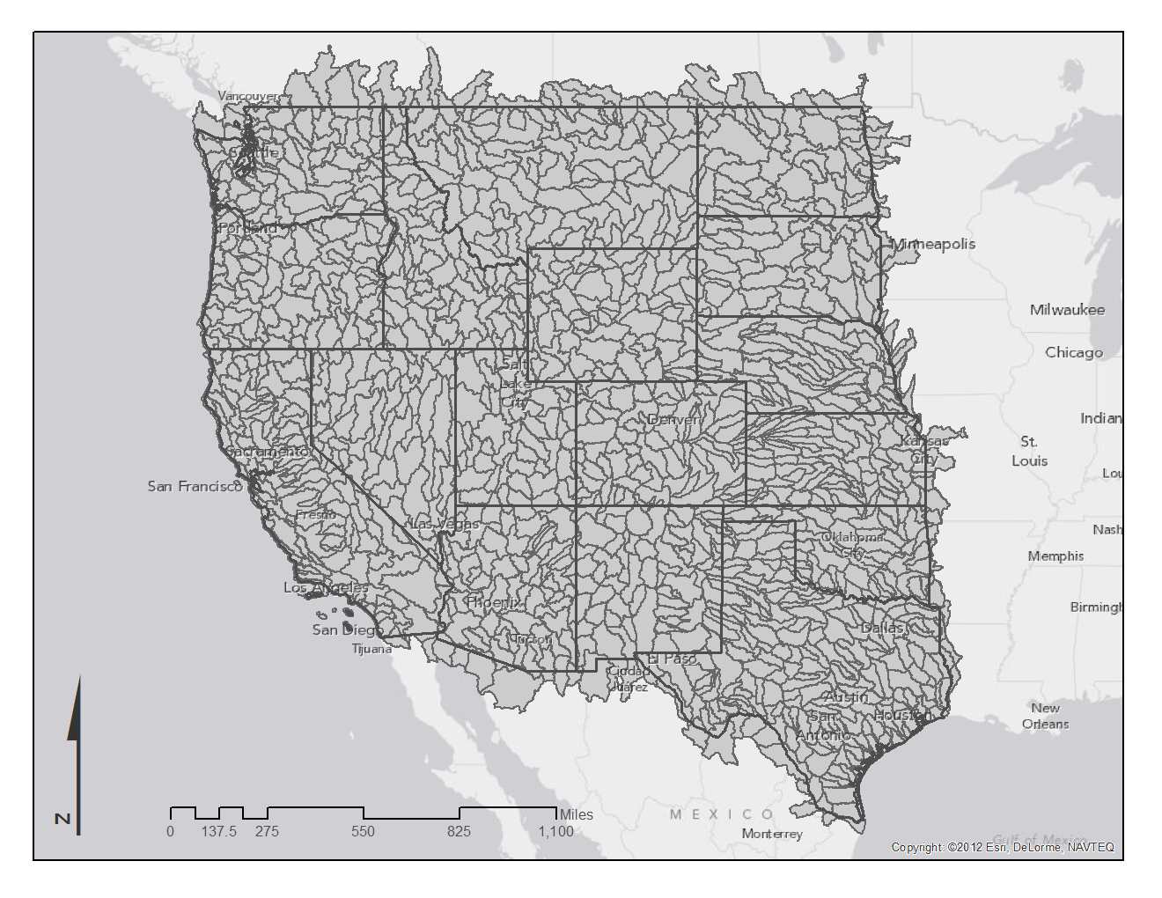
Figure 5. Map of Western 8-Digit Hydrologic Unit Code (HUC) Basins
The state may use HUCs, counties, regional planning areas, or some combination of these for summarizing information depending on how the planning program has evolved over the years. Most of the states use a variation of a hydrologic basin with an additional customization of administrative or jurisdictional boundaries. An example would be a state that uses approximately a HUC-6 scale of hydrologic boundary, but adds on a section of an adjacent smaller HUC for simplicity, or stops a hydrologic boundary with that of a county. Some states have the ability to summarize their data by county, which may facilitate its use in the USGS five-year water use estimates.
Figure 6 is a map of some of the planning regions, water resource inventory areas, water administrative basins, detailed accounting units, etc. that the states are using to organize their water data. The map reveals the mosaic of actual state water planning program boundaries. The states that use more refined watershed delineations have the ability to aggregate their data to a larger scale, but the reverse is not always the case. It is also only a geographic unit with which a state might summarize their data. Some of the states are currently doing this for some subsets of data, but targeted data like water availability are usually only analyzed on a site-specific and ad hoc basis. Some states responded in the survey that there is the potential to introduce additional spatial summaries into their workflows. This is a potential solution to the disparity in spatial scale used by the states, and is discussed more in the “Solutions” section below.
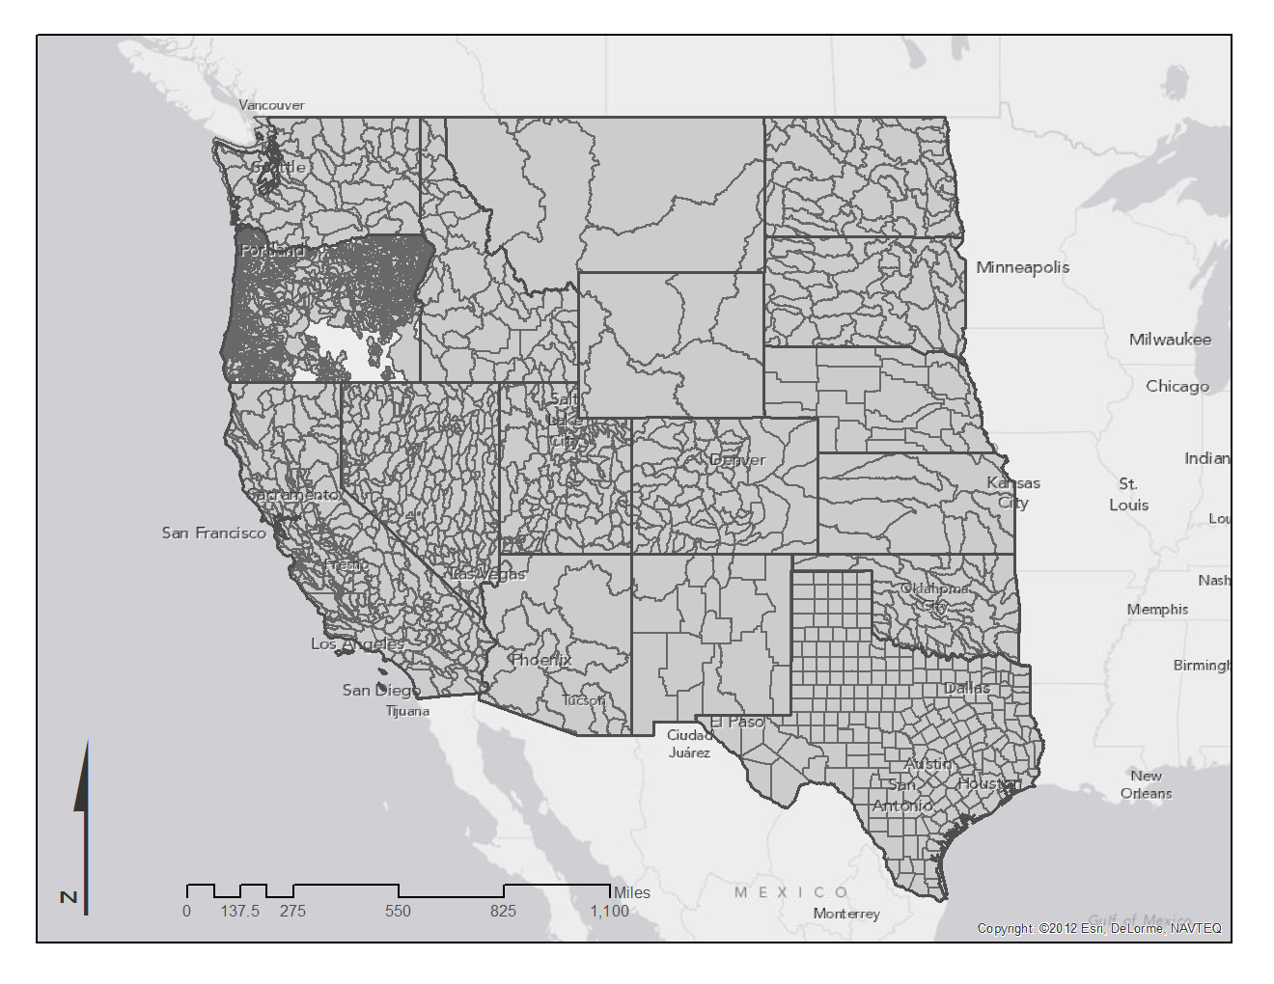
Figure 6. Map of Examples of Boundaries Used by State Water Agencies to Summarize Water Data

Methodological Differences
Each state has a methodology for estimating their important figures such as physical supply, legal availability, and water use data. They also have their own models for capturing water permitting/rights data. Some states use the drought of record to decide whether water can be appropriated, some use other statistical analyses. Some use sophisticated decision support tools to support their appropriations, while others generate sophisticated hydrologic models to review applications on a case-by-case basis. In many states, the methods used also vary based on past case law regarding water within the state. Methods involving water use are also incredibly varied because often the requirement to report use is based on the individual permit. The use may be self-reported by the water right owner. The state my require reporting by certain segments of beneficial use, but not require it by others. Uses for these may or may not be estimated by the state agency. Some permits require metering and others do not. Some users report water diverted, while others do try to estimate their consumptive use. Agricultural land-use surveys and satellite imagery are increasingly being used to estimate the consumptive use of water within this sector. As member states utilize such varied methods to evaluate water availability, water use, and other estimates, it would be misleading to display a map of these gathered estimates and then apply a color-ramp (a symbology that suggests that comparisons may be made) across basins. This would give rise to the assumption that the data were comparable across states’ borders.
This is one of the reasons why the WaDE portal, at the current time, allows for data discovery using custom delineations used by the states, but does not apply any internal shading or coloring. It is also one of the reasons why each estimate is closely accompanied by metadata that describe the method from which the value was derived. Given these differences in approach, a primary concern for the development of the WaDE portal is to impose a strong end-use agreement or disclaimer that informs incoming clients that different states (or potentially even regions within a state) are using different methods to create estimated values. It is the intention of the WaDE program to portray the data and methods that the states currently have, while also pointing them in a direction that will help to create a more uniform and spatially complete picture of water availability and use in the West in the future.

Possible Solutions
There are many approaches that can be considered for remedying or addressing the challenges listed above. States returning the survey indicated that they have more flexibility with regard to water diversion data when interested in summarizing this data by geographic unit. Points of diversion and water withdrawals related to those diversions are primary subsets of data within most allocation administration programs, and are more accessible. Most of the states can generate water diversion or withdrawal summaries for some portions or regions of their state. It is important to note that these summaries constitute diversions of water, not depletions or consumptive uses.
To get at a full suite of targeted WaDE data, it is recommended that the state water agencies first widen their water use reporting programs to include regions of the state not yet assessed, and second, expand water reporting to beneficial use categories or sectors that are currently not required to report. Ultimately, with an estimate of total withdrawal for the state and by sector, the states could also work toward estimating the consumptive use of those withdrawals and the accompanying return flows.

Recommendation #1 – Expand water withdrawal and water use reporting programs to include regions and sectors/beneficial use categories within the state that not yet assessed or required to report. Implement or expand consumptive use and return flow estimation programs.

Survey responses indicate that states typically look at water availability as a two-stage process. The first is to establish the physical existence of water in the streambed for the point of diversion. This involves accessing streamgaging information and reviewing figures such as the average annual streamflow, the statistical probability of water being present during a specific period, or reviewing what are considered to be drought conditions within the stream. After looking at streamflow conditions, state agencies typically review the upstream and downstream withdrawals and possibly the estimated return flows to arrive at a preliminary water budget for the site under review. The second stage is to review the legal and institutional requirements that surround the proposed point of diversion. This could include a review of minimum desired streamflow, endangered species protections, public interest, designation of partially closed or closed basins, aquifer safe yield estimates, downstream river compact obligations, etc.
When WaDE was initially being reviewed for data that should be targeted, the first activity described above was designated as the “Physical Water Supply Summary,” and the later, the “Legal/Institutional Water Availability,” as shown in Table 1. The outputs of these processes were hoped to be summarized statewide, with consistent time interval and geographic scales, but most states perform these functions as needed. A solution to this difficulty is to make the recommendation that the states modify the processes they are already using for reviewing physical and legal water availability to be performed on a set statewide and basin-level scale and time interval. In the meantime, those states that can generate summaries of these two products will be able to share data via the WaDE portal, provided the methodologies for each estimate are well-documented and attached as important metadata. Unfortunately, this means that this targeted dataset is likely to remain only partially complete until the states can begin to include the modified process (or another solution) described above in their planning program workflow.

Recommendation #2 – Modify or expand the workflow processes states are already using for reviewing physical and legal water availability to basin-level and statewide scales, and seasonal/annual time intervals.

With regard to the spatial, temporal and methodological differences between state water program estimates and summaries, the first step toward a more unified approach is to acknowledge the differences in the states’ current approaches. A review of the planning programs and their products allows state agency managers the opportunity to see how other states perform the same essential functions and decide whether their current approach is sufficient or if perhaps a review of processes and procedures is warranted. This document and the WaDE portal will allow the states to do this quickly and easily.
The next logical step toward a more regional picture of water in the West is to decide whether there is the potential to add specific products into the states’ workflows that could fit into the targeted data schema. Understanding that many of the states would not be supplying the requested WaDE data in the near future, the data schema for WaDE has been designed to be a guide for a set of information that the states can work toward. Knowing that other states will be actively working toward some of these targeted datasets may encourage other states to supply more of their data or to add facets to their programs that fit within the WaDE framework.
One example would be for the states to continue their site-specific analysis of water availability, but add an annual summary of water availability based on the same criteria that provide that information over a series of hydrologic basins on a specified scale – all states agreeing to supply this information on a HUC-8 scale for example. For some states this task would add a significant amount of work to their programs, but for others it may be as simple as running additional database queries.
Another approach might be to perform summaries on a much smaller scale (since this is closer to the more site-specific analysis that is already performed), and summarize these, thus allowing these numbers to be aggregated to a larger basin as needed, and providing additional flexibility and fit for the National Water Census Program.
Differences in temporal scale can also be allowed for within the WaDE framework. The current schema allows for reporting of water planning information using a specified timeframe, and allows the agency to select for a calendar or a water year. Once the agencies have a grasp of what other states are doing, there is the potential for a discussion on whether the same sets of data could possibly be aggregated to a preferred timescale. For example, a state that currently reports water use by calendar year, but has monthly data, could re-aggregate their figures to report for the water year as well. Small shifts in workflow products amongst the states could generate a much more uniform picture of water planning recommendation.

Recommendation #3 – More generally, encourage states to review the WaDE targeted data schema for possible inclusion in future program effort. Encourage the adoption of a standard spatial scale for the most common workflow products, such as physical water supply and availability analyses and summaries of water diversions, and also the adoption of a preferred timescale for reporting summary and detailed WaDE data – annually or monthly, using either a calendar or water year.

And finally, one of the most fundamental issues needing to be addressed is simply to find a common set of definitions, terms and methods for water planning program tasks that should be included in WaDE.

Recommendation #4 – Facilitate a state-by-state dialogue or repository for a glossary of terms relevant to legal processes behind the state’s management of water resources, as well as the physical and environmental processes. For example, what are the processes of granting a water permit, water right, the understanding of water allocations in a state database? How are terms such as consumptive use, depletion, withdrawals, conveyance, returns and losses used in the context of state management documents and databases?

State-by-State Summary

Alaska
The waters of Alaska are managed by two primary agencies within Alaska’s Department of Natural Resources, Division of Mining, Land & Water, Water Resources Section. First, the Water Management Unit oversees the appropriation and the issuance of temporary permits for water for the state of Alaska, as per the Alaska Water Use Act, Alaska Statute Title 46 Chapter 16.15. This Unit also maintains the Water Maps and Data Application, which allows users to access active and temporary water rights authorization in a spatial and tabular format. Spatial locations of water allocations can also be found on the agency’s Geographic Information System (GIS) enabled web mapping application “Alaska Mapper 3.0,” or the “Alaska Land Status Map.” Information on locations of diversions and the acreage of irrigated area at the time of appropriation are also tracked. The second agency, the Alaska Hydrologic Survey (AHS) Unit, oversees the recording, evaluation, distribution and publication of water quantity, quality and locational information about Alaska’s waters as mandated by Alaska Statute Title 41 Chapter 41.08. This includes the collection and assembly of information on surface water flows and groundwater.

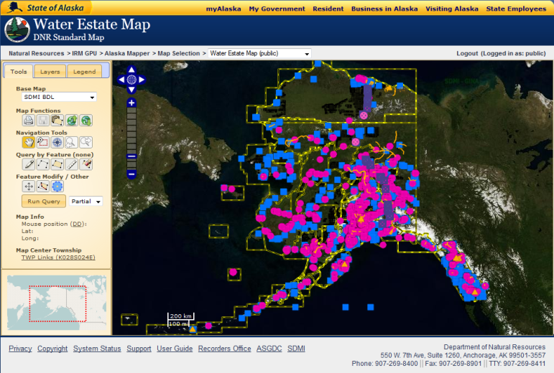
Surface Water
The AHS manages and stores its own stream gaging network, but also funds USGS to maintain stream gages. The data from stream gages are used to estimate water availability in various basins and to support the Water Management Unit. Water usage data is also stored and tracked by beneficial use on a site-specific, daily, monthly and/or annual basis, depending on when the permit holder is required to report. Some users are required to report diverted quantities or in some cases flows upstream of the diversion, and possibly the consumptive use, as specified in their water right. Alaska does not track instream flows, but has policies which allow water to be appropriated for this purpose. Typically, diversions are not metered, with the exception of water allocated to power generation. Reported or metered quantities are not posted to the agency’s website. Only users that have a reporting and metering requirement in their water right are required to do so. For other users, water use is not estimated. Some data cannot be shared (such as military installation use) for security purposes. The Alaska Water Resources Section issues water allocations, and tracks which have been adjudicated, the acres irrigated as specified in the water permit, and irrigation method used. They do not track the energy produced by water allocated to the thermoelectric sector, nor the energy facility and fuel type. Community water system populations are verified by another entity, the Alaska Department of Environmental Conservation.
Figure 7. Alaska Mapper 3.0 Application

Groundwater
The Water Resources Section has developed a regional groundwater monitoring program jointly with USGS in areas experiencing the highest population growth. Information from groundwater modeling is also incorporated into water budget estimates, which in turn are used in water availability estimates. Site-specific groundwater withdrawals are tracked by aquifer and beneficial use (as specified in the permit) on a daily or annual basis, as are the location of wells (some geographic coordinate, others by the PLSS). The locations of injection wells, groundwater recharge areas, closed basins, and special management areas are not tracked. Groundwater allocations and adjudication are tracked, as well as the acres irrigated at the time of the permit issuance. Irrigation method is also tracked, while energy produced by water allocated to the thermoelectric sector is not. Reporting requirements for groundwater users are similar to those for surface water. Users may be required to report both withdrawn quantities and consumptive use, as specified in a user’s permit. Public suppliers who use groundwater are metered, as well as some commercial uses.

Technology
Alaska Water Resources Section uses an assortment of databases to store its water information. It uses Oracle for some applications and Microsoft Access and Excel for others. They host their web applications using a Microsoft IIS web server. Java and Python are their preferred programming environments. The Water Resources Section offers much of its data to the public on its website, such as well locations, water right locations, water quality samples, streamflow measurements, etc.

Methodology
The term “water availability” for the state of Alaska is referred to in the context of whether the water being reviewed is available for appropriation. As such, Alaska does not provide a summary of water availability by any geographic grouping, but the estimate is site-specific to the reach under investigation by the Water Management Unit on behalf of the permit applicant. The data gathered by the Water Resources Section program are used to create water budgets. As part of their water budget evaluation of a given site, the Water Resources Section also assumes that all appropriated water upstream is entirely consumed unless metered quantities are available, and/or water is not diverted and returned to the basin. The calculations involved for these site-specific analyses are made available to the public, but are not summarized in any fashion, nor posted on the agency’s website.

Arizona
The approach the Arizona Department of Water Resources (ADWR) has for managing water availability, allocation, use and planning data depends on the location within the state and whether the use is of groundwater or surface water. In the Active Management Areas (AMAs), which are areas in the state where groundwater levels were declining most and population and use was growing prior to the passage of the 1980 Groundwater Management Act (the Code), ADWR tracks detailed information regarding the groundwater allocation and use of any type of water for most municipal, industrial and agricultural uses on an annual basis for both regulatory and planning purposes. Municipal use regulated by the Arizona State Code (the Code) includes water delivered for non-irrigation uses by a city, town, and private water company or irrigation district. Industrial use regulated by the Code is the non-irrigation use of water, not supplied by a city, town or private water company, including animal industry use. Agricultural use regulated by the Code is the application of water for two or more acres of land to produce plants, or parts of plants for sale or human consumption, or for use as feed for livestock, range livestock or poultry.
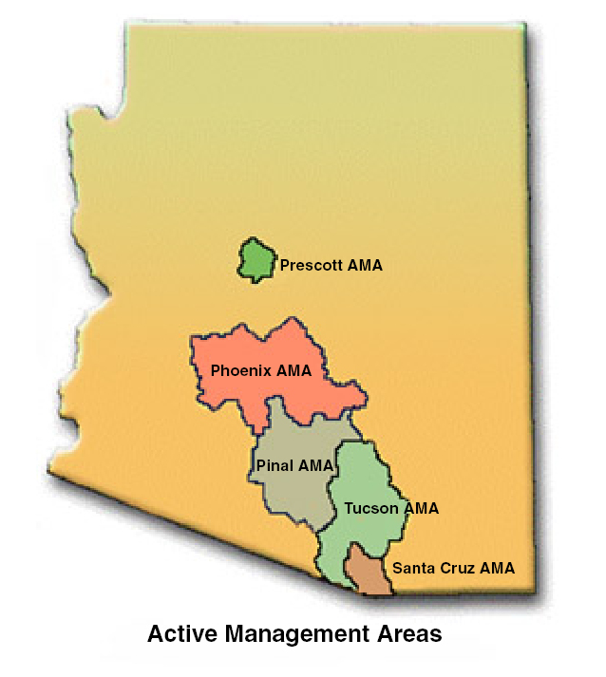
In Irrigation Non-expansion Areas (INAs), which are areas within the state where groundwater levels were declining, but the potential for increased use and population was less than in AMAs, ADWR collects annual water use data except for groundwater allocations, as they typically don’t apply in those areas. They also track the number of acres that are permitted to be irrigated, but do not track how many acres are actually irrigated each year. Outside of the AMAs and INAs, ADWR contracts with USGS to estimate annual groundwater and surface water use data, and estimates for agricultural, municipal, mining, electrical power generation, and some drainage pumping. ADWR also collects annual water use for community water systems statewide. Program plans for the future include continuing the compilation of annual water use information by source and sector, and updates within a year after the use reports have been filed. Infrastructure improvements include testing of an Oracle database for storing water use information that will be made available online. During the last five years ADWR has also produced the Arizona Water Atlas, a comprehensive statewide reference for water supply and demand and related hydrologic information. ADWR hopes to update the Atlas on a more frequent time scale – every few years as time and resouces allow. In October of 2011, the Water Resources Development Commsision (WRDC) released a report on the future availability of water supplies and needs for the state for the next 100 years. The WRDC study looked at the potential for shortage/surplus over this timeline and potential sources of additional supply that could be made available.
Figure 8. Arizona Active Management Areas

Surface Water
ADWR works in close cooperation with USGS in estimating stream flow. ADWR makes extensive use of USGS stream gages and also works closely with them to estimate water availability and use in areas outside of the AMAs. In these areas, community water systems must report to the state and use can be compiled by county. Within the AMAs, ADWR requires annual reporting of surface water use by municipal, industrial, and agricultural users, by beneficial use, and by county, watershed or its specific sources (point of diversion and place of use). Data are compiled annually within the AMAs and for community water systems outside the AMAs, and gage data is compiled every four years outside the AMAs for instream flow applications. The WRDC Supply and Demand report and the Water Atlas provide summaries of water supply and demand data for basins located throughout the state. Points of diversion and the size of the diversion are tracked within the AMAs. The AMAs and INAs serve as the agency’s designated special management areas. The agency also tracks the acres irrigated within the state, and energy production from water for large scale energy facilities. ADWR has policies regarding instream flow that are defined in their “Guide to Filing Applications for Instream Slow Water Rights in Arizona.”

Groundwater
ADWR monitors approximately 1,700 “index” wells throughout the state and operates a network of about 120 groundwater monitoring sites. The data gathered from these sites are included in water availability estimates. All groundwater wells greater than 35 gallons per minute (gpm) are metered and their withdrawal is reported back to ADWR. Community water systems outside the AMAs also report their groundwater withdrawals. Consumptive use data and estimates are compiled for ADWR by USGS for all sectors outside the AMAs annually. ADWR maintains a database of registered wells down to ten acre parcel, and a database for Groundwater Site Inventory (GWSI) wells by latitude and longitude. Groundwater is also summarized statewide in the Arizona Water Atlas.

Technology
ADWR primarily uses Oracle to store their water supply, uses and permitting data. They also use Microsoft Access to a much lesser extent. They use Microsoft’s IIS web server software for hosting their website and web applications, and also use .Net as their preferred programming platform. Their data are compiled in the “Assessments” and are made available for download over the agency’s website as Microsoft Excel spreadsheets. The State Water Atlas is also available, as are community water system totals by basin for 2008. ADWR makes their data available through three interactive online spatial tools: 1) a spatial well locator, 2) a site that allows users to access Assured and Adequate Water Supply Program data, and 3) a tool for accessing groundwater levels, well locations and viewing related hydrographs. Some queries of the Oracle databases can also be performed to retrieve water permitting data.

Methodology
ADWR has three working definitions for the term “Water Availability.” First is a hydrologic test used in the approval process for new subdivision permitting. This entails determining if there is a 100-year supply of groundwater, surface water or both that are “physically available” based on “firm yield” estimates for surface water. The second definition is called “Continuous Availability” and requires that adequate delivery, storage, treatment and conveyance infrastructure exist to provide water on a continuous basis for 100 years. The last definition is for “Legally Available” water, which requires that the legal right to provide the water for 100 years exists. All of these terms are specific to the ADWR’s Assured and Adequate Water Supply (AAWS) program. As stated earlier, ADWR summarizes groundwater and surface water uses annually by groundwater basin and sub-basin within the AMAs, and uses USGS estimates outside AMAs. Water usage inside the AMAs and INAs is estimated annually by compiling reported data for non-exempt groundwater users via flow meters on wells and surface water streamgages for surface water deliveries. Outside these areas, USGS uses air photos, satellite imagery and crop-type assessment field work to estimate consumptive use by the agricultural sector. Other data on municipal, mining, drainage and electric power generation water uses are compiled from Arizona Corporation Commission records, calls to water users and community water system reports.

California
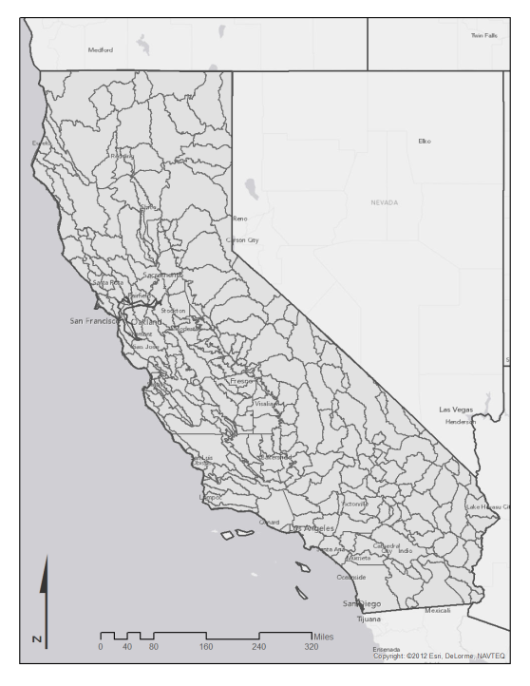
Water resource management in California is divided between the California Department of Water Resources (CDWR) and the California Water Resources Control Board. The Water Resources Control Board and nine Regional Water Quality Control Boards protect water quality and allocate surface water rights for the state. CDWR is responsible for the management of water, including the delivery of water to two-thirds of California’s population through the State Water Project. They oversee and provide for many programs and data-gathering efforts that enable them to do this. The CDWR collects and maintains hydrologic measurement data, including surface water, groundwater and water quality data. These are collected following USGS’ standards for data collection. The data are used to support strategic planning of water supplies and demands in the State, to support integrated water management at regional and local levels, for flood control planning and a variety of other programs. CDWR also collects urban water management plans (UWMPs) from approximately 450 local water utilities every five years. These include historical water use and planning information. Water uses are reported by customer classes, but not by source of water supply. Delivery information is collected from water utilities annually also.
Figure 9. California's Detailed Analysis Units
Another CDWR program includes preparing partial water balances for developed supplies every year. The spatial scale of the water balances are at the intersection of county boundaries and Detailed Analysis Units (DAU), a custom delineation within the department. These are not true balances because many of the flows of the hydrologic cycle cannot be measured. The estimates usually run about four years behind the current year. CDWR also performs a water-related land-use survey, primarily of agricultural land, for different portions of the state each year so that they can summarize the results by county for the entire state on a 10-year cycle. During the survey CDWR attempts to identify the source of the water being used (i.e., surface water, groundwater or mixed supply), and the type of irrigation system in use (flood irrigation vs. sprinkler system). Urban and native vegetation areas are also mapped, but not at the same level of detail as the agricultural survey. These figures serve as the basis for computations of current and projected water uses within the state.
The State Water Resources Control Board (State Water Board) and the nine Regional Water Quality Control Boards (Regional Boards) work to protect water quality and ensure the proper allocation and efficient use of surface water rights for the state of California. They maintain a number of databases that include summary reports and GIS data of both water quantity and water rights information. The primary database used to track water rights is the Enhanced Water Right Information Management System (eWRIMS). eWRIMS provides agency staff and the public access to California’s water rights information using a GIS and web-based portal. It can be searched for more detailed information about water right status, water right type (beneficial use), to whom the water right belongs, its identification information and more information about its location (watershed, county, water source, etc.). eWRIMS can also display points of diversion, upstream and downstream points of diversion, and fully appropriated streams to determine whether or not water is potentially available on that reach.

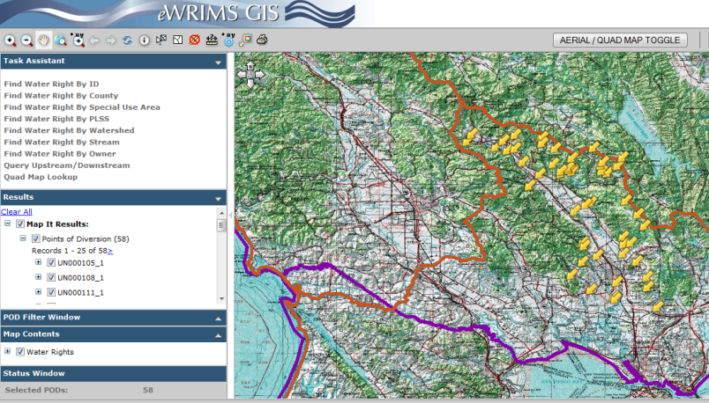
Surface Water
CDWR manages streamgages and also stores streamgaging data in house. They use these and USGS streamgage data to estimate water availability. They also track and store water use data by public water system, categorized by customer type and collected annually. These figures have locational information attached, but are not stored in a GIS format. CDWR has spatial data for managed wetland areas. In lieu of specific information regarding the State Water Boards’ use of streamgaging information, spatial data collected, and water use reporting, a link to the California water code that describes the water appropriation process (the segment of water administration that the State Water Board is responsible for) is included. These describe the criteria used to evaluate water availability for the permitting process and also for water use reporting by different water users and beneficial use categories.
Figure 10. California Water Board's eWRIMS interface.

Groundwater
In most areas of California, overlying land owners may extract percolating ground water and put it to beneficial use without approval from the State Water Board or a court. California does not have a permit process for regulation of groundwater use. In several basins, however, groundwater use is subject to regulation in accordance with court decrees adjudicating the groundwater rights within the basins. CDWR manages its own groundwater monitoring wells and stores relevant groundwater data in-house. They use this information to calculate water availability by estimating changes in groundwater storage. They maintain spatial data for well locations, injection wells and recharge basins. Uses of groundwater are not tracked by CDWR or the State Water Board. Please refer to the California water code above for further information

Technology
CDWR uses Oracle and Microsoft’s MySQL databases for housing their data. Their environments for hosting web applications and programming are Linux, and Java/.Net, respectively. GIS software is also relied upon heavily to analyze and publish spatial data. CDWR makes their data available over the internet from a variety of sites. They have separate applications for a surface and groundwater data library, surface water for operations, land and water use surveys, and water balances for the California Water Plan. These are made available through a GIS-enabled web mapping application and basic websites, but not published using web services.

Methodology
California uses a variety of methods for estimating availability that cannot be effectively summarized in this report. More information about how the state defines water available for appropriation is available on the California Water Code website (footnoted above), and in the Technical Guide Appendix for the State Water Planning Program.

Colorado
The Colorado Division of Water Resources (DWR), also known as the Colorado Office of the State Engineer, administers water rights, issues water well permits and represents Colorado in interstate water compact proceedings. They also oversee streamflow and water use within the state, the approval of construction of dams and dam safety inspections, licensing for well drilling and numerous databases that contain Colorado’s water information. Their water allocation criteria are based on the prior appropriation doctrine, on prevailing climatic conditions, and water use by fellow appropriators. Since Colorado is a headwaters state, water availability is generally considered to be a result of the prior year’s climatic events and reservoir conditions. The state is divided into seven large watershed divisions, with offices maintained in each. In addition to the DWR office, Colorado also relies on the expertise of the Colorado Water Conservation Board (CWCB), which was created to provide policy direction on water issues. This agency is governed by a 15-member Board, with responsibilities that range from protecting Colorado’s streams and lakes, to water conservation, flood mitigation, watershed protection, drought planning, water supply planning and water project financing. In addition to funding and policy development, they also provide data collection and analysis, and technical assistance for planning efforts. Colorado also benefits from the formation of the Interbasin Compact Committee (IBCC) and Basin Roundtables – established by the Colorado Water for the 21st Century Act – which serve as its grass roots “think-tanks” on water issues. The IBCC and Basin Roundtables play a leading role in developing approaches to cooperatively manage water and implement solutions for future water needs for all manner of water users, providers and regulators. The IBCC is a 27-member committee that actively participates in the state’s water decisions and creates a local driven process for decision-making by those living in the state’s river basins. The Basin Roundtables were established for each of the major river basins and the Denver metropolitan area. Each is required to develop a basin-wide water needs assessment that addresses consumptive and non-consumptive water needs, available water supplies (surface and ground), an analysis of any unappropriated waters, and proposed projects or methods to meet any identified water need and achieve water supply sustainability over time. CWCB supports and staffs the Basin Roundtables and the IBCC, provides water supply and demand information, and conducts technical analyses for these entities.
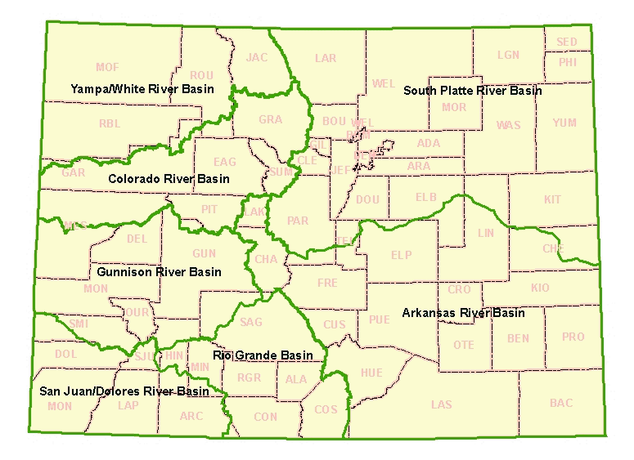
In 2003 the Colorado legislature authorized the CWCB to implement the Statewide Water Supply Initiative (SWSI), an 18-month basin by basin investigation of existing and future water needs. SWSI explored each of the major river basins’ climate, topography, surface water and groundwater resources, water quality, and riparian issues. It explored the gap between available supplies and projected needs in 2030 and specific tools to address those needs. The essential water supply and demand results used in the SWSI effort (and later updates) were derived from Colorado’s suite of decision support systems (CDSS). The CDSS is a water management system developed by the CWCB and the Colorado DWR for each of the state’s major river basins. The CDSS is based on Hydrobase, the main database for housing Colorado’s historical climate, groundwater, agricultural, streamflow, water rights and structures/diversions data. These measurements and raw data numbers are incorporated into models or data management interfaces (DMIs) that can generate estimates of consumptive uses, surface water planning derivatives, groundwater planning derivatives and water budgets. These results are not necessarily comprehensive however, as models have only been developed for a portion of the basins.
Figure 11. Map of Colorado's Divisions and Counties

Surface Water
Colorado DWR owns and manages their own streamgages and uses these as part of their water availability estimates. Use of the water is tracked by beneficial use and by measurement structure, but is not summarized by any area. These data are available on a daily, monthly and annual time scale depending on various factors. Water availability and water uses are not kept in a spatial format, although the data can be summarized by their source of water. Diversions and return flows are tracked and spatial information on closed basins and designated special management areas are also available. Water allocations are tracked, along with the acres and irrigation method used by the agricultural sector. Energy produced by water allocated to energy production is not tracked, nor is the facility or fuel type. Users of surface water are required to report on their volume diverted to Colorado DWR, but the timeframe varies from real-time (using a data recorder) to annually. Colorado does have statutes that address instream flow requirements as well as interbasin transfers. CWCB also works to ensure that interbasin transfer statutes are adhered to and best serve all Coloradoans.

Groundwater
Colorado DWR does not own groundwater monitoring wells, but tracks groundwater elevations in targeted areas. Some are available on a daily basis, while others are reviewed monthly or annually. These are not used to estimate groundwater availability, but are used for the purposes of administering water rights or plans that manage surface water impacts based on groundwater diversions. However, additional oversight is used within Designated Groundwater Basins in Colorado where groundwater use and rights are issued while understanding that the aquifer in question is being mined. Groundwater users must also report their diversions. Colorado DWR has spatial data for well locations, and has data for individual locations/structures. These could potentially be summarized on a basin-wide scale. They also track the locations of injection wells and recharge basins, but this only occurs in the Denver Basin bedrock aquifers. Other areas that receive additional oversight have been designated as special management areas. Colorado DWR has information on the acres irrigated and the irrigation method used. Most water users report diversions, in both rates and volume diverted, but consumptive use can be determined using accepted methodologies, some of which are required by water right decrees. The remainder of users who are not required to submit a report are required to maintain diversion information, but this is not estimated by the agency.

Technology
Colorado uses Microsoft’s SQL Server for the bulk of their data storage. Their main database repository is the Hydrobase application. There are several modules that run off the data in Hydrobase, including StateMod (a daily and monthly surface water allocation and accounting tool), StateCU (used to estimate historical consumptive use based on water user reported data), and StateWB (calculates a basin-wide water balance and generates a consumptive use and losses summary). These are all part of Colorado DWR’s Decision Support System (CDSS). They also host a large amount of GIS data developed through the DSS, which area available for download and also published using web services. The environment used for hosting web applications is Microsoft’s IIS web server, and .NET is their preferred in-house programming language.

Methodology
Colorado does not have a ready definition of “water availability;” however, CWCB and Colorado DWR do co-chair a Water Availability Task Force. During the water allocation process, legal availability of water is used to determine whether water rights are granted using the modeling tools described above, but this is performed on an ad-hoc, site-specific basis. When answering the survey, Colorado DWR noted that reducing water availability to a reportable condition, it is important to note that factors such as snowpack, recent precipitation, streamflow and reservoir storage are always in flux. When determining consumptive uses, Colorado will use one of three approaches based on the type of diversion. Consumptive use may be calculated using a pre-determined consumptive use factor through analytical approaches (i.e., use Modified Blaney-Criddle or Penman-Monteith for irrigation estimates), or through empirical mass balance approaches. Performing the consumptive use calculation requires diversion and water use data related to crop type, climate data, streamgaging, etc.

Idaho
The Idaho Department of Water Resources (IDWR) has several planning programs and studies related to water supply and demand. They are especially active in pursuing new ways to track and manage water used for irrigation, the largest water use category in Idaho (and most other Western states). A program called the Comprehensive Aquifer Management Planning (CAMP) effort focuses on developing aquifer management plans to meet current and future water needs in selected aquifers across the state. Studies undertaken to support CAMP development include water demand forecasts, potential for groundwater recharge, surface water storage feasibility, and weather modification. Technical studies are also being performed to ensure any plan is technically feasible. IDWR is developing a comprehensive database to store data developed in technical studies in support of the CAMP efforts, as well as historical data collected throughout the state. IDWR is in the process of updating models for water resources in northern Idaho (Rathdrum Prairie) and southwestern Idaho (Treasure Valley), the Eastern Snake River Plain aquifer model, and the Snake River Plain river and reservoir operations planning model. The models will be used to analyze or project impacts related to water infrastructure developments and other water management efforts.

Surface Water
IDWR manages and maintains a few streamgages, but contracts with other agencies/companies to maintain the others. They store data from these gages and also from USGS’ NWIS website. They use this information to evaluate water availability. They also track and store water use data by IDWR’s categories of beneficial use. The water use data are tracked at a site-specific spatial scale (by diversion location) on a daily, monthly and/or annual basis. They also identify water “places of use” using satellite imagery, and estimate evapotranspiration (ET) on identified agricultural lands using Landsat satellite imagery. Much of the water availability and water use data that is tracked is gathered on a site-specific basis and is not summarized by a spatial area. IDWR also tracks return flows, closed basins, and special management areas. Allocation information is maintained and includes the status of the permit’s adjudication, beneficial use, and acres irrigated. They do not track the energy production or fuel type for water allocated to the energy sector. The population served by community water systems is tracked by another agency, the Idaho Department of Environmental Quality.
Users of surface water vary in their reporting requirements. In active, regulated surface water districts, watermasters and hydrographers typically record diversion data daily or weekly. Some districts may be limited to just miscellaneous measurements or infrequent measurements when regulation is required. Reports are submitted to IDWR annually but a number of larger districts enter daily data using an IDWR data entry application. Within these water districts, diversions are reported as flows in cubic feet per second. The flows are typically read and recorded as an instantaneous measurement although some diversions do have instrumentation and data loggers or other equipment where average daily flows are recorded and reported. Diversions are reported, but not the consumptive use of the water. Not all users of surface water are required to report on their use, but IDWR does perform estimates to account for these. Idaho has policies regarding instream flow and interbasin transfers. The state has compacts with the state of Wyoming regarding water originating in that state that flow into Idaho. There are also compacts regarding the Bear River with other neighboring states. Some water is leased by the federal government to be used downstream in other states related to the flow within the Columbia Basin.

Groundwater
IDWR manages and stores groundwater monitoring data and also acquires additional data from USGS’ NWIS website. These are used in water availability calculations. Site-specific groundwater use data are stored for certain areas of the states, most notably the Eastern Snake Plain Aquifer, the Big Lost River basin and, beginning in 2013, the Upper Wood River basin area, on an annual basis. Summarized groundwater use is available for a number of large water districts. Some geothermal groundwater diversions from different areas of the state are also collected and stored. The groundwater use records that are stored are not associated with a beneficial use category. IDWR has locations for injection wells, closed basins and special management areas. Allocations for groundwater include information about legal status, the acreage to be irrigated in the water right (not actual acres irrigated). Information energy production and fuel types for water allocated to the energy sector are not included. Reporting requirements for groundwater are similar to those for surface water, such that they vary and the method used to report also varies. Annual volume of groundwater diverted is reported for areas where measurement and reporting are required. Consumptive use is not included in that report. In areas where groundwater measurement and reporting is required, many withdrawals are metered (almost all municipal, commercial and industrial uses), but a majority of groundwater withdrawals outside of these sectors are estimated using power consumption records and development of power consumption coefficients, mostly for irrigation pumps. Single family domestic and small stock water uses from ground and surface water sources are not required to report. Typically irrigation uses of five acres or less are not required to be measured and/or reported, apart from new reporting requirements beginning in 2014 in the Upper Big Wood River basin area. The amounts not required to be reported are not estimated by IDWR. Most records of water use data are publicly available, with the exception of power consumption records that are used to estimate groundwater diversions and some data related to public safety.

Technology
IDWR uses a myriad of database platforms for its access and storage of water data, including Microsoft’s SQL Server, Dbase, Microsoft’s Access and GIS software. Microsoft’s Excel is also used to process some of the data downloaded from dataloggers prior to their import into the applicable database. IDWR uses Microsoft’s IIS web server software for serving their online web applications. They support Java, .Net, and Python programming environments. Much of IDWR’s water data is available on their website, some of which are also made available using web services. They host an online mapping application where users can access myriad water-related datasets. They also have reports available on their website that contain water-related data.

Methodology
Applications to appropriate new water supplies are evaluated based on a set of criteria put forth in the Idaho State Code, which requires an assessment be made of the impact of the proposed use on water availability for existing water rights, the adequacy of the water supply for the proposed use, whether the application is being filed for speculative purposes, the financial ability of the applicant to complete the project and the effect of the proposed use on the local public interest. Water availability is also subject to the location of the proposed development. “Critical groundwater areas” are defined as any basin not having sufficient groundwater resources to provide a reasonably safe supply for irrigation of cultivated lands, or other uses in the basin at current rates of withdrawal, or projected rates of withdrawal. “Groundwater management areas” are defined as any groundwater basin or designated part which the Director of IDWR has determined maybe approaching the conditions of a critical groundwater area. These areas typically have mandatory reporting mechanisms set up with IDWR. Availability within these areas can only be approved by the Director after he has determined on an individual basis that sufficient water is available and that prior water rights will not be injured. An example of how water availability can be determined is the method used within the Bear, Upper Snake, Boise, Payette and Big Lost River Basins. Water availability assessments for these areas use a determination of natural flow and storage in each river reach and the daily allocation of diversions, with optional program calculation methods. IDWR determines consumptive use using two methods. The first is within irrigation district and groundwater model cells. These use available data to estimate how much water was consumptively used within the district. The second is the use of satellite imagery and a methodology known as the METRIC process to estimate irrigation water requirement. Both of these methods estimate use on daily, monthly and seasonal time frames. IDWR is planning to develop a spatially enabled geometric network that will allow dynamic modeling of the actual hydrologic network for water distribution. Model parameters are selectable to allow watermasters to configure the accounting procedures as necessary, and also to allow comparison with the legacy method of accounting. Data that are needed to run the consumptive use models include daily stream flow, reservoir storage, diversion data, water rights data, weather station data and Landsat thermal band satellite imagery.
One interesting innovation for IDWR is the creation of a “Water Supply Bank.” This is used to encourage the highest beneficial use of water, provide a source of adequate water supplies to benefit new and supplemental water uses, and provide a source of funding for improving water user facilities and efficiencies. It is a water exchange market operated by the Idaho Water Resource Board to facilitate movement of existing water rights to natural flows or water stored in reservoirs. Water right holders can offer unused water rights to the Bank. From there, the water can be rented to water users who do not have adequate water rights to meet their needs.

Kansas
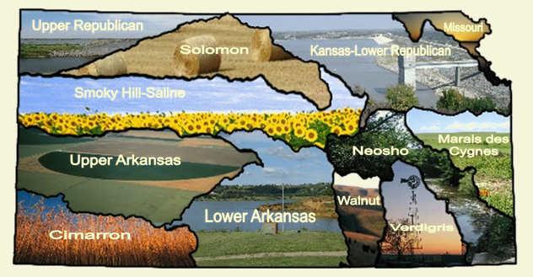
There are two agencies with responsibilities related to water quantity planning in Kansas, the Division of Water Resources (DWR) and the Kansas Water Office (KWO). The Kansas DWR administers the laws and responsibilities, including the Kansas Water Appropriation Act, which govern how water is allocated and used; statutes regulating the construction of dams, levees and other changes to streams; the state's four interstate river compacts; as well as coordinating the national flood insurance program in Kansas. Responsibilities related to water permits, reviews and inspections are performed by the Appropriation Section, while the Water Management Section provides technical and data support to all agency water programs. This includes any interstate water issues related to the compacts that allocate water from the Arkansas, Big Blue, Missouri and Republican rivers. The interstate water issues staff help the chief engineer in technical data collection. This data collection includes analysis and modeling. It is used to determine whether Kansas and neighboring states are complying with compact terms and/or whether any actions are necessary.
The Basin Management Team program works to develop water management strategies to address water resource issues identified in the Kansas Water Plan. This group also works with local stakeholders on groundwater model development and provides decision support work products for the division. The Operations and Data Management section maintains the Water Rights Information System (called WIMAS) and the Water Structures Inventory databases. They are essential for the Water Appropriation program and Water Structures program. The team tracks applications and permits and makes informed decisions related to program responsibilities. They also make timely and accurate responses to open record requests and other inquiries. The data management team is also responsible for the annual data entry and quality control of nearly 15,000 water use reports for more than 30,000 active water rights.
Figure 12. Planning Basins for Kansas Water Office
The Kansas Water Office (KWO) conducts water planning, policy, marketing and coordination throughout the state. They also make recommendations to the Governor and Legislature of Kansas for needed legislation to ensure water policies and programs address the needs of the state. KWO staff provide information on reservoir storage and drought, water conservation, water marketing and develop recommendations for water policy legislation. KWO also authors the Kansas State Water Plan (SWP), a publication that is issued every five years on the status of water resource supply and demand. The publication of the SWP includes a Kansas Water Atlas, which summarizes the surface water and groundwater outputs described below into maps of water use within counties and subdivided by beneficial use category. The Atlas also contains the volumes and types of crops and livestock grown within the county.

Surface Water
The Kansas DWR does not manage its own streamgage network, but does store information downloaded from USGS’ NWIS website. These are used to perform water availability calculations. They also track and store water use data by beneficial use category. The spatial scale for the amount of water diverted is on a site-specific and primarily annual scale. Spatial data is available for water availability and water uses can also be summarized by querying DWR databases. The DWR also has locations for water diversions – about 80% of which are metered – and closed basins. Allocation data are stored, as well as acres irrigated, crop type, and method of irrigation. The energy produced by water allocated to energy production is not tracked. Kansas does have policies regarding instream flow (called Minimum Desirable Streamflow) and interbasin transfers, although transfer policies have not been employed to date. Surface water users are required to report their amount diverted, acres irrigated, crops grown and irrigation system type on an annual basis. Diversions are not metered. Not all beneficial uses are required to report. Domestic uses are exempt, but may be estimated if needed for a specific application. Community water system information is requested on annual water use reports and is then verified using U.S. Census data.

Groundwater
The Kansas DWR manages and stores groundwater level data, as well as incorporating USGS’ groundwater monitoring data. The data are used to estimate water availability. Groundwater use data is tracked by allocation on a site specific, annual basis. The locations of wells and the source aquifer are tracked. The amount of water withdrawn is reported annually and can be summarized by different geographic units. The spatial extents of closed basins and special management areas are also maintained. Groundwater users are required to report their amount diverted, acres irrigated, crops grown and irrigation system type on an annual basis. Diversions are not metered. Not all beneficial uses are required to report. Domestic uses are exempt, but may be estimated if needed for a specific application. The amount of energy produced by water allocated to this sector is not tracked, nor is the energy facility fuel/generator type.

Technology
Kansas uses Oracle to store their data and also uses Microsoft’s IIS web server for its online applications. The programming environments preferred by the DWR office are Java and .Net. Their data are shared via their website and are also made available using web services.

Methodology
Kansas’ guidelines regarding surface and groundwater availability are defined in the “Rules and Regulations” section of the Kansas Water Appropriation Act. Surface water availability is defined as water in a non-closed basin that may be withdrawn for designated beneficial use if the Minimum Desirable Streamflow (MDS) and DWR targeted streamflow may still be met downstream, and that senior water rights holder requirements may also be met. There are also several seasonal restrictions and federal/local agreements that users must consider and adhere to in order to withdraw water. Groundwater availability is defined in the same document as water available for withdrawal that adheres to local restrictions defined further in five groundwater management district “Rules and Regulations.” These generally allow withdrawals of water that are regarded to be within the safe yield of the region, with a variety of allowed exemptions, such as smaller domestic withdrawals.
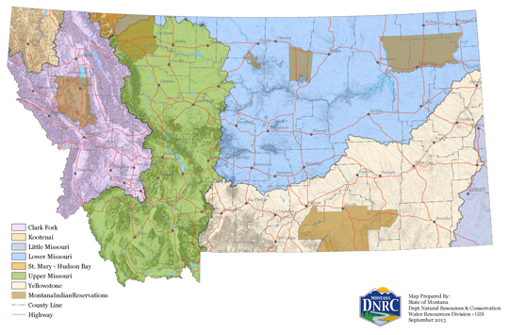
Kansas DWR analyzes consumptive uses when evaluating water transfer requests using a variety of criteria, including ensuring that consumptive use of the water does not increase with the change of use. The transfer of use rules identify procedural methods for determining whether a proposed change of application meets the minimum legal requirements for the transfer to proceed, but does not identify the method use to estimate water withdrawals and consumptive use. Kansas DWR does identify the data sources that supply their groundwater modeling efforts as being critical to their planning program, such as aquifer extent, saturated thickness, transmissivity, storage coefficient, water level data, and water level changes.

Montana
The Montana Division of Water Resources (DWR) carries out its duties for the purpose of promoting the general welfare and prosperity of the people of Montana. Sound coordination of the development and utilization of the state’s waters allows the Division to protect existing uses and to promote adequate future supplies for domestic, industrial, agricultural, recreational, conservation of water for wildlife, aquatic life and other beneficial uses. The Division is divided into six bureaus that oversee different facets of the water planning program. State data on water availability, allocation and use is primarily managed through the Bureau of Water Rights using their Water Rights Database (DNRC WRDB). Within the Division, the Water Management Bureau performs surface and groundwater studies, and water planning activities and reports, including the Montana State Water Plan. As directed by the Montana Legislature, the DWR is launching an initiative to update the Montana State Water Plan. The 2015 Montana Water Supply Initiative (MWSI) will engage citizens in a planning process to develop strategies and recommendations for meeting Montana’s future water needs. The new process will take advantage of advances in information technology to develop, analyze, interpret, store, deliver and archive water availability, allocation, use, and other planning data.
Figure 13. Montana Major Water Planning Basins

Surface Water
Montana DWR manages a small number of streamgages related to special projects or studies undertaken by their staff hydrologists, but acquire and store streamgage data from USGS’ NWIS website. These are used for water availability analyses, but these are not summarized by basin. Water supply data are available in the form of streamgage data supplied by USGS and snowpack water supplies given by the National Resource Conservation Service (NRCS). These are summarized on a county scale. DWR does not have a program specifically geared toward monitoring water use, but the state’s water rights adjudication process documents water use through the claims examination process. This is not intended to regularly track or monitor waters, but DWR does partner with USGS to produce their “Estimated Water Use in the U.S.” report every five years. These efforts result in estimates of water used that cover the previous ten years, organized by county and HUC. Water rights are attributed with a purpose, such as irrigation, wildlife, and stockwater, etc., but the actual use is not tracked by category. Water rights are site specific, but are organized by water right basins that roughly correspond to 4-digit HUCs. Instream flows do have a specific water right designation within Montana, as well as water reservations. DWR does have spatial data for some points of diversion and places of use by PLSS description. About 20% of water rights in Montana now have geographic coordinates for location. DWR also tracks the locations of a small inventory of return flows, closed basins and special management areas. Water rights information includes which rights have been adjudicated, acres irrigated and irrigation method. DWR does capture the amount of energy produced with water allocated to energy producers for state-owned facilities, but not other facilities or fuel types. The populations served by community water systems are not tracked. Montana DWR also has policies regarding interbasin transfers and river compacts.

Groundwater
Groundwater monitoring wells are managed by the Montana DWR and the data are stored in the Groundwater Information Center database at the Montana Bureau of Mines and Geology. The water elevation data is not used to evaluate water availability and groundwater use data is only tracked when required by specific permit requirements. Any data that are tracked are generated on a site-specific basis and are not summarized. DWR does not track spatial data related to well locations, special management districts, injection wells, or source aquifer. DWR does maintain allocation data for groundwater, and tracks which have been adjudicated, acres irrigated and irrigation method associated with the water right. Energy produced by water allocated to the energy production sector are not tracked, nor is the energy facility (apart from state-owned facilities) or fuel type. Populations served by community water system are not reported. Reporting requirements by water right holders vary by specific permit requirements, but for those that are required, the withdrawal of water is reported (not consumptive use).

Technology
Montana DWR uses both Oracle and Microsoft’s SQL Server database platforms to store their water data. They also use Linux and Microsoft’s IIS web servers for hosting their web applications. The programming environments supported in their office include .Net, Python and PL/SQL. Water rights data are available on the DWR’s website. One thing to note is that the DWR’s water rights database is hosted by the Montana State Library’s Natural Resource Information System (MSL NRIS) as opposed to in-house.

Methodology
To determine whether water would be available for a newly requested water right or amendment, Montana DWR uses one of two methods. The first involves analyzing the seven lowest consecutive days that have a ten percent chance of occurring in any one year. This amount is often used to define drought conditions. The second looks at the 30 lowest consecutive days that have a 50 percent chance of occurring in any one year, often described as the annual low flow. Also, when evaluating the availability of surface or groundwater for physical and legal availability Montana Rules and Regulations stipulate that surface water permitting is subject to the legal demands in the area, evaluated on a monthly basis, of the proposed point of diversion, and withdrawals from subsurface flows must also account for their impact on surface water and nearby legal demands, evaluated on a yearly basis. These are further defined in the “Permit Application Criteria” for surface and groundwater. When evaluating consumptive use for the change application process, historic use has been used to determine water consumptively used by agriculture prior to 1973. Montana DWR uses USGS’ streamgage data, USGS’ StreamStats website, Landsat satellite imagery and weather station information for their analyses.

Nebraska
The Nebraska Department of Natural Resources (DNR) is charged with overseeing and administering most surface water-related programs in the state of Nebraska. They provide a broad array of water resources data on their website and maintain spatial data relating to its surface water administration duties, such as diversion points and digital maps of surface water rights. The DNR has well registration related responsibilities and maintains a well registration database. They administer a stream gaging program that includes approximately half of the state’s 170 stream gages, as well as multiple Cooperative gages with USGS, while maintaining a major stream gaging database. In addition the Nebraska DNR maintains extensive water rights, water administration and dam safety related databases and has maintained an innovative and productive floodplain mapping effort. Use of these and other resources datasets have been important to planning and management efforts carried out by the DNR and other state and local agencies. In conjunction with the DNR, the University of Nebraska School of Natural Resources Conservation and Survey Division acts as the State Geologic Survey and maintains a groundwater level database and a variety of other geo-hydrologic data.
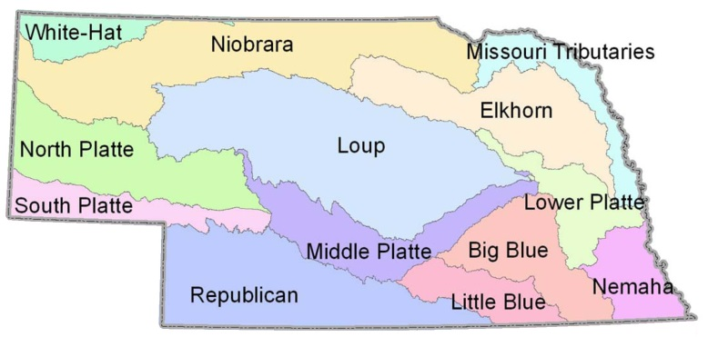
Despite the high accessibility currently available to other agencies and the public, the DNR has identified a need to improve data accessibility for future planning efforts and for improved public understanding of those efforts. Improved accessibility could contribute to a better understanding of water availability and use and the water balance, challenges and opportunities in the state’s basins. For that reason the DNR has initiated work on an Integrated Network of Scientific Information and GeoHydrologic Tools (INSIGHT) program. INSIGHT will complement and expand upon work already completed by DNR and the state’s natural resources districts (NRDs).
Currently, water managers must gather data from a variety of sources. It is often complicated to associate records with their locations. Some agencies store overlapping data that is difficult to correlate. The development of INSIGHT will seek to overcome some of these issues, and provide a series of web-based interactive maps, freely available to the public, that are directly linked to basin specific data on water supply and demand. It will provide a single platform, where water managers can access hydrologic data and analyses maintained by the state. The general public will also be able to access the data to better understand their own environment and local issues. The information will be organized by surface water basin to tell the story of each basin.
Figure 14. Map of Nebraska's Planning Basins

Surface Water
As mentioned above, the Nebraska DNR operates, reports and stores data from a large network of streamgages, reservoir gages and many canal and return flow gages. They also access USGS streamgage information from the NWIS website. They use the information to estimate water availability of hydrologically connected water supplies in basins not already declared fully allocated or over appropriated. They also track and store some water use data. Local Natural Resources Districts’ (NRDs) water use data is used for tracking water use for compact compliance. NRDs may also track or store limited water use data for their own planning purposes. Metering of water is not required in all parts of Nebraska, but is required on the main stem of the North Platte and Platte Rivers from the Wyoming – Nebraska state line to Grand Island, Nebraska. Likewise in the Niobrara River Basin metering is required in the Compact section of the river from the state line to Agate, Nebraska. A handful of other streams have metering requirements, and the Director of the DNR has the authority to impose any reasonable conditions on surface water appropriations, including water use reporting and/or metering.
The DNR is developing databases to store this usage information. Diversions are tracked by beneficial use category, and can be summarized by NRD. Otherwise they are site-specific. Some older diversions only have a legal description that narrows down location to the township, range, section and quarter-quarter. New appropriations require a precise legal description and are sometimes located using Global Positioning System (GPS) technology. The DNR is also developing spatial datasets of land with surface water irrigation rights, utilizing the National Hydrography Dataset (NHD). Where metering is required, appropriators must file a usage report by the end of the calendar year for their diversion amounts. When reported, the appropriator must submit the total volume diverted for the calendar year (not including consumptive use) and, if the beneficial use is for agricultural irrigation, the acreage and types or crop raised and the type of irrigation delivery system for each crop type. The DNR also tracks whether the irrigator practices conservation tillage, in those select basins where it is required. For the rest of the state, where metering is not required, the DNR estimates how much water is withdrawn from surface and groundwater resources. The INSIGHT program will be utilized to integrate these datasets into a web-based tool for accessing water use and availability information, including summaries of such data on a basin by basin scale. The DNR tracks the location and amounts of some return flows in major canal systems back into the natural system. They hope to focus on this area for more detailed monitoring and conjunctive management projects in the future. However, the information is mostly found in an analog format of scanned paper files. Public water supply information is gathered, but it cannot be published, by executive order.

Groundwater
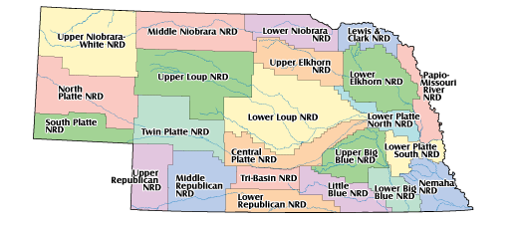
In Nebraska, Natural Resources Districts (NRD) are the preferred regulators of groundwater with the specific statutory exceptions of municipal and industrial transfers, which are managed by DNR, and transfers to adjoining states are also managed by the DNR. Allocations and beneficial uses of the groundwater are tracked by the NRD. Where reporting is required, total volume withdrawn (not consumptive use) is gathered on a site-specific and annual basis. New wells are required to provide GPS coordinates for their locations, and all other locations are keyed to the nearest section line. For NRDs that do not require reporting, their uses are estimated for modeling and for the USGS’ “Estimated Water Use in the U.S.” report. Summary information can be found at the local NRDs, and the DNR is developing the capability to store and collect summary groundwater availability and use information by NRD at the state level. All new wells permitted by NRDs are statutorily required to be registered with DNR.
Figure 15. Nebraska Natural Resource Districts
As each new well is registered, the depth to water is stored by the DNR. Annually or semi-annually water level information is collected across the state by local NRD staff, in cooperation with the University of Nebraska-Lincoln (UNL) and USGS. Some these local readings have continuous data recorders. Groundwater levels are available online on the University of Nebraska School of Natural Resources site and via the USGS. Groundwater level data is used for groundwater models that in turn describe water availability. Groundwater use data that is relevant to optional municipal groundwater transfer permits or mandatory industrial groundwater transfer permits are tracked through mandatory annual reporting on a calendar year basis. In areas that have groundwater allocations the ministerial unit of government is the local NRD. The state is currently engaging in a series of pilot studies on diverting excess canal flows using seepage during the spring and fall seasons. DNR maintains the locations of these recharge sites as well as injection wells related to underground conjunctive management demonstrations. The DNR also maintains spatial information for hydrologically connected groundwater aquifers in areas that have been declared fully or over-appropriated. The DNR estimates irrigated acres on a basin-level scale to support planning, while local NRDs may track irrigation methods. Some NRDs may track municipal use depending on their rules and the Nebraska Department of Health and Human Services does a survey of municipalities every three years to ascertain number of connections.

Technology
The Nebraska DNR uses Microsoft’s SQL Server and Access to store their water-related data. They also use Microsoft’s IIS web server for hosting online applications. The programming environments supported within the DNR’s office are .Net and Python. While the DNR has a variety of data available on their website, the INSIGHT project will enable the state to share a “bigger picture” of water use and availability across the state. This project is likely to come online by mid-2014. The DNR does share some information for specific purposes as REST web services. Additional services will be developed for the INSIGHT project for water uses and availability.

Methodology
As part of their Integrated Water Management Planning, the DNR estimates the basin water supply (BWS) and the available water supply (AWS). The BWS estimate is essentially the amount of streamflow that would occur in a basin in the absence of the development of water uses; in other words, the sum of streamflow, surface water uses, and depletions to streamflow due to groundwater uses. The AWS value is the BWS that is available for use within a basin. This requires an adjustment for obligations limiting water use (for example, interstate compact allocations) reducing AWS and for additional water sources (for example, imported water) increasing AWS. The calculation of AWS can also take timing and location into account. An annual evaluation of the expected availability of surface water supplies and hydrologically connected groundwater supplies is completed each year to determine further development.
When determining water availability for permit planning the public interest is also considered. The Nebraska Constitution stipulates the following concerning unappropriated waters: “The right to divert unappropriated waters of every natural stream for beneficial use shall never be denied except when such denial is demanded by the public interest. Priority of appropriation shall give the better right as between those using the water for the same purpose, but when the waters of any natural stream are not sufficient for the use of all those desiring to use the same, those using the water for domestic purposes shall have preference over those claiming it for any other purpose, and those using the water for agricultural purposes shall have the preference over those using the same for manufacturing purposes. Provided, no inferior right to the use of the waters of this state shall be acquired by a superior right without just compensation therefor to the inferior user.”
Statewide, the Nebraska DNR undergoes a statutorily required process designating that areas currently not deemed fully or overappropriated must be reviewed each year and the “FAB Report” (or Fully Appropriated Basin Report) must be published by the end of each calendar year. Integrated Management Plans (IMPs) jointly developed by the DNR and pertinent NRDs have been adopted where an area has been declared fully or overappropriated. IMPs utilize adaptive management and contain additional provisions and monitoring requirements based on hydrologic conditions within the NRD. Some NRDs are currently in the process of adopting voluntary IMPs.
For consumptive use estimates, the Nebraska DNR utilizes the CROPSIM method, which calculates the consumptive use of full physiological development of crops without water stress; and takes into consideration climate data, soil data, land use data, and agricultural practices. The DNR then imports CROPSIM into models in an iterative fashion to assess the validity of the data. Validation is done against historical pumping data. The DNR uses a wide variety of input data for its availability and use estimates, including USGS streamgage data, Nebraska streamgage data, climate data, soils data and land use.

New Mexico
The New Mexico Office of the State Engineer (OSE) oversees planning and appropriation for the waters of New Mexico. The State Engineer’s approval is required for most uses and his permission is needed to make a new appropriation, drill a well, divert surface water, or change the place or purpose of use of an existing water right. The Office of the State Engineer acts on water rights applications, evaluates existing water rights, measures and tracks water use and resources, promotes conservation, and performs the scientific, historical and legal research needed to support all of its activities.
Although separate under state law, the Interstate Stream Commission (ISC) staff members function as a division within the Office of the State Engineer. The Legislature created the Interstate Stream Commission in 1935 and gave it broad powers to investigate, protect, conserve and develop the state’s water supplies. Its separate duties include protecting New Mexico’s right to water under eight interstate stream compacts and ensuring the state complies with each of those compacts, as well as developing and promoting regional and statewide water planning.
Water management in New Mexico is guided by several 100-year-old principles in the New Mexico Constitution: (1) All unappropriated water belongs to the public and is subject to appropriation by law. (2) The acquisition or continuation of a water right and where and how much water can be used is dependent on how the water is put to beneficial use. (3) Older water rights have priority over more recent water rights. Since 1907, a permit from the State Engineer has been required to divert surface water and to put water to beneficial use. Since the State Engineer has declared all the groundwater basins in the state (i.e., an area declared by the State Engineer to be underlain by a groundwater source with reasonably defined boundaries that is subject to OSE jurisdiction), permits are required for diverting groundwater everywhere in New Mexico.
The Water Resources Allocation Program (WRAP) with the Office of the State Engineer is responsible for processing water rights applications, conducting the scientific research for making those water rights decisions, maintaining water rights records, and enforcing any conditions or restrictions on water use. Water masters in the program measure stream flow, allocate the water within a stream system based on state water law, and regulate and control diversions. Staff also inventory water resources, monitor water use, and cooperate with the U.S. Geologic Survey in monitoring groundwater levels throughout the state. Additional duties are licensing all well drillers, maintaining and updating the rules and regulations of the State Engineer, inspecting non-federal dams, evaluating subdivision water-supply plans submitted by counties, and promoting water conservation.
For planning purposes, the state may be divided geospatially in a number of ways. The OSE uses the groundwater basin delineation for administering groundwater. Water rights are administered by Water Rights Division’s District Office Areas, while the ISC Planning and Communications Division has subdivided the state into 16 Regional Water Planning Areas. Regarding the New Mexico State Water Plan, the OSE and ISC are required to undertake a review of the document every five years and to subsequently update the plan as needed.

Surface Water
OSE/ISC cooperates with USGS on a statewide stream gaging network, and operates additional gages in selected areas. Data from the cooperative network is stored in NWIS and obtained from the USGS website and used in evaluating the potential for water appropriation or change of use permitting. OSE also tracks an stores water use data by beneficial use category. The spatial scale of water use collected varies from greater than county level, down to the specific diversion point. The temporal scale of water use data collection varies from quarterly to annually. OSE stores water availability and water use in a spatial format and has the ability to report this information by specific location (i.e., point of diversion and place of use). OSE collects locations for points of diversion as well as return flows. They also maintain spatial data for closed basins where no additional appropriation is permissible and special management areas. Tracked and stored water rights data include those that have been adjudicated, and how many acres are irrigated with the appropriated water. Irrigation method and water used for energy production (as well as facility type) are not tracked. OSE uses the population reported by the New Mexico Environmental Division Drinking Water Bureau to evaluate the population served by community water systems.
Surface water users may be required to report their withdrawals, but it varies by permit. Some diversions are metered, but it varies based on basin administration, permit requirements and the age of the water right. For users that are not required to report, OSE does estimate their use. New Mexico has policies related to instream flow, which allow to them to be acquired by the ISC under statute to: 1) benefit threatened and endangered species through water management efforts; or, 2) ensure interstate stream compact compliance. New Mexico also has policies regarding interbasin transfer of water, which are recognized on a case-by-case basis, subject to the provisions of the various interstate stream compacts to which the state is a party. If the ISC believes that a proposed interbasin transfer may, for example, increase stream depletions such that New Mexico's compact delivery obligations will be jeopardized by the transfer, the ISC will object. The case-by-case consideration would also be subject to the same conditions as any other transfer (i.e., no impairment of other water rights, not contrary to conservation, and consistent with the public welfare).

Groundwater
OSE/ISC cooperates with USGS on a statewide groundwater level network, and collects additional groundwater level data in selected areas, although they do not manage any monitoring wells. Data from the cooperative network is stored in NWIS and obtained from the USGS, either via their website or through a periodic data download. These data are used to evaluate the potential for the appropriation of water or a change of use. Groundwater use data is collected and stored by beneficial use category. The data are available using a variety of spatial scales, including aquifer, county and by point of diversion. The temporal scale of groundwater use data collection varies. OSE also collects the locations of injection wells and groundwater recharge basins, as well as tracking groundwater areas that are closed to further appropriations. Spatial data for these special management areas are available, as well as the aquifer source. Groundwater allocation data include those which have been adjudicated and the acres of land irrigated. The irrigation method used and water used for energy production (as well as facility type) are not tracked.
The requirement for groundwater users to report their use varies based on permit requirements. For those that do, the water withdrawn is reported, with some using meters, based on basin administration, permit requirement and age of right. Groundwater use that does not have a reporting requirement is estimated by OSE.

Technology
The New Mexico OSE uses Microsoft’s SQL Server, Informix, PostgreSQL and GIS databases as their primary database management platforms. They also use Microsoft’s IIS, Linux and Sun Solaris web servers for hosting their web applications. Java is the preferred programming environment supported by the OSE office. The OSE and ISC use advanced technology to support their operations and to provide information to key stakeholders. These include PC-based hydrologic modeling software, wireless (satellite and radio) water meter data-collection systems, and sophisticated water rights document and transaction processing systems.
WATERS is the name of the central data, document and transaction system of water rights and water use data used by OSE. WATERS is accessible by all agency staff and the public via the Internet. The public may view electronic images of paper water right documents using the NM Water Rights Reporting System. The agency also has over 100 employees that use GIS to support their work activities. ESRI’s GIS desktop and server software is used to store, manage and analyze spatial data. OSE also has reports that based on the data within their system that are available on their website, but are not interactive.

Methodology
The New Mexico OSE does not use the term “water availability” for their water planning and appropriation processes, as surface water is fully appropriated; however, there is the potential to apply for a change of use of existing permits that would require an evaluation of the water potentially available for that request. There remain a few areas where groundwater may still be available in New Mexico, but all assessments are made on a case-by-case basis.
OSE uses an Original Blaney-Criddle based methodology to estimate the amount of water consumed by irrigated agriculture for the purposes of providing withdrawals for the New Mexico Water Use by Categories report (published every five years). This method has been used since the 1950’s and data are generated for monthly and seasonal timeframes for both surface and groundwater. OSE also uses a Modified Blaney-Criddle-based methodology to estimate the amount of water consumed by irrigated agriculture in the Upper Colorado River Basin for the purposes of providing withdrawals for the New Mexico Water Use by Categories report, published every five years. The data from this method are also used by the ISC to calculate Consumptive Uses and Losses for the Upper Colorado River Basin, and used by the OSE for adjudications and permitting.
For sensitivity and error evaluation, OSE uses an ASCE Standardized, Hargreaves-Samani-based methodology for estimating reference evapotranspiration for recent adjudications, in order to compare the results of the Original and Modified Blaney-Criddle outputs. Finally, OSE uses remotely-sensed satellite information to evaluate water use in specific basins. With regard to planned changes to methods used by OSE, they provided direction by New Mexico courts and case law for which methods may best be used in adjudications. OSE plans to continue accepted methods for those adjudication cases, while maintaining their expertise on other consumptive use methods for other applications.
For its planning purposes, OSE relies on meteorological data, such as temperature and precipitation for reference evapotranspiration calculations. They also rely on crop land-use information and USGS streamgage and groundwater monitoring data.

Nevada
The Nevada Division of Water Resources (NDWR) is responsible for quantifying existing water rights; monitoring water use; distributing water in accordance with court decrees; reviewing water availability for new subdivisions and condominiums; and monitoring water resource data and records; among many other tasks. Most water rights administration tasks are dealt with by the Water Rights Section, while the Water Planning Section oversees conservation efforts in the state, publishes many publications, such as basin summaries and groundwater usage reports, and compliance enforcement. Water rights data, streamgage data, groundwater elevation data are all maintained in databases. Crop and pumping inventories for select basins are maintained and published as analog reports. More recent data are being saved in spreadsheet programs and some information is maintained in a database for specific administrative functions. Plans for program development include a GIS-related effort to map points of diversion and places of use of water rights. NDWR is also working toward the incremental integration of their water rights database with other databases to improve cross-linking of data. Some database development is occurring for maintaining meter-collected data.

Surface Water
NDWR manages and stores data from their own network of streamgages in addition to downloading USGS data. These are used to estimate site-specific water availability related to the water right permitting process. Water use data is stored and tracked by beneficial use category and is summarized by hydrologic basin. NDWR has a partial dataset for the locations of water diversions, and is developing spatial data for places of use. Special management areas are also maintained in a spatial format. NDWR tracks and stores water allocation data, including which have been adjudicated, the acres irrigated, and irrigation method. The amount of energy produced by water allocated to this sector is not tracked, however the facility and fuel type is. Reporting by water users varies by permit type. When required, users report their quantity of water diverted and consumptive use. Some permits require metering, and often include municipal water providers and energy generation facilities. NDWR does have policies regarding instream flows, which permit the support of recreational uses and/or environmental/wildlife augmentation. They do not have policies related to interbasin transfers.

Groundwater
NDWR manages and stores data from its own network of monitoring wells. The information is used to evaluate water availability on a case by case basis. Groundwater usage data is stored and tracked by beneficial use. These are based on a point of diversion or place of use permit. The time scale depends on any reporting requirement in the terms of the permit, but is typically monthly. Spatial data are available for points of diversion and these can be summarized using NDWR’s hydrologic basins. They also track the locations for groundwater recharge areas and injection wells for increased underground storage and maintain spatial data for special management areas. Other groundwater information tracked includes the adjudication status, acres irrigated and irrigation method. Energy produced by water allocated for that use are not tracked, but the energy facility and fuel type is. Community water system populations or number of connections are not verified. Water user reporting depends on the requirements specified in the terms of the permit, but will be monthly, quarterly or yearly. Even if reporting occurs less frequently, the time scale for uses reported is typically still monthly. The amount diverted is required, but sometimes consumptive use is also required. Previously, irrigation rights were not required to have a meter, just another measuring device, but all other uses do have a metering requirement. Future permits will likely have meter requirements, even on irrigation water rights. Domestic uses exempt from the permitting process do not have a meter requirement, unless by a specific order. Domestic use of water is exempt from water right permitting. All permits require at least one report to establish the beneficial use for the issuance of a certificate. NDWR does estimate the use for those who are not required to report.

Technology
NDWR uses Microsoft’s SQL Server, Access and MySQL to house their data. They also use Microsoft Excel spreadsheets. They also use both Microsoft IIS and Linux for hosting web applications. Their office supports Python, PHP and Cold Fusion. NDWR is planning on migrating the Excel data to databases in the future. Planning data are made available on their website, and are also published in other reports in an analog format.

Methodology
The perennial yield of a basin may be defined as the maximum amount of groundwater that can be salvaged each year over the long term without depleting the groundwater reservoir. Perennial yield is ultimately limited to the maximum amount of natural discharge that can be salvaged for beneficial use. The perennial yield cannot be more than the natural recharge to a groundwater basin and in some cases is less. This definition of water availability is used for permitting and also for long-range planning. NDWR also uses actual measured streamflows to analyze the amount available for permitting and planning. Groundwater discharge is also used to estimate perennial yield, availability for permitting and planning. For hydrologically closed basins, the groundwater ET will equal groundwater recharge (and is easier to measure), and will be the perennial yield. Methods include remote sensing, vegetation indices, site measurements (ET stations). Old data for these processes are available, newer data are not as easily obtained.
NDWR’s consumptive use method for selected basins uses LandSAT data to determine monthly evapotranspiration from various crop types to derive an estimated consumptive use. The method is commonly referred to as METRIC (see Methodology section for Idaho). Annual evapotranspiration and net irrigation water requirement are used statewide to facilitate permitting and establish beneficial use. NDWR’s definition of consumptive use includes water consumed by the crop. Water lost to the atmosphere but utilized by the crop is excluded from their evaluation.
Groundwater availability models are continually revised as better data are made available. Data inputs for these efforts include consumptive use estimates based on crop type and climate/weather data. Availability data for groundwater are based on estimates of the pre-development water budgets of hydrographic basins, recharge from precipitation, basin to basin flow (surface and subsurface) and ET of phreatophytic plants. Availability of surface waters are based on observed flows. Note that because Nevada lies within the Great Basin, they do not have significant downstream water users.

North Dakota
The North Dakota State Water Commission (SWC) and the Office of the State Engineer (OSE) manage, develop, and allocate water resources in North Dakota. The Water Appropriations Division of the NDSWC acts on behalf of the State Engineer when making evaluations and recommendations on water permit requests. The Water Appropriations Division also works on behalf of the SWC when involved in resource management and monitoring. The Water Development Division is responsible for the management and regulation of water infrastructure and flood control projects. The Planning Division is involved in water resource planning issues with local governments, county water resource boards, as well as international and interstate water issues. The Planning Division also provides procedures and guidance for selection, financing, construction, and operation of SWC funded projects throughout the state. They develop a biennial state-wide water plan used by the legislature and water resource boards in water project planning. The Atmospheric Resources Division is involved in precipitation and snowpack data collection, as well as hail suppression and rainfall enhancement projects.
With regard to future water planning steps, the SWC is currently seeking comments on the DRAFT SWC Water Project Prioritization Guidance Concept. The purpose of the prioritization concept is to assist with water project prioritization during future biennia.

Surface Water
North Dakota SWC has a cooperative agreement with the USGS to operate and maintain 124 stream monitoring gages throughout the state of North Dakota. The data from the USGS gages are available through USGS’ NWIS website. Historically, the SWC has operated and maintained 1,077 staff gages and wire weight gages throughout the state. There are currently 257 staff gages and wire weight gages that are active. Technicians with the SWC maintain and monitor the gages on a monthly, quarterly or annual basis. Some staff gages have contracted observers making daily observations from April through October. All the data gathered from the gages are entered into a SWC database for use by agency personnel in hydrologic analyses. The general public can access the data by request.
Water use data are also tracked by beneficial use category. These are delivered as site-specific data using the PLSS, (Township-Range-Section-QQQ) and are available on a daily, monthly and/or quarterly timeframe depending on the site. Water use is determined through a number of methods. Water use reporting by the permit holder has been the primary method since 1977. Other methods include the use of Landsat satellite data and using the ISODATA method for extracting surface water areas. Map algebra is used to calculate differences in surface water area between different Landsat scenes. Using Landsat scenes from different months or different years assists in understanding the impacts of pumping water from surface water sources or understanding the impacts of changing weather patterns. Aerial photographs from satellite-imagery are used for validation of irrigation water use. The irrigated land is identified from the aerial photographs and compared to the Annual Use Forms submitted to the SWC by the permit holder.
Water users who are required to report do so annually, including the both diverted flow and the consumptive use of the permit. All permits, except "water spreading", flood control, Fish & Wildlife, and recreational uses have a metering requirement. Permits types that do not require reporting are Fish & Wildlife and Recreational uses, which only have evaporative water loss.
SWC maintains spatial data for water availability and use and publishes summaries organized by location in their “Bi-Annual Report Summary.” They also maintain spatial data for points of diversion, closed basins and special management areas. Return flows are not tracked by SWC. Water allocation information includes which permits have been adjudicated, how many acres are irrigated by a permit, and the irrigation method. Energy generation is not tracked by as part of a permit, but all ten power generation water permits in North Dakota are associated with coal-based thermoelectric facilities. Population served by individual community water system is also not required by the State Engineer. North Dakota does not have policies related to instream flows or interbasin transfers.

Groundwater
North Dakota SWC maintains a comprehensive observation well network of over 4,100 monitoring wells. More than 80% of the wells are measured monthly from May to December. The remaining wells are measured quarterly or annually. Water quality samples are collected every five years from each well for determination of basic cations and anions and selected trace elements. On the average about 1,000 water quality samples are collected each year. There are more than 56,000 water quality samples and more than 5 million water levels stored in a database. These are supplemented with USGS data that is acquired through their website. The information is used for water availability analyses related to permitting tasks. Groundwater withdrawal and use data is tracked and stored by beneficial use category. These are all site specific and organized by PLSS and gathered on a daily, monthly, and/or quarterly timeframe. These are summarized and published in SWC’s “Bi-Annual Report Summary.” Water permits are required for all diversions of water, with the exception of domestic and livestock wells withdrawing less than 12.5 acre-feet per year. For each water permit, regardless of use, and for each point of diversion within the water permit, spatial data (points of diversion and use) are recorded within the SWC Database. Recorded data includes the requested amount of appropriation and rate of withdrawal, the amount and rate of diversion appropriated for the water permit, and the status of the water permit (Conditional, Perfected, Denied, In Abeyance). An annual withdrawal and consumptive use report is required from all permitted users, and is recorded in a database. Totalizing in-line flow meters are required for all industrial, irrigation, municipal and rural water users. The locations, amounts and types of irrigation are included in the water permit application.
Most new wells are now surveyed, and state-plane and latitude/longitude coordinates are available in the database, either through translation of the PLSS data or from direct survey measurements. In addition ancillary map data, including aquifer boundaries, political boundaries, infrastructure features, satellite photos, and USGS quad maps of various scales and others are available in the database and can be accessed as overlays with the hydrologic data. Well logs for private well drillers are also available and can be downloaded as pdf files from a database.
SWC also tracks the locations of recharge basins and injections wells, as well as special management areas and closed areas based on aquifer boundaries. Groundwater allocation data include which have been adjudicated, how many acres are irrigated, and irrigation method used. The energy produced by water allocated to the energy sector is not tracked. Ongoing ground-water resource evaluation of all major aquifers, and all water supplies is conducted by qualified hydrologists assigned to each aquifer and each management area. Subsurface exploration plans, water sampling plans, water-level monitoring plans, and other concerns, including aquifer maps and boundaries, are supervised, expanded, and revised by twelve staff ground-water hydrologists on an ongoing basis. Ongoing data acquisition is conducted by four full time field technicians.
The Water Appropriation Division, in cooperation with the U.S. Geological Survey and the North Dakota State Geological Survey, conducted a comprehensive County Ground-Water Studies program beginning in the late 1950s, and completed in the early 1980s. These studies identified the location and extent of major aquifers, hydraulic properties, water chemistry, estimated well yields; and the occurrence and movement of ground water, including sources of recharge and discharge. The County Studies have provided the basic framework for ongoing ground-water resource evaluation. As a result of ongoing investigations, numerous other reports and publications on ground-water resources have been completed, including 118 “ND Ground-Water Studies,” many of which are related to water-supply needs of various communities; and 54 Water Resource Investigations pertaining to specific water-resource issues and problems. A comprehensive survey of water supplies for energy use, including an evaluation of potential ground-water availability, was published as a WRI report (WRI No. 49) in 2010.

Technology
The North Dakota SWC and OSE uses PostgreSQL and 4th Dimension Databases as their primary data management platforms. They host their web applications using Mac OS and support Python and PHP programming environments. The OSE is predominately an “open source” shop. They use PostgreSQL, PostGIS and MapServer as their primary spatial service engine and data delivery platform.
OSE staff have also developed SOAP (Simple Object Access Protocol) services for the transmission of water meter data directly into their water permit 4th Dimension database. The SOAP services were the end result of a telemetry pilot study, which was undertaken in 2012. SWC and OSE also make much of their data, such as permits, wells and GIS data, available using mapping applications. They are currently working on deploying some web services and hope to make these public in the coming year. They also have other published reports that are not interactive, but based on the data of their system.

Methodology
As used by the North Dakota State Engineer, water availability is defined and determined by the ability of a permit applicant to put water to beneficial use that is sustainable, without creating an undue impact on a prior appropriator and is in the public interest based on a rebuttal presumption in favor of water permit approval. This definition is used as a guide during the water permitting process. The availability of water is determined for specific project locations by using hydrological analyses and other tools, which are performed as needed and on request of a potential permitee.
In North Dakota all water, ground and surface, is held in trust by the state for appropriation to the public. Water availability for appropriation is dependent on order of application, beneficial use, sustainability, impact on prior appropriators, and public-interest criteria. Water rights are established through the permitting process. Each water permit application is evaluated on a case-by-case basis by a staff hydrologist assigned to the project area in the order of the date of the application. Project areas for ground water are usually, but not always, defined by counties. Project areas for surface water are assigned by basin.
By statute, the State Engineer must protect the rights of prior appropriators and ensure the appropriation is in the public interest. Staff hydrologists perform a comprehensive analysis of all water permit applications to minimize the need for adjudicative proceedings. Evaluations can require a few weeks to a several months, depending on hydrologic conditions and available information. Areas where the data is sparse may require additional test hole drilling, observation well construction, and water level monitoring for completion of the evaluation. Where there is competition for water from a single aquifer, a groundwater modeling study may be necessary; these studies may take several months to complete.
Surface water permit applications are evaluated by three staff hydrologists assigned to the specific area of the application location for the criteria described above. Appropriate surface-water data are accessed and analyzed to determine the potential impact of the application in reference to State criteria. Analyses are increasingly comprehensive as demand for water and stress on the resource increases, and frequently require the use of surface-water models, such as the HEC-RAS model from the US Army Corps of Engineers . The hydrologist, based on the permit evaluation, recommends a course of action to the State Engineer who approves or denies the permit.
Groundwater permit applications are evaluated by ground-water hydrologists assigned to the specific area of the application location for criteria discussed under “Methods.” Appropriate groundwater data are accessed and analyzed to determine the potential impact of the application in reference to State criteria. Analyses are increasingly comprehensive as demand for water and stress on the resource increases, and frequently require the use of ground-water models. The hydrologist, based on the permit evaluation, recommends a course of action to the State Engineer who approves or denies the permit.
Water use is monitored primarily by annual reports from water users. Other methods of verification include Landsat satellite data, using the ISODATA method for extracting water surface areas. Aerial photographs are used for validation of irrigation water use through cross comparison with annual use reports. SWC sends approximately 3,000 Annual Use Forms (AUF) to permit holders at the end of each year to report their annual water use. The information provided in the AUFs is validated by agency staff and then entered into their water permit database. 2013 marks the start of SWC’s online AUF reporting process. The online system allows for a permit holder to file their water use information in a similar fashion to that of the paper AUF they are familiar with receiving in the mail. Once the online information is completed, it is stored in a preliminary data file, which is then checked by agency staff. After the water use data entry is validated by agency staff, it is permanently stored in SWC’s Water Permit Database.
Parameters for the approaches to appropriation listed above include those gathered from precipitation, satellite imagery, etc. The Atmospheric Resource Board (ARB) has a network of over 700 observer rain gages. This provides a very dense concentration of precipitation data. SWC uses data from the ARB rain gage network for validation of AUF data. The precipitation maps help to confirm if an area was wet or dry and the potential need for irrigation water. Landsat with an ISODATA method is used for extracting surface water areas. SWC uses map algebra to calculate differences in surface water areas from year to year or month to month. This helps SWC gain an understand of the possible impacts of pumping or weather patterns. SWC also utilizes air photographs for validation of irrigation AUF data by identifying irrigated land.
SWC incorporates the North Dakota State University NDAWN (North Dakota Agriculture Weather Networks) "Crop Water Deficit" calculations into their analyses for the validation of AUF data. The Jensen-Haise model is used by the NDAWN system for computing reference ET in determining the "Crop Water Deficit" calculation. NDAWN operates cooperatively with the High Plains Regional Climate Center (HPRCC) in Lincoln, Nebraska. These are used in tandem with Landsat and a supervised classification method to determine crop types grown under irrigation. These are combined to estimate water use for an irrigation area.
Future changes in methodology may include METRIC and additional SOAP implementation. The SWC and OSE is exploring the use of the METRIC methodology developed by the University of Idaho. They are working in collaboration with the University of North Dakota on the development of the METRIC tools for application in North Dakota. They have also developed a SOAP protocol, which is being used for reporting selected industrial water permit meter locations. The SOAP implementation automatically sends water meter data (and hence water use data) once every 24 hours directly into the agency’s water permit database.

Oklahoma
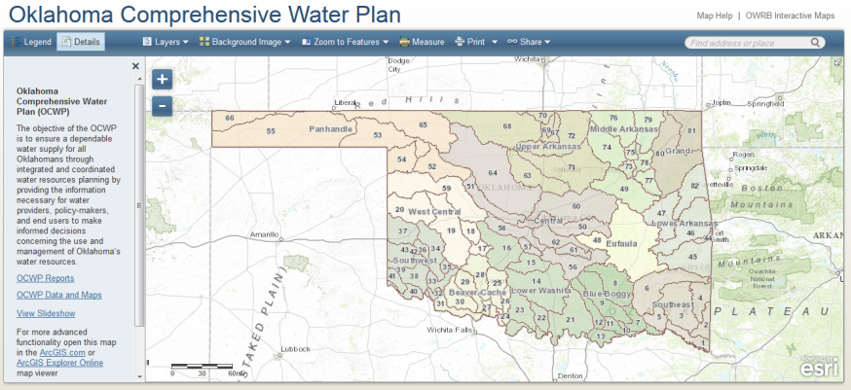
Oklahoma Water Resources Board (OWRB) oversees the hydrologic studies performed throughout the state as well as stream water allocation modeling for the water permitting process. They also oversee and implement Oklahoma’s water quality standards. The water well level mass measurement program and cooperative streamgaging program is also managed by OWRB. Aquifer and surface water maps indicating water availability are maintained by OWRB. They are also in charge of publishing and updating the Oklahoma Comprehensive Water Plan (OCWP), issued every five years. The OCWP is a comprehensive management plan that projects water supplies and demands for the state of Oklahoma out to 2060. This analysis, called the Statewide Supply and Demand Analysis, results in forecasts of water demand and supply availability utilizing a variety of demographic, economic, and related data, consumptive water demands for municipal & industrial (M&I) sectors, self-supplied industrial (including oil and gas production), and agricultural (irrigation/livestock) water use. M&I demands and future water supply alternatives are determined down to the provider level. Projected demands are evaluated in light of current and future water supplies to identify areas of potential surplus and shortfall. Future plans for OWRB program development include efforts to increase the accuracy of spatial data, and allowing greater access to data by publishing the information online.
Figure 16. Online Mapping Application for OCWP Data Discovery

Surface Water
OWRB manages and stores data from their own network of streamgages, while also downloading streamgage data from USGS' NWIS website. The information is used to estimate water availability, which can be summarized by a variety of geographic scales (county, HUC, etc.) They also track and store water use information by beneficial use category and have the ability to summarize this information as well. OWRB tracks the locations of water diversions, but does not track return flows, closed basins or special management areas. With regard to their water permit administration, OWRB tracks and stores water allocation information, acres irrigated and irrigation method. They do not track the amount of energy produced by water allocated to the energy sector, nor the facility or fuel type. OWRB reviews the population served by community water systems based on water use reports submitted annually and reported every five years in the OCWP. Surface water users that are required to report do so annually and return both withdrawals and consumptive use values in gallons or acre-feet used. However, diversions are not required to be metered. There is only one use in the state that is required to be metered, those in the municipal sector. The Oklahoma Department of Environmental Quality (ODEQ) is the agency that requires this. Domestic users (users that withdraw water for household or household purposes, farm and domestic animals up to five acre-feet per year) are exempt from reporting, but their use is estimated by OWRB. Instream flow policies have been developed, although there is only one officially approved instream flow at this time. OWRB also has policies for development of interbasin transfers.

Groundwater
OWRB manages groundwater monitoring wells and also stores information from USGS, annual reports and their “Mass Measurement Program.” These data are used for estimates of water availability done for hydrologic studies. Annual groundwater use is also tracked on a site-specific and also a summarized scale. OWRB maintains spatial data for well locations, injections wells, and from aquifer sources. They do not track closed basins or special management areas. Groundwater water withdrawal and use information includes the acres irrigated and irrigation method. Groundwater users that are required to report send the amount withdrawn, and the consumptive use of the water, although no withdrawals are metered. Domestic users are not required to report if their use is less than five acre-feet per year. Groundwater domestic use is not estimated

Technology
OWRB uses Oracle, Microsoft’s SQL Server and GIS database formats to house their data. Web applications are hosted by Oklahoma's central information technology division. .Net and Java are both supported within the OWRB office. Publication of availability and use information via OWRB's website is in the planning stages and will likely include GIS and web-services components. Written reports that summarize important OWRB data are also made available online, and can be generated as requests for information are made.

Methodology
For the purposes of water appropriation, OWRB defines surface water availability as water that can be appropriated after it has been determined that the average annual runoff at the proposed point of diversion or by the dependable yield of the storage reservoir, as well as taking into account legal limitations imposed by senior water rights, downstream users and compacts. In considering the amount of water requested the Board may review the efficiency of the work proposed to place the water to beneficial use and may order modifications. They may also review population projections for the area served if the application is for a public water supply project. Additional factors are also considered, such as scenic rivers designations, and “outstanding resources” waters, recreational purposes and the existing water quality in the stream. Groundwater availability is determined by hydrologic studies of basins and subbasins, using guidelines specified in OWRB’s Rules and Regulations. This document also specifies how temporary groundwater permits are to be issued, including annual revalidation procedures.

Oregon
Oregon Water Resources Department (OWRD) uses the water availability analysis program to allocate new water uses, both surface and groundwater. When an application for a new use is received, one of the first things in the application review process is to make a determination of water availability. If water is available, the review moves on to include a number of public interest issues. If no water is available, the applicant is provided the opportunity to offer a means to mitigate or offset water use, or the application is denied. A statewide water availability analysis is also used in planning for the future of water use and how water resources can be managed on a sustainable basis. The analysis provides a clear picture of water resources in Oregon that can be used by the entire water interest community. The analysis program is continually updated with new consumptive use data, and expanded as needed for higher resolution analyses. Additionally, when new and relevant hydrologic data becomes available, these are incorporated into the model. When programmatic resources become available, a major development would be to add basin yield data. The current analysis provides flow information in the form of cubic feet per second water available for a location on a reach. A basin yield analysis will provide quantity or acre-feet volumes available, which would facilitate winter-time storage planning.

Surface Water
OWRD manages and stores their own suite of streamgages, as well as accessing data via the USGS’ NWIS web services for streamgage data. They use the data to estimate water availability, which can be accessed spatially on a site-specific basis. Water use is tracked by beneficial use category, by location of water diversions, but not return flows. They also have the location and extents for closed basins and special management areas. OWRD maintains water allocation information, including adjudication status and acres irrigated. They do not track the energy production that utilizes water or fuel type, within the industrial sector. Concerning surface water reporting requirements, many new permits and government entities have conditions requiring water meters to be installed and annual use reports to be submitted. The annual use reports break down water diverted into monthly increments. They are not required to report a consumptive use. Some users are not required to report to the state, but this use is estimated when needed for a water availability analysis. The state of Oregon regulates instream flow and also has policies related to interbasin transfers.

Groundwater
OWRD manages and maintains its own groundwater monitoring wells and accesses USGS well data as needed. These figures are incorporated into their water availability analyses. Groundwater use is tracked by beneficial use, acreage irrigated, and populations served by community water system, within OWRD’s allocation/permitting system. Withdrawals of some larger users and municipal irrigation districts are metered. These developed on a monthly and annual time scale and on a site-specific basis, but can be extrapolated to an aquifer or basin scale. Some users are not required to be report their use and these uses are not estimated. The location of injection wells are known, as are the location and extent of closed groundwater areas and special management areas. Consumptive use is not required to be reported.

Technology
OWRD uses an Informix and Microsoft’s SQL Server database management system to access and store data. They use Microsoft’s IIS web server software to host their online applications. Their preferred programming environments utilize .NET and Python. Much of OWRD’s data are available on their website. Some are also available within written reports.

Methodology
Within Oregon, water availability is defined by the amount of water that can be appropriated from a given point on a given stream for new out-of-stream consumptive uses. It is estimated by subtracting existing in-stream water rights and out-of-stream consumptive uses from the natural stream flow. This method is employed primarily for permitting, but can be used as a planning tool also. Typically this amount is calculated at the outlets of what OWRD calls “Water Availability Basins” or WABs, a custom delineation that is similar to a watershed within each of the eighteen OWRD administrative basins. For the entire state, water availability has been calculated for over 2,200 WABs. In general the calculation of water availability at one WAB cannot be considered in isolation from other WABs. Any upstream use subtracts from water availability at all points downstream as well as upstream. For water to be available at any given upstream point, it must be available at all points of calculation downstream. WAB analyses are generated on a monthly basis for surface water only and the results are available to the public online. This methodology – in use since 1995 – incorporates primarily stream gage data, precipitation data and other characteristics, as well as existing appropriations. Consumptive use estimates are generated on a WAB scale, and can be aggregated to a statewide level. These are used in two cases. Consumptive uses may be added to gaged stream flow to arrive at a natural streamflow estimate. Second, during the water availability analysis, an estimate of the stream losses that are expected is generated, as well as impacts to all water rights on the system and storage. In either case, the calculations of consumptive uses are the same, and differ only in the number and type of water rights included in the analysis. These are also available to the public.

South Dakota
The South Dakota Department of Environment and Natural Resources Water Rights Program (NRWRP) section oversees the allocation activity for South Dakota. Water availability and allocation is managed through collection of data from observation wells and stream gaging stations coupled with reported water usage for irrigation and, to a lesser extent, usage by municipal and rural water systems. Based on this information and any available hydrology studies, determinations are made as to the availability of water for new appropriations. Water development in South Dakota involving governmental entities occurs at the local level (e.g. municipal and rural water systems). The “state water plan” in use by South Dakota relates to funding of projects such as water/wastewater/water quality projects by units of local government. The availability of water for projects involving water supply is addressed separately from funding under South Dakota’s state water plan.

Surface Water
South Dakota does not manage or store any streamgage data, but does download information from USGS’ NWIS website. The data gathered are used for water availability estimates for permitting, but these estimates are not summarized by any geographic location. NRWRP tracks the locations of points of diversion and stores water use data on a site specific and annual basis. SD does not track return flows, but does have spatial data for closed basins. The acres irrigated that are associated with each allocation is also tracked. Community water system population is not tracked or verified. Users who are required to report – all irrigation, except water-spreading activities – report their water diverted on an annual basis. Some water distribution systems (municipal, rural water, etc.) report under recently approved permits, but not older water rights. For users that don’t report, their use is not estimated. NRWRP does have an instream flow policy, which stipulates that appropriations may be made for instream flows and base flows are protected regardless to protect domestic water uses which have preference over appropriative rights. They do not have policies regarding interbasin transfers.

Groundwater
NRWRP manages and stores data from their own network of groundwater monitoring wells. They use the information to estimate water availability. Groundwater well locations and use data is stored and tracked by aquifer source (and can therefore be summarized by aquifer source). The data recorded in bi-weekly intervals and daily from continuous data loggers. Spatial data include closed basins and special management areas. Allocation data is tracked including the acres irrigated. Energy produced by water allocated to that sector is not tracked, nor is the energy facility and fuel type. Groundwater users that are required to report do, send their annual water withdrawal amount (not consumptive use). Some groundwater use is estimated in lieu of reported figures.

Technology
NRWRP uses Microsoft Visual FoxPro to store their water planning data and for their programming. They use Microsoft’s IIS web server for hosting web applications. They are taking preliminary steps to migrate their data to Microsoft’s SQL Server. Some data are available online and all data are available upon request. These include observation well data and water right permits. If the data are not online, it is provided to the public via FTP site, email, or electronic media such as CD/DVD or hard copy.

Methodology
South Dakota NRWRP defines water availability as the amount of water in a river or stream where there is a reasonable probability sufficient flow is available for further development for an authorized purpose while maintaining a base flow for domestic use purposes. This is used to determine water availability from a surface water source for water right permitting. Ground water is available only if average annual withdrawals from a water source are estimated to be less than the estimated average annual recharge – “Safe Yield Determination.” Methods of determining water availability for surface water sources include statistics and/or NRCS watershed yield estimates. South Dakota Law describes methods used for determining groundwater availability and observation well analysis that are performed for specific aquifers or groundwater management units. Estimates of consumptive use are provided by annual reports from some irrigators and other water users that cover both ground and surface water. Data required to perform these analyses include USGS streamgage data, topographic data and land use/surface cover data, and observation well data.

Texas
The state of Texas' water planning and water rights administration is divided between two agencies: the Texas Water Development Board (TWDB) and the Texas Council on Environmental Quality (TCEQ). The former is primarily involved in developing hydrologic and groundwater models for planning purposes. TCEQ is primarily responsible for water rights allocation, which is accomplished through their permitting process. Water availability for new permits is determined using water availability models, maintained by TCEQ. The dataset for the permitting models are made available on their website. Water availability models are updated as new permits are issued, as modeling capabilities change, and in response to new data. TCEQ maintains and updates a current conditions dataset that incorporates recent use and return flows. This dataset is updated when water use conditions change significantly. Due to severe statewide drought conditions in 2011, TCEQ is in the process of evaluating whether the hydrologic period of record dataset for the model should be updated (2011 was the single driest year in the state’s history). In addition TCEQ is evaluating the utility of sub-monthly time-step modeling for water rights permitting applications and also assessing their current water rights data model.

Surface Water
TCEQ downloads datasets from the USGS streamgage website. These are used to develop the hydrologic datasets for their water availability models and permitting. TCEQ has some ability to summarize their water availability findings. They also track water use and have some capability to report water by beneficial use type. Generally use information is associated with individual water rights and are therefore site-specific, but TCEQ does have some ability to summarize and spatially aggregate the data. TCEQ also maintains the locations of points of diversion and return flows. Water users who are required to report, do so on an annual basis, but include monthly water diversions and return flows, and could potentially provide an estimated consumptive use. Some water right permits are not required to report. An example is a recreational, instream water right. In watermaster areas, diversions are metered and water rights holders must report their diversions prior to diverting water. Water allocation data and adjudication status is tracked and can be summarized by geographic location. The acres irrigated using surface water and the irrigation method used are not reported or tracked. The energy produced by water allocated to the energy sector is not tracked, nor is the facility or fuel type. Community Water Systems report their population served and the TCEQ field office staff perform a verification on site every three years. Typically the number of connections is used with an average persons per connection taken from US census information, or a better alternative if available. It is important to know that the purpose of TCEQ's spatial data collection is to support public notice requirements for new water rights or changes to existing water rights, to maintain water right ownership records, to facilitate administration of water rights and to develop input datasets for TCEQ's water availability models. Water use data and water availability data can be associated with spatial information to generate locationally aware summaries. Texas does have policies related to instream flows and for interbasin transfers, which are governed by the Texas Water Code. A water right permit is required for an interbasin transfer of water between river basins. The statute sets out application requirements, notice and public meeting requirements, and other factors that TCEQ shall consider prior to granting an interbasin transfer request. The statute does provide exceptions to the requirements, although a permit is still required for these exempt interbasin transfers.
TWDB also maintains a water use survey program that tracks information collected from individual water systems, industrial facilities, and some mining activities. These are aggregated to a county and "water planning region" scale. The survey collects monthly water intake volumes, with sales of water collected annually. Their program for determining agricultural water use is based only on secondary data to develop estimates and is not part of the survey. TWDB is explicitly not allowed to survey agricultural users under state law.

Groundwater
TCEQ does not maintain any information regarding groundwater usage. TWDB has access to monitoring wells and stores water level data, and also maintains groundwater models for the state that track their fluxes and availability. TWDB has also performed an assessment of brackish groundwater throughout the state. TWDB does track groundwater withdrawals by beneficial use category and stores this data in databases. They issue a water use survey to individual water systems and industrial facilities, and some mining water use estimates at the county level. The amount of water volume taken into each system is collected monthly and the sale of water is tracked annually. Connections are generally metered, but some are estimated. These can also be summarized on a “planning region” scale or for the state. The acres of agriculture irrigated are also tracked. The population served by community water systems is verified on an as-needed basis for planning and financial efforts. The survey is issued annually

Technology
TCEQ uses Microsoft’s Access to store their water data, and IIS web server for hosting web applications. They utilize Java, .Net, and Python in their office. TCEQ is planning on migrating their water rights information to an Oracle database over the next two years. Water rights data are available to the public on TCEQ’s website, but are not shared via web services. Water availability model reports, which are typically kept in an analog format, are in the process of being migrated to the Texas Digital Library. TWDB uses Microsoft’s SQL Server database platform to organize their data. The water use survey is hosted online using Microsoft’s IIS web server and .Net and Python are supported within their office. TWDB provides much of its data via its website, including mapping application access to data. These are not yet available as web services. The water use survey is published in an analog format, but is in the process of developing dynamic reports that pull from the database.

Methodology
To ensure that water is available in the source of supply and that existing rights area not harmed by new permits or amendments to existing permits, TCEQ determines the amount of water that the stream furnishes minus the amount of water already appropriated to others. Any amount of water left over is defined as water that can potentially be appropriated. A water availability model is sued to determine water availability on a site-specific basis. The models simulate the predicted amount of water by month that would be in a river or stream under a specified set of conditions. This is performed for all sources of water except groundwater sources. TWDB defines water availability as the maximum amount of water available during the drought of record, regardless of whether the supply is physically or legally available to appropriate. This represents a distinctly different interpretation for “water availability” put forth by two agencies within the same state. This assessment of water availability is used for regional and state water planning over a 50-year horizon. Specific analyses related to assessing water availability throughout the state include both Surface Water Availability Models (WAMS) and groundwater-based modeling (GAMS) . These are performed annually, and include the prior decade of information. They also take water reuse into account. Water withdrawals are generally assumed to be fully utilized throughout the state and is not surveyed or reported with the exception of water consumed by the power generation sector. These are evaluated on an annual basis.

Utah
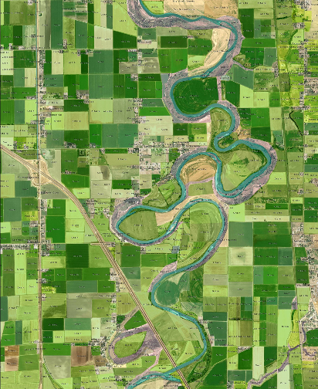
The Utah Division of Water Resources’ (DWRe) mission is “to plan, conserve, develop and protect Utah’s water resources.” The Division accomplishes this mission by 1) Protecting the state’s right to develop and use interstate waters; 2) providing technical and financial assistance to necessary water development projects; and 3) identifying future water needs and helping local entities implement water management, conservation and development strategies to meet those needs. The agency is divided into two main groups: the Planning Section, and the Water Development section. The Planning section oversees comprehensive state water planning, individual basin plans, computer models and applications, technical services and water conservation and education programs. For planning purposes the state has been divided into 11 primary river basins. Surveys of land-use/crop types and basin plan documents are performed and issued on individual basins on a rotating basis. The Water Development section works with the local districts and water providers to implement the state’s revolving loan fund and larger water development projects. The state’s loan fund is also administered by an 8-member Board of Water Resources, which represent larger individual river basins. Other shared administrative tasks include review of interstate streams and oversight of its interstate compacts on the Colorado and Bear Rivers.
The Utah Division of Water Rights’ (DWR) mission is to “provide for the order and certainty in the beneficial use of Utah’s water.” The DWR is primarily responsible for overseeing water allocation in the state, but also oversees dam safety efforts and addresses stream alteration issues throughout the state. Many areas of the states are administratively “closed” to new appropriations of water. In those areas new diversions and uses of water are established by the modification of existing water rights. Water appropriation issues in specific geographic areas of the state are often administered using policies and guidelines designed to address local conditions. These policies and guidelines are generally developed for all or part of the a “Water Rights Area,” of which there are many throughout the state. Seven regional offices oversee the administration of local policies and guidelines. Both agencies, the DWR and the DWRe, use a science-based approach to water management and lean heavily upon available water data to formulate planning and in making determinations for water allocation. Water-related data is shared between agencies as needed. Concerning future plans for program development, DWR and DWRe strive to provide the best analysis possible within the constraints of available data and engineering practices. To do so, they frequently evaluate new methods and technologies that could improve their efforts. At the time of the survey, no major changes in data collection or analysis methodologies are anticipated.
Figure 17. Sample Map of Land-Use Inventory Program

Surface Water
Utah’s DWRe manages and stores data from its own streamgaging network in addition to data supplied by USGS. DWR provides access to real-time records of these and other gages that are of interest to their agency. DWRe uses this information for estimates of water availability and supply. Water use data is also tracked by beneficial use category, but at a site specific scale and on a monthly basis. Water availability and water use is not currently summarized on a basin scale, but there are plans for the implementation of a statewide water budgeting system that will report summary data for 150 subareas (subbasins), which adhere to HUC-12 boundaries. The water budgets will be composed of water supply estimates of surface and groundwater, irrigated areas, potential consumptive use and an estimate of actual consumptive use from irrigated lands, as well as municipal and industrial diversions and depletions for each subbasin. Surface water diversions are tracked by the state and some locations for return flows. Spatial delineations of areas that are closed to further appropriation and special management areas are partially available. For specific allocations, the acreage irrigated and the method of irrigation are tracked. Energy production from such facilities and for specific fuel types is not tracked. For community water systems, each is surveyed every five years to verify data reported and the population is reconciled with data from the state. To assist in determining consumptive use by irrigated lands, the DWRe conducts a land-use inventory for selected basins, which includes crop type and irrigation method. This results in a statewide dataset that is fully updated every five years. Some surface water users are required to report on their diversions, use, number of connections, storage and population on an annual basis. Some of the diversions – those for public water suppliers, industrial users, and some areas called “distribution systems” – are metered. For users that are not required to report, the DWRe estimates those uses. Some uses are proprietary (for example some industrial uses) and can be aggregated and reported, but individual facility withdrawals and uses cannot be shared with the public. Utah does have instream flow and interbasin transfer statutes.

Groundwater
The Utah DWRe acquires and stores groundwater monitoring data from the USGS’ NWIS website, but does not manage any of its own wells. Groundwater uses are tracked on a site specific and monthly basis. The locations and source aquifer for groundwater withdrawals and injection wells are known, as well as the location and extent of closed basins and special management areas. The acres irrigated by groundwater withdrawals is also tracked, but irrigation method and energy production within the industrial sector are not. Irrigation method is tracked within the land-use survey program described above, but is not tied to allocation data. For community water systems that use and report on groundwater, surveys are sent every five years to verify reported data and to gather the population served within that community. Users of groundwater are required to report annually on their diversions, uses, number of connections, any storage, and population served if it is a community water system. Consumptive use of any withdrawals is not required for reporting. Some withdrawals in certain sectors are metered, such as public water suppliers, industrial users and irrigation use in some areas. Industrial uses are aggregated to protect industrial use information.

Technology
Utah DWRe and DWR both use Microsoft’s SQL Server as their database management platform. They use Microsoft’s IIS web server for hosting their online applications. Their offices support .Net, Python and .ASP programming environments. Much of the water allocation and water use reporting is available via the Utah DWR website in a tabular format, but are not hosted as web services. The new Utah DWRe water budget program results are anticipated to be made available in reports and also online.

Methodology
The Utah DWRe defines water availability as the reliable potable water supply for a given planning basin. The method used to estimate this is generally the annual volume within the maximum developed water supply that is available to meet peak demands. This is calculated as 100% of the maximum supply from surface water sources, 50% of the maximum yield of groundwater wells, and between 50% and 100% of the average annual spring flows within the area. This method is used for statewide and hydrologic river basin planning, and to evaluate a municipal water provider’s ability to provide water for a community’s existing and future population. This method is further defined in Utah’s most recent State Water Plan publication. The Utah DWRe also uses a second definition for water availability that uses a more conservative “Dry-year Supply” methodology to evaluate how well systems and basins would perform during a repeat of the drought of record. Thirdly, the DWR performs a site-specific analysis of water availability when investigating a proposed water permit. With regard to consumptive use, the DWR performs a statewide analysis of depletion by irrigated agricultures on a monthly basis. These estimates – dating back to 1998 – are publicly available on their website. Utah DWRe’s water budget model will compare the calculated potential consumptive use using the method described above to available water supply to estimate total depletions. This calculation may also be used to indicate how much water is not consumed and may be available to downstream users. USGS stream gage data, precipitation and temperature data, climate data from Oregon State University, as well as water rights streamflow and canal data are used to perform the consumptive use estimates.

Washington
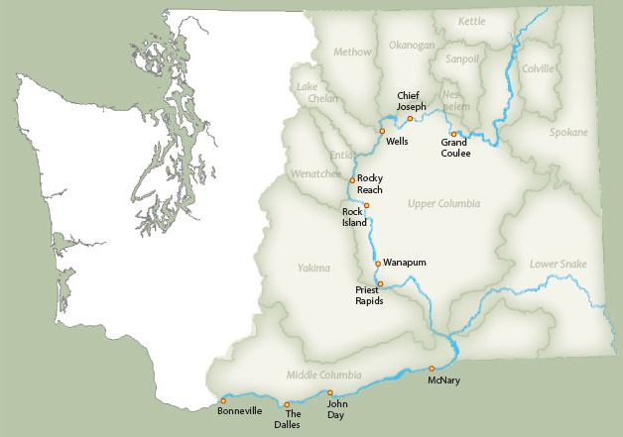
The water program within the State of Washington’s Department of Ecology (Ecology) is responsible for much of the administration of water, including water supply monitoring via streamgaging, water rights administration, water conservation programs, wastewater monitoring, as well as water quality for surface water, marine and coastal water and groundwater. While their office does not perform an analysis of water availability on a statewide basis, they are required to make the determination that water is available (legally and physically) in order to approve new water rights. During this analysis, the department looks at instream flow rights, and any surface water closures, as well as any substantiated impairments water impacted by the proposed right. Ecology can and has issued water rights that are conditional on instream flow rights such that diverters must stop when the required flows are not being met. Other factors that affect the ability to receive a water right permit in the State of Washington include Federal flow requirements (for example, the Yakima Basin), adjudications such as tribal water rights, ESA-listed species, seawater intrusion, senior water rights, and un-adjudicated claims. Projected population growth and the impacts from climate change are likely to increase the difficulty of obtaining new, un-mitigated water rights. The Office of the Columbia River (a sub-agency within the Dept. of Ecology) conducts an assessment of existing and future water supply and demand every five years for the Columbia River and all watersheds east of the Cascade Mountain range, covering approximately half of the state. Plans for planning program development include increasing water availability analysis to a statewide scale.
Figure 18. Office of the Columbia River - Major Basins

Surface Water
Ecology manages a network of streamgages and stores streamgage data, some of which are collect from USGS. Streamgage data are used to estimate water availability for permitting purposes and to establish instream flow information. While they do not track or store water use data on the vast majority of water rights, Ecology does require metering on all new water right permits and sometimes requires permittees to submit their data. This varies to a wide degree by water right and location. Some older water rights have no reporting requirements; others may be required to report monthly or annually. Some are required to collect data and only provide it to Ecology upon request. Users that are required to report usually supply the diversion or withdrawal rate and annual volume, not consumptive use. In addition, a ruling in 1999 brought on by American Rivers, the Center for Environmental Law and Policy (CELP) and other groups, requires that Ecology achieve 80% metering compliance in sixteen Fish Critical Basins in the state. Data collected regarding that effort are stored. Any other data are tracked on a site-specific basis by water right. The summaries conducted for water availability and usage are published for basins east of the Cascade Mountain Range. Ecology does track the location of water rights and their diversion points, closed basins, special management areas, and the acreage irrigated by a permit. They do not track the locations of return flows, irrigation methods, energy produced by water allocated to energy production beneficial uses, or those facilities’ fuel type. The population served by community water systems is updated as water system plans are updated. The State of Washington has policies regarding instream flows and permitting can vary depending on whether instream flows are impaired or not. There are laws, regulations and policies regarding water right transfers that would affect whether or not a water right could be transferred to another basin but Ecology does not have any policies specifically about interbasin transfers.

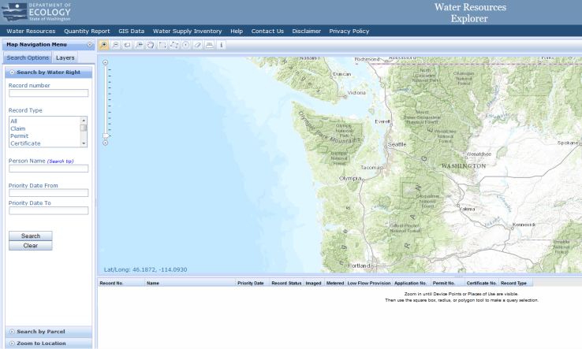
Groundwater
Figure 19. Department of Ecology Water Resources Explorer Application
Ecology manages groundwater monitoring wells and stores the data from those wells. These are used as part of their water availability analysis for the permitting of water. Some groundwater rights are metered and are required to report their withdrawals to Ecology, while most groundwater rights do not. What is reported is not associated with a beneficial use category and is not reported as a consumptive use. Groundwater use that is tracked is maintained on a site-specific basis and the timescale for reporting varies by location. Some wells are measured two to four times annually, while others have more frequent reporting via data-loggers. The locations of injection wells are tracked. Permitting of groundwater can be restricted based on its impacts to surface water flows. If a groundwater permit could potentially impact water within a basin that is closed to surface water appropriations, that permit would be denied unless its impacts could be mitigated. Some water withdrawals are tracked by source aquifer in central and eastern Washington, but not for most of the estate. The acres irrigated with groundwater is tracked by what is authorized within the water right.

Technology
Ecology uses Microsoft’s SQL Server as their preferred database management platform. Groundwater data is stored in Microsoft’s Excel and Access and in the agency’s environmental database, called EIM. Much of their water availability/water rights program data is stored in GIS database format. They also use Microsoft’s IIS web server technology for hosting web applications. Their preferred programming environment is .Net. Much of their data is available online for access by the public, but only some is available via a web services format. The Office of the Columbia River maintains a couple of mapping applications with water supply and demand information as well.

Methodology
Although Ecology does not have a specific definition of water availability, the Pollution Control Hearings Board (PCHB) – the Board responsible for hearing appeals to agency decisions) has taken a fairly narrow view of the term. The PCHB has general approached the issue of availability as a matter of physical presence of water in the stream or aquifer and the ability of the aquifer to support a sustained yield. Conflicts over the ownership or priority of use for water physically present in a stream or aquifer have been analyzed under the impairment and public welfare prongs of several important cases brought before PCHB in the past. To determine whether water would be available for a newly requested water right, Ecology employs a four-part test: physical availability within the streambed, whether the withdrawal will cause impairment, whether the use of the water will be beneficial, and whether the approval of the application would be detrimental to the public welfare or interest. Each test is meant to be considered independently from the other tests, although frequently evaluation of water availability somewhat overlaps with what is arguable in the impairment and public interest prongs of the test. For example, what institutions and infrastructure are present to manage conflicts among existing water users when a shortage occurs? Ecology also adopts rules that can close water sources. This regulatory action results in a determination that water is not legally available for the source. Ecology is authorized to define the safe and sustainable yield of an aquifer. This has not been performed in a systematic way across the state, but would consider estimated recharge and discharge and water level monitoring, among other things. When determining consumptive use of withdrawn water for a proposed change of application or beneficial use, Ecology uses a variety of methods described in their “Annual Consumptive Quantity Policy.” The data needed for availability and use modeling include streamgaging data (both from Ecology and USGS), climate data, groundwater elevations, domestic and agricultural water use estimates, population data, consumptive use coefficients and Surface Energy Balance Algorithm for Land (SEBAL) evapotranspiration satellite imagery in some locations.

Wyoming
There are two agencies in Wyoming with responsibilities for water resource administration and planning. The State Engineer’s Office (SEO) is charged with the regulation and administration of water resources in Wyoming, while the Water Development Commission (the Commission) was established in 1975 to promote the optimal development of the state’s human, industrial, mineral, agricultural, water and recreational resources. The Commission provides procedures and policies for planning, selection, financing, construction, acquisition and operation of projects, including basin planning activities. Water planning inventories and studies are completed/updated for each of the seven major basins in the state on a rotating basis (about every five years). Basin plans are completed in conjunction with the SEO and the University of Wyoming, which houses much of the Commission’s data entitled the “Wyoming Resources Data System” or WRDS. WRDS is a clearinghouse of hydrological and climatological data and other information for the State of Wyoming. WRDS is also responsible for posting and maintaining Wyoming’s water planning information. Basin plans also provide current use information, water use projections out to 50 years, as well as water availability information. The SEO manages water allocation and use based on the prior appropriation doctrine. The collection and analysis of water use data by the SEO varies greatly across drainage basins. The primary factor determining the level of data collection and analysis is the requirement or need to satisfy interstate compacts or decrees. As examples, the North Platte and Bear River drainages have intensive and extensive data collection efforts, the Colorado River Basin (Green and Little Snake drainages) has a developing program, while many smaller basins have little or no continuous data collection efforts other than regular administration activities.

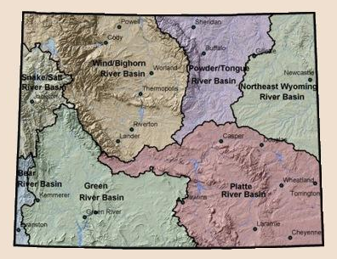
Surface Water
The SEO maintains and manages its own network of streamgages, in addition to accessing additional USGS data. These are made available using their real-time streamgage status mapping application. They use streamgage information for current year forecasts of water availability, but also utilize projections from federal agencies. Water availability estimates are generated and organized by location and vary by basin, but are published mostly in written annual reports. Use of surface water is tracked in some locations, but varies greatly. Where it is tracked, its beneficial use category is also included, and reported as an annual figure by major river basin and also by 8-digit HUC. Diversion locations are tracked, but not return flows. Some spatial data for closed basins and special management areas are also kept. The status of water allocations are tracked, but irrigation method and acreage irrigated is tracked only in some basins. Energy production and fuel type within the industrial sector is not tracked. Population served by community water systems are self-reported. Census data are used to confirm and estimate the number of connections.
Figure 20. Wyoming Major Planning Basins
Reporting requirements fluctuate to a degree based on location/basin and type of water permit. Temporary water use agreements can be used statewide to temporarily (usually two years) change the use of a water right. These are used primarily for oil and gas wells, and highway/road construction. These are required to report weekly, whether the water is used or not. Basins that are subject to the Platte River Recovery Implementation Program (PRRIP), are required to report and be summarized annually based on the water year. This reporting includes all surface water used by all industries and any new uses from previous years. Surface water subject to the North Platte Modified Decree are required to report surface and hydrologically connected groundwater diversions and storage, irrigated acreage, and consumptive use annually. In other locations, the State Engineer’s Office estimates the consumptive use of water. Some diversions are metered and include municipal, industrial, temporary uses, some larger private irrigators, and some agricultural diversions. Most are required to report their beneficial use category, but rural domestic and stockwater uses are not. In some locations and for this category of water use, the SEO estimates their use. Most of the data received by their office is open for public review. The exceptions include a few select water right holders based on request that are within the industrial use category. Wyoming has policies regarding instream flows. These types of flows are assigned a priority date akin to other water rights. Applications for instream flow permits and the approval process are much more rigorous when compared to the typical water right application process, and these types of water rights can only be held by the State of Wyoming.

Groundwater
The SEO manages and maintains its own network of groundwater monitoring wells, which are used in water availability estimates. Some groundwater use is tracked and stored by beneficial use category. These uses are tracked on a site specific basis, and also by county and aquifer, and are available on a daily, monthly or annual basis. Some summary data related to appropriation are available for groundwater usage as well, but are not spatial. Locations of source aquifers for groundwater use are tracked, as well as injection wells and special management areas. Groundwater allocation legal status and acres irrigated are tracked, but not the energy produced or fuel type within the industrial sector. Large water users are required to submit an annual report to the SEO on their monthly withdrawals. Newer water rights are metered. For sectors/users that are not required to report, their uses are estimated on an as-needed basis.

Technology
The SEO uses Microsoft’s SQL Server as their database management platform. They also use Microsoft for their web server and online applications. Their preferred programming environment is .Net. They also contract with a contractor to assist with their implementation of the “Aquarius” software, a data storage, retrieval and analysis program for streamgaging. The University of Wyoming uses Microsoft’s Access, Excel and Oracle to store some of the figures that are used in the Commission’s basin water planning. Their website applications are hosted using a Solaris (Unix-based) operating system and they use a mix of Java, Python, C, Fortran and Shell for programming applications. Most of the SEO and the Commission’s water-related data are available to the public over their websites, and water allocations are also available as a web service.

Methodology
The Commission determines physical availability of surface water through the construction and use of simulation models that calculate the estimate based on the presence of water at a site specific location, less historical diversions, compact requirements and minimum flows. The determination of available surface water is broken into seven component steps: compilation of historic streamflow records, study period selection, data extension, estimation of natural flow on ungagged reaches, determination of streamflow during wet, normal and dry years, model development and calibration, and determination of physically present surface water. These analyses are used in water planning and development tasks and reports for the seven major river basins within the state. Future demand scenarios are also compiled. Within the SEO, the term water availability is not used, but administration of new or existing water rights is based on prior appropriation (i.e., whether water is available after senior through junior water right requirements are met), while incorporating legal and institutional regulations, such as Endangered Species Act requirements, instream flow minimums, compact obligations, special management areas, etc. Wyoming uses several methods to assess consumptive use, including; 1. inflow-outflow, 2. standard reference ET estimation, and 3. remote sensing/energy balance algorithms.

Appendix

Table 3. Types of Data (Surface Water)
State | Streamgaging/Well Monitoring Data | Water Use Data | Spatial Data | Water Allocation/Appropriation Data
AK | State manages and stores its own network of streamgages, as well as using USGS data. These are used in site-specific water availability analyses. | Some water user are required to report withdrawals (and some small consumptive use) on a site-specific basis (not summarized) based on permit type on varying temporal scales. | No spatial summaries exist, but there are locations for points of diversions/locations of wells. | Maintains a database of water allocations, available on the Alaska Mapper online web application.
AZ | State stores streamgage data in surface water files pertaining to instream flow rights. State does not manage their own streamgages, but acquires streamgage data from USGS database. | Municipal, industrial, and agricultures users in Active Management Areas (AMA) are required to report annually. The amount of water allocated to a surface water right is stored in a database. Data in the AMAs are summarized by groundwater basin. Outside of the AMAs, data are summarized by county, watershed, and to a specific diversion. AMAs have data back to 1985. Community Water Systems data outside of AMAs have data back to 2006. | No spatial summaries for water availability. The state does track spatial information for water use. Summary data are available by AMA reported by groundwater basins. Diversion locations are maintained, but not return flows. | Maintains a database of water allocations, but since none of AZ has been adjudicated, the state does not have any adjudication information. The state tracks acres irrigated, and irrigation method, but does not track method after the issuance of the certificate of the water right. The state tracks energy production annually for large-scale thermoelectric uses (>25 MW) in an AMA.
AZ (Colorado River) | State does not manage their own streamgages, but acquires streamgage data from USGS database. | Water use data tracked by Colorado River Entitlement holder and is stored monthly and yearly. | No spatial summaries for water availability. State does track diversion, place of use, and return flow locations. | Water allocation data are tracked. Both acres irrigated and irrigation method are stored. Thermoelectric energy production is not tracked.
CA | State manages and stores data from its own network of streamgages, and uses USGS data. | CDWR tracks and stores water used by public water system. These systems have locational information attached, but are not summarized. | No spatial summaries exist for water availability, but CDWR does perform a water balance on a spatial scale of county intersected with their custom detailed analysis unit. These are usually published about 4 years behind the current year. | The California State Water Resources Control Board maintains a number of databases for water rights. The primary database is called eWRIMS, and it contains points of diversion, fully appropriated streams, beneficial uses, legal status, etc.
CO | State stores and maintains both USGS and CO owned streamgaging data. | Water use data is tracked by ‘measurement structure’ on a daily, monthly, or annual basis. | No spatial summaries for water availability or water uses. Summaries are available by ‘source’ (natural streamflow, reservoir water, ground water, transbasin water, nonstream flow, reusable water). | Maintains a database of water allocations, including which have been adjudicated. State also track acres irrigated and irrigation method for irrigation uses. State does not track energy produced for thermoelectric uses nor fuel type.
ID | State manages a few streamgages, contracts out the rest. Acquires streamgage data from USGS database. | Individual diversion points are tracked, as well as consumptive use estimates based on Landsat thermal imagery. Daily flow and diversion data are assembled monthly or yearly. | State provides spatial data for water availability (but not summaries), place of use, diversions, and return flows. The state also tracks spatial data for closed basins and special management areas. | Water allocation data are tracked, including which allocations have been adjudicated. The state tracks acres irrigated, but not irrigation method. State does not track energy produced for thermoelectric uses nor fuel type.
KS | State stores data from USGS’ website, but does not maintain any gages on its own | Use of surface water is tracked with approximately 80% being metered. | State has the ability to summarize water availability and use on several different scales | Water allocation data are tracked, including irrigated acres, crop type and method of irrigation. Energy produced and fuel type are not tracked.
MT | Manages a small number of streamgages used for special projects. Acquires streamgage data from USGS via StreamStats. | Water rights are attributed with a purpose (i.e. irrigation, wildlife, stockwater, etc.), but the amount of water used is not tracked. Water rights are organized by ‘Water Rights Basin’. | State stores points of diversion and places of use. 20% of the data is attributed with x,y coordinates. Some information is available for return flow locations. The state also tracks spatial data for closed basins and special management areas. | Water allocation data are tracked, including which allocations have been adjudicated. The state tracks acres irrigated, and irrigation method. State tracks energy produced at state-owned energy facilities, but not at others.
NE | 187 streamgages in NE, of which DNR operates and reports on 85. 12 operated in cooperation with USGS. State annually evaluates the availability of water in basins not already declared fully appropriated. | Local districts track water use data for compact compliance. DNR tracks canal diversions, but not deliveries. Metering is required in some basins. For metered basins, water use reports are required every year. DNR is building a new data system to capture water rights and water use data. | State maintains coordinates for diversion points and is georeferencing those points to the National Hydrography Dataset (NHD). State has some spatial data for water use and return flows, and is planning building out that capability as part of their new data system. State has spatial data for closed basins and special management areas. | Water allocation data are tracked, including which allocations have been adjudicated. The state tracks acres permitted to be irrigated, but not irrigation method (planned for new database). State does not track energy produced for thermoelectric uses nor fuel type
NM | State cooperates with USGS on a statewide stream gaging network, and operates additional gages in selected areas, accesses additional data from USGS. | Surface water users maybe be required to report their withdrawals, but it varies by permit. Some diversions are metered, but it varies based on basin administration, permit requirements and the age of the water right. | NM stores water availability and water use in a spatial format and has the ability to report this information by specific location (i.e., point of diversion and place of use). Collects locations for points of diversion and return flows. Maintain spatial data for closed basins and special management areas. | Water rights data include those that have been adjudicated, and how many acres are irrigated with the appropriated water. Irrigation method and water used for energy production (as well as facility type) are not tracked.
NV | State manages and stores data from their own network of gages, as well as accessing USGS data. | State tracks and stores use by beneficial use category and can summarize these by hydrologic basin. | State has a partial dataset for locations of water diversions, and is developing a places of use spatial layer. Special management areas are also available. | Water allocation data are tracked, including those that have been adjudicated, acres irrigated, and irrigation method. Energy produced is not tracked, but facility type is.
ND | State has a cooperative agreement with the USGS to operate and maintain 124 stream monitoring gages. The data from the USGS gages are available and accessed from USGS’ NWIS website. | Water use data are tracked by beneficial use category and are site-specific using the PLSS, available on a daily, monthly and/or quarterly timeframe. Water use reporting by the permit holder is main method for gathering information. Others include use of satellite data and ISODATA method for extracting surface water areas. | State maintains spatial data for water availability and use and publishes summaries organized by location in their “Bi-Annual Report Summary.” They also maintain spatial data for points of diversion, closed basins and special management areas. | Water allocation information includes which permits have been adjudicated, how many acres are irrigated by a permit, and the irrigation method. Energy generation is not tracked by as part of a permit.
OK | Most gaging data comes from USGS. State does own and manage some of their own gages. These data are used to help estimate water availability. | State tracks annual, site-specific water use data. | State has spatial summaries of water availability, spatial data for water use, and water diversions. Return flow spatial locations are maintained by OK DEQ. State does not have spatial data for closed basins or special management areas. | Water allocation data are tracked, but not which allocations have been adjudicated. The state tracks acres irrigated, and irrigation method. State does not track energy produced for thermoelectric uses nor fuel type
OR | State stores and maintains both USGS and OR owned streamgaging data. USGS data are acquired via web services. Data are used to estimate water availability. | State tracks monthly, site-specific water use data. | State has spatial summaries of water availability, spatial data for place of use, and water diversions. The state does not have return flow locations, but does have spatial data on closed basins and special management areas. | Water allocation data are tracked, including which allocations have been adjudicated. The state tracks acres irrigated, but not irrigation method. State does not track energy produced for thermoelectric uses nor fuel type.
SD | State downloads data from USGS site for estimating water availability for permitting. | State tracks some annual, site-specific water use data for newer water distribution systems. | State has spatial data for points of diversion and special management areas, and closed basins. | Water allocation data are tracked, as well as acres irrigated.
TX | State accesses and stores data from USGS site for estimate water availability for models and permitting. | Water use is tracked, with some beneficial use categories included, and reported on a site-specific basis. There is some ability to summarize the data by county and region. | State has spatial data for points of diversion and some return flows, these can be summarized by county | Water allocation data are tracked, as well as adjudication status. Acres irrigated, irrigation method, energy produced and energy facility are not tracked.
UT | State stores and maintains both USGS and UT owned streamgaging data. USGS data are acquired via NWIS web site. Data are used to estimate water availability. | State tracks monthly, site-specific water use data. Dept. of Water Resources is developing a water budget system that will report summary data for 150 subareas that cover the entire state. | State has spatial data for water use, water diversions, and return flow. The state has spatial data on closed basins and special management areas. | Water allocation data are tracked, including which allocations have been adjudicated. The state tracks acres irrigated, but not irrigation method. State does not track energy produced for thermoelectric uses nor fuel type.
WA | State stores and maintains USGS, WA owned, and other owned streamgaging data. Data are used in part to establish instream flows. | State does not track water use data for a majority of its water rights. Metering is required on all new rights, and the state is working toward achieving 80% metering compliance on all water rights. | State has prepared supply and demand forecasts for basins east of the Cascades. State has spatial summaries for water availability, spatial data for water use, and water diversions, but not returns flows. The state has spatial data on closed basins and special management areas. | Water allocation data are tracked, including which allocations have been adjudicated. The state tracks acres irrigated, but not irrigation method. State does track energy produced for thermoelectric uses, but not fuel type. These data are populated for those water rights where the state has a water right certificate, but not for the others.
WY | State uses both USGS and state owned streamgages. Data are acquired via the GOES satellite and via the state’s own radio network. State uses federal agency water availability estimates for current year forecasts. | State tracks diversion data on an hourly, daily, monthly, or annual basis. Data are organized by water user in major river basins and by 8-digit HUC. Level and detail varies greatly by basin. Information is not stored in a central database. | The availability of spatial data varies by basin. For some basins, the state has spatial summaries for water availability (however in many cases the summaries are in written reports), spatial data for water use, and water diversions, but not returns flows. The state has spatial data on closed basins and special management areas. | Water allocation data are tracked, including which allocations have been adjudicated. The state tracks acres irrigated in some basins, but not irrigation method. State does not track energy produced for thermoelectric uses nor fuel type.
WY (U. of Wyoming) | Organization does not own or manage streamgages. Makes use of state and USGS gages. | During alternate years, the organization conducts surveys of public water systems and irrigation districts on water use. | Host Wyoming Basin Outlook Reports generated by NRCS. Also have locations for water diversions, but not return flows. | This organization does not track water allocation data, but does track the number of acres irrigated in each basin.

Table 4. Types of Data (Groundwater)
State | Groundwater Level Data | Water Use Data | Spatial Data | Water Allocation/Appropriation Data
AK | State doesn’t maintain own network of wells, but stores information from USGS | State requires some users to report their use and aquifer source on a daily or annual basis based on the permit type. | Spatial locations for wells are tracked with some by geographic coordinates, others by township, range and section. The state tracks aquifer source, but not injection wells, recharge areas, closed basins, etc. | State maintains a database of water allocations, including legal status, number of acres irrigated at the time of permit issuance, and irrigation method. Energy production is not tracked.
AZ | State owns three wells, monitors an additional 1700 ‘index’ wells throughout the state. Also operates 120 automated water level monitoring sites. | State receives annual groundwater pumping totals from non-exempt wells in AMAs and Irrigation non-expansion areas (INAs). CWS outside of an AMA must report annual withdrawals. Data are stored by groundwater basin. | Spatial locations are maintained for both withdrawal wells (at the center of a 10 acre parcel) and monitoring wells. Groundwater use is summarized in the state Atlas. The state does not track aquifers for withdrawal points, but has developed groundwater flow models for all AMAs in the state. | The state maintains a database of water allocations, including the legal status based on whether or not the water was being used prior to the passing of AZ’s Water Code (1980). The state knows the total number of acres that have the right to be irrigated and the method used, but they don’t track how much was actually irrigated. The state tracks energy production annually for large-scale thermoelectric uses (>25 MW) in an AMA.
CA | State owns and manages groundwater monitoring data | Groundwater use is not monitored or tracked | Groundwater use is not tracked, but locations and relevant groundwater data are managed by CDWR to estimate water availability. Locations for monitoring wells, injection wells and recharge basins are available from CDWR. | State maintains a database of water allocations that includes the legal status, amount of withdrawal and locational information that is made available on eWRIMS.
CO | State does not own wells, but does monitor water levels at certain wells in targeted areas. | Data are stored only for the purpose of administering water rights or plans that mitigate surface water impacts based on ground water diversions. Data that are maintained, are maintained on a monthly or annual basis. Some locations have daily withdrawals. | Spatial locations are maintained for well locations as well as the aquifer from which the water is drawn. Summary information is maintained by ‘measurement structure’. Locations are also maintained for groundwater storage; however, stored groundwater is later withdrawn from the same location (occurs only in the Denver Basin bedrock aquifers). The state also maintains locations for special management areas. | The state maintains a database of water allocations, including which have been adjudicated. State also track # acres irrigated and irrigation method for irrigation uses. State does not track energy produced for thermoelectric uses nor fuel type.
ID | State manages groundwater monitoring wells as well as makes use of USGS wells. | State tracks site-specific use data, especially in Eastern Snake Plain Aquifer, Big Lost River Basin, and beginning in 2013, the Upper Woods Rivers area. Data are reported annually. | Spatial locations are maintained for withdrawal points and areas of use. Summary data is only available for certain water districts. The state does not track aquifers for withdrawal points. The state also tracks spatial data for closed basins and special management areas. | The state maintains a database of which groundwater rights have been adjudicated as well as the irrigated acres associated with the water right. State does not track energy produced for thermoelectric uses nor fuel type.
KS | State manages and store groundwater monitoring wells, as well as use of USGS wells. | State tracks groundwater by allocation on site-specific, annual basis. | Locations of wells and the source aquifer are tracked. Amount of water can be reported annually and summarized by different geographic units. Closed basins and special management areas are also tracked. | Allocation data are maintained in a database, including acres irrigated and irrigation method. Energy-related information is not tracked. Domestic well users are not required to report.
MT | Groundwater level data are stored in Groundwater Information Center database at the MT Bureau of Mines. State manages some monitoring wells, but does not estimate groundwater availability. | State tracks water use data as specified in specific permit conditions. Data are not organized by beneficial use. | State does not have any spatial locations for groundwater withdrawal wells. | Water allocation data are tracked, including which allocations have been adjudicated. The state does not track acres irrigated, nor irrigation method. State does not track energy produced for thermoelectric uses nor fuel type.
NM | State cooperates with USGS on a statewide groundwater level network, and collects additional groundwater level data in selected areas, although they do not manage any monitoring wells. | Groundwater use data is collected and stored by beneficial use category. The data are available using a variety of spatial scales, including aquifer, county and by point of diversion. The temporal scale of groundwater use data collection varies. State also collects the locations of injection wells and groundwater recharge basins, and groundwater areas that are closed to further appropriations. | Groundwater data are available using a variety of spatial scales, including aquifer, county and by point of diversion. Special management areas are available, as well as the aquifer source. | Groundwater allocation data include those which have been adjudicated and the acres of land irrigated. The irrigation method used and water used for energy production (as well as facility type) are not tracked.
NE | Groundwater level is estimated using groundwater models and uses depth to water data stored in DNR databases. | Groundwater use data is tracked by Natural Resource Districts (NRDs). NRDs have the primary authority for groundwater, with DNR oversight. NRDs provide information to DNR for specific uses (municipal and industrial). | State maintains spatial locations for wells, however not all are with GPS coordinates. Some are from legal descriptions or distance from the nearest section line. State is developing the capability to store summary level data. State does not track the aquifer from which water is withdrawn. | Some allocations are tracked by NRDs, but state subscribes to the doctrine of correlative rights as the predominant regulatory schema for groundwater management.
NV | State manages and stores data from its own monitoring wells, which are used to evaluate water availability. | Groundwater usage is stored and tracked by beneficial use, point of diversion and place of use permit. Time scale depends on reporting requirements of the permit. | Locations of points of diversions, groundwater recharge areas, injection wells and special management areas are tracked. | Allocation data are tracked and stored in a database, including adjudication status, acres irrigated, irrigation method. Energy-related information is not tracked.
ND | State maintains a comprehensive observation well network of over 4,100 monitoring wells. More than 80% of the wells are measured monthly from May to December. The remaining wells are measured quarterly or annually. | Groundwater withdrawal data is tracked and stored by beneficial use category. These are all site specific and organized by PLSS and gathered on a daily, monthly, and/or quarterly timeframe. These are summarized and published in SWC’s “Bi-Annual Report Summary.” Water permits are required for all diversions of water, with the exception of domestic and livestock wells withdrawing less than 12.5 acre-feet per year. | For each water permit, regardless of use, and for each point of diversion within the water permit, spatial data (points of diversion and use) are recorded within the SWC Database. Most new wells are surveyed, and state-plane and lat-long coordinates are available in the database, either through translation of the PLSS data or from direct survey measurements. Aquifer boundaries are also available. | Groundwater allocation data include which have been adjudicated, how many acres are irrigated, and irrigation method used. The energy produced by water allocated to the energy sector is not tracked, nor is fuel/facility type.
OK | State maintains and monitors its own wells through its Mass Measurement Program. State also uses USGS data. Water availability estimates are made for hydrological studies only. | State tracks annual, site-specific water use data. | State has spatial data for wells, and summary data that can be rolled-up to any scale. State also has locations for recharge wells which are permitted by ODEQ. State does track the aquifer from which water is drawn. | Water allocation data are tracked, but not which allocations have been adjudicated. The state tracks acres irrigated, and irrigation method. State does not track energy produced for thermoelectric uses nor fuel/facility type.
OR | State manages groundwater monitoring wells as well as makes use of USGS wells. State acquires data from USGS on an as needed-basis. State uses this information to determine groundwater availability. | State tracks a small percentage of site specific groundwater use data on monthly and annual basis. | State maintains spatial locations for wells, but not spatial summaries. State maintains spatial data for closed basins and special management areas. State maintains the aquifer from which water is drawn for more recent water rights. | Water allocation data are tracked, including which allocations have been adjudicated (which is complete for groundwater). The state tracks acres irrigated, but not irrigation method. State does not track energy produced for thermoelectric uses nor fuel type.
SD | State manages and stores data from own network of groundwater monitoring wells for estimating availability. | Groundwater users who are required to report send their diverted amounts. Diversion data is stored and tracked by aquifer source in weekly/daily time intervals. | Spatial data include well locations, closed basins, special management areas. | Allocation data is stored in a database and include acres irrigated. Energy-related information is not tracked.
TX | TWDB has access to groundwater monitoring wells which are used to maintain groundwater models for availability assessments. | TWDB tracks groundwater withdrawals by beneficial use category and stores this information in databases. This information is gathered using a water use survey that can be aggregated to the county. These are submitted annually. | Spatial data include locations of water systems and industrial facilities for the water use survey, and planning regions. | Groundwater data are not included in TCEQ’s allocation program. TWDB does track acres irrigated for their annual water use survey.
UT | State uses USGS wells. Data are acquired via NWIS. These data are used to determine water availability. | State tracks monthly, site specific water use data. Dept. of Water Resources is developing a water budget system that will report summary data for 150 subareas that cover the entire state. | State maintains spatial summaries organized by ‘water right areas.’ State maintains spatial locations for wells, and spatial data for closed basins and special management areas. State maintains the aquifer from which water is drawn. | Water allocation data are tracked, including which allocations have been adjudicated. The state tracks acres irrigated, but not irrigation method. State does not track energy produced for thermoelectric uses nor fuel type.
WA | State manages groundwater monitoring wells as well as makes use of USGS wells. These data are used for water availability estimates. | State tracks water use data for each well. Some wells have data loggers, while others are measured 2-4 times a year. | State has prepared supply and demand forecasts for basins east of the Cascades. State has spatial summaries for water availability, and spatial data for withdrawal points. The state has spatial data on closed basins and special management areas. Closed basins are based on surface water availability. New groundwater withdrawals in a closed basin would require mitigation for the potential impacts. State maintains the aquifer from which water is drawn. | Water allocation data are tracked, including which allocations have been adjudicated. The state tracks acres irrigated, but not irrigation method. State does track energy produced for thermoelectric uses, but not fuel type.
WY | State manages groundwater monitoring wells as well as makes use of USGS wells. These data are used for water availability estimates. | State tracks monthly and annual site specific data at some of the wells. | State maintains spatial locations for wells, but not spatial summaries. State maintains spatial data for special management areas, and does not have any fully closed basins. State maintains the aquifer from which water is drawn for more recent water rights. | Water allocation data are tracked, including which allocations have been adjudicated. The state tracks acres irrigated, but not irrigation method. State tracks energy produced for coal bed methane development (reporting ratio of water/gas production).
WY (U. of Wyoming) | Organization does not own or manage wells. Makes use of state and USGS wells. | Organization tracks groundwater use data on a daily, monthly, yearly scale for multiple spatial scales. | Organization maintains spatial locations for wells and spatial summaries. | None

Table 5. Reporting Requirements (Surface Water)
State | How often are users required to report? | What is reported? | Is Consumptive Use Reported? | Is Diverted Flow Reported? | Are Diversions Metered? | Do all beneficial uses report? | Instream flows?
AK | Daily, monthly or annually depending on the permit | Water withdrawals primarily. | For some permits | Yes | Public suppliers who use groundwater are metered, as well as some commercial uses. | Yes, when required by permit, excepting water related to military installations for security concerns | Water can be appropriated to instream flows.
AZ | In an AMA, annually. Statewide, stock pond use must report every 5 years the amount of water being stored, and that uses have not changed. | Volume diverted and beneficial use. | Yes in AMAs | Yes in AMAs | Yes in AMAs | Yes if regulated by the Water Code in AMAs. No for outside of AMAs. The state estimates use for those uses that don’t report. | Covered by statute in AZ.
AZ (Colorado River) | Colorado River entitlement holders report to Reclamation monthly; other users on a semi-annual basis. | Volume diverted and return flows. | Yes | Yes | Yes, large irrigation and municipal users. | Small domestic and small irrigation users don’t report on a monthly basis. | N/A
CA | Please refer to the California Water Code. http://www.leginfo.ca.gov/cgi-bin/calawquery?codesection=wat&codebody=&hits=20
CO | Some continuous, others annually | Volume diverted and beneficial use | No | Yes | Yes (generally) | Yes (with none being proprietary) | Covered by statute in CO. Water right owned by CO Water Conservation Board.
ID | In active regulated surface water districts, diversions are recorded on a daily or weekly basis. Reports are submitted to IDWR daily, weekly, or sometimes monthly. Other districts take infrequent measurements when regulation is required. | In active regulated surface water districts instantaneous measured flow is reported. Some data loggers are in place where the need requires an average daily flow. | No | Yes | No | No, but the state estimates use for those users who are not required to report. | The state has established minimum stream flows for several watersheds. Water is managed within these watersheds to maintain that minimum stream flow.
KS | Required to report on an annual basis | Amount diverted, acres irrigated, crops grown and irrigation system type | No | Yes | No | No. Domestic uses are exempt. | Yes. Kansas has defined a Minimum Desirable Streamflow (MDS) for some locations
MT | No water user reporting requirements. | N/A | No | No | No | State estimates use in cooperation with USGS. | State has established water reservations and water rights for instream flows.
NE | If required to report, users are required to report once a year by the end of the calendar year. | Volume diverted, crop raised, acres irrigated, and irrigation method. | No | Yes | Yes, for those basins where it’s required as part of an interstate compact or water administration. | No, state estimates use for those uses that are not required to report. Public Water Supply information is proprietary, and cannot be shared. | State has established statutes for instream flow.
NM | Varies by permit | Users may be required to report their withdrawals, | No | Yes | Varies based on basin administration, permit requirement and age of permit | No, varies by permit | Yes, recognized in NM statute for ESA and to ensure interstate stream compact compliance
NV | Varies by permit | Users may be required to report their withdrawals and consumptive use | Yes | Yes | Some, usually municipal providers and energy generation facilities | No, varies by permit | Yes, permitted in support of recreational or wildlife manners of use
ND | Annually | diverted flow and the consumptive use of the permit | Yes | Yes | All diversion except for beneficial uses mention in following column | All permits, except "water spreading", flood control, Fish & Wildlife, and recreational uses | No
OK | Annually | Volume diverted, types of irrigation systems, # meters served, population served, water sold and purchased. | Yes | Yes | No | Yes. Domestic use (as defined in OK state law) is not required to report. Domestic use is estimated by the state. | Covered by state rules.
OR | Annually | Volume of water diverted on a monthly basis. | No | Yes | Yes, some new permits require metering. Government entities are also required to meter diversions. | No. State estimates use for those that are not required to report as needed in support of the water availability program. | Instream flow is managed as a water right.
SD | Annually | Water diverted | No | Yes | No | All irrigation, except waterspreading. Some water distribution systems, but not older water rights | Yes, appropriations may be made for instream flows, base flows are protected
TX | TCEQ – Annually  TWDB – Annually | TCEQ – Monthly diversions and return flows  TWDB – Annual water use survey | TCEQ – No  TWDB – Yes | Yes | TCEQ - Yes, in areas with a watermaster | TCEQ - No, all users except permits that remain instream (e.g. in-place recreation, reservoirs)  TWDB – Annual water use survey queries all but agricultural users | Yes, will adopt environmental flow standards for each basin and bay system in this state to support a sound environment, considering public interests and other factors
UT | Annually | Volume or rate diverted, use, # connections, storage, and population served. | No | Yes | Yes, public water supplies, industrial, and some irrigation use. | No. In some areas of the state only public supply and irrigation are required to report. The state estimates use for those uses that don’t report. Individual industrial use is proprietary. Only aggregated data are shared. | Instream flow is managed as a water right.
WA | Varies by water right. Some have no reporting requirement, some monthly, annually, or upon request. | Diversion withdrawal rate, annual quantity. | No | Yes | Yes | No. Some older rights may not have reporting or metering requirements. For some of these, the state has estimated use. | Instream flow is managed as a water rights, and surface water basins being closed to further water rights.
WY | Depends on permit and basin. Temporary water use agreements require weekly reporting. Surface water use under the Platte River Recover Implementation Program is reported once a year. | Diverted volume. | No, although some users report consumptive use. In other areas, state estimates consumptive use. | Yes | Some, municipal, industrial, temporary uses, some larger private irrigation reservoirs, and some agricultural diversions. | No. Rural domestic and stockwater are not required to report. In some basins, the state estimates these uses. A few select water right holders’ reports are proprietary. | Intream flow is managed as a water right. Only the state can own an instream water right.

Table 6. Reporting Requirements (Groundwater)
State | How often are users required to report? | What is reported? | Is Consumptive Use Reported? | Is Withdrawn amount reported? | Are Withdrawals Metered? | Do all beneficial uses report?
AK | Daily, monthly or annually depending on the permit | Water withdrawals primarily. | For some permits | Yes | Public suppliers who use groundwater are metered, as well as some commercial uses. | Yes, when required by permit, excepting water related to military installations for security concerns
AZ | In AMAs and INAs, municipal, industrial, and agricultural users are required to report annually. | Volume withdrawn and beneficial use, with specific reporting requirements depending on use. | Yes | Yes | Yes | No. Exempt wells (<35 gpm) are not required to report. The state estimates the use for these users. Some CWS data are not made available to the public.
CA | Please refer to the California Water Code. http://www.leginfo.ca.gov/cgi-bin/calawquery?codesection=wat&codebody=&hits=20
CO | Depends on provisions of water right | Depends on the provision of the water right. | No | Yes, sometimes in rate and sometimes in volume. | Yes, not in all cases, however. | No. Some water users may be required to maintain diversion data, but the diversions may not be subject to actual submitted reporting. Some data are proprietary in rare cases.
ID | In active regulated surface water districts, diversions are recorded on a daily or weekly basis. Reports are submitted to IDWR daily, weekly, or sometimes monthly. Other districts take infrequent measurements when regulation is required. | In active regulated surface water districts instantaneous measured flow is reported. Some data loggers are in place where the need requires an average daily flow. | No | Yes | Yes | No. Exempt wells do not report. Power consumption records used to estimate groundwater diversions are proprietary. Public drinking water locations are not shared with the public.
KS | Required to report on an annual basis | Amount diverted, acres irrigated, crops grown and irrigation system type | No | Yes | No | No. Domestic uses are exempt.
MT | Variable depending on permit requirements. | Variable depending on permit requirements. | No | Yes | Yes, when specified in the permit condition. | No
NE | Municipal and industrial uses as well as transfers to other states are required to report annually. | Annual use under the permits and total volume relative to permits. Not all water us is permitted, so actual use may be higher. | No | Yes, but only the amount that is related to a permit. | Permitted withdrawals are metered. | Dependent upon specific NRD rules. State estimates water use for those uses that don’t report. Public Water Supply information is proprietary, and cannot be shared.
NM | Varies by permit | Users may be required to report their withdrawals, | No | Yes | Varies based on basin administration, permit requirement and age of permit | No, varies by permit
NV | Depends on any reporting requirement in the terms of the permit, but will be monthly, quarterly or yearly. Even if reporting occurs less frequently, the time scale is typically still monthly. | Amount diverted is required, but sometimes consumptive use is also required | Sometimes | Yes | Current permits will likely have meter requirements even on irrigation water rights. Exempt domestic uses do not have a meter requirement, unless there is a specific order. | No, all but domestic users
ND | Annual Use Form is required. | Withdrawals and consumptive use | Yes | Yes | Yes, for industrial, irrigation and municipal and rural water categories | Yes
OK | Annually | Volume diverted, types of irrigation systems, # meters served, population served, water sold and purchased. | Yes | Yes | No | No. Domestic use (as defined in OK state law) is not required to report.
OR | Annually | Annual report of monthly withdrawals. | No | Yes | Yes, mostly larger users, municipalities, irrigation districts. | No
SD | Annually | Water diverted | No | Yes | No | All irrigation. Some water distribution systems, but not older water rights.
TX | TCEQ – None  TWDB – As part of the annual water use survey | TWDB – water withdrawn | No | Yes | No | TWDB – Annual water use survey queries all but agricultural users
UT | Annually | Volume or rate diverted, use, # connections, storage, and population served. | No | Yes | Yes, public water supplies, industrial, and some irrigation use. | No. In some areas of the state only public supply and irrigation are required to report. The state estimates use for those uses that don’t report. Individual industrial use is proprietary. Only aggregated data are shared.
WA | Varies by water right. No reporting is the most common. Some reporting is upon request or required by a lawsuit. | Withdrawal rate, monthly or annual quantity. | No | Yes | Yes, although most are not. | No. State tracks what is authorized by the water right, but don’t have specific reporting requirements.
WY | Large producers are required to submit an annual report of monthly production. | Quantity of groundwater beneficially used on a monthly basis. | No | Yes | Yes, at least for newer water rights. | No. State estimates use for those that don’t report on an as-needed basis.

Table 7. Data Management and Data Publishing
State | Database Environment | Server Environment | Programming Environment | Data available via website? | Data available via web services? | Non Interactive Reports?
AK | Oracle, Access, Excel | Microsoft | Java, Python | Yes | No | Yes
AZ | Oracle, Access | Microsoft | .Net | Yes | Yes | Yes
AZ (Colorado River) | Oracle, Access, Excel | Not specified | Not specified | No | No | Yes, via USBR website
CA | Oracle, MySQL, Hydrstra | Linux | Java, .Net | Yes | No | Yes
CO | SQL Server | Microsoft | .Net | Yes | Yes | Yes
ID | SQL Server, Dbase, Access, ArcMap with SQL Server | Microsoft | Java, .Net, Python | Yes | Yes (map services) | Yes
KS | Oracle | Microsoft | Java, .Net | Yes | Yes | Yes
MT | Oracle, SQL Server | Microsoft, Linux | .Net, Python, PL/SQL | Yes | No | Yes
NE | SQL Server, Access | Microsoft | .Net, Python | Yes | Yes | Yes
NM | SQL Server, Informix, PostgreSQL, Geodatabase | Microsoft, Linux, Sun Solaris | Java, Informix 4GL | Yes | No | Yes
NV | SQL Server, Access, MySQL | Microsoft, Linux | Python, PHP, Cold Fusion | Yes | No | Yes
ND | 4th Dimension DB and PostgreSQL | Mac OS | Python, PHP | Yes | No, but working to deploy | Yes
OK | Oracle, SQL Server, File Geodatabase | Not specified | .Net, Python | No | No | Yes
OR | Informix | Microsoft | .Net, Python | Yes | No | Yes
SD | MS Visual FoxPro, migration to SQL Server | Microsoft | Visual FoxPro | Yes | No | No
TX – TCEQ | Access (migration to Oracle) | Microsoft | Java, .Net, Python | Yes | No | Yes
TX – TWDB | SQL Server | Microsoft | .Net | Yes | No | Yes
UT | SQL Server | Microsoft | .Net, Python | Yes | No | Yes
WA | SQL Server | Microsoft | .Net | Yes | No | Yes
WY | SQL Server | Microsoft | .Net | Yes | Yes | Yes
WY (U. of Wyoming) | Oracle, Access, Excel | Solaris | Java, Python, C, Fortran, Shell | Yes | No | Yes

Sandia National Laboratory. Energy and Water in the Texas and Western Interconnects. (http://energy.sandia.gov/?page_id=1741).
Environmental Protection Agency. National Environmental Information Exchange Network. (http://www.exchangenetwork.net/).
The Consortium of Universities for the Advancement of Hydrologic Science, Incorporated. CUASHI Home Page. (http://www.cuahsi.org/).
The Open Geospatial Consortium. OGC WaterML Home Page. (http://www.opengeospatial.org/standards/waterml).
U.S. Geological Survey. USGS Water Data for the Nation. (http://waterdata.usgs.gov/nwis).
The number of digits used in the HUC coding also indicate the relative refinement of watershed basins such that lower numbers (such as HUC-1) indicate large watershed basins, and higher numbers (such as a HUC-12) represent progressively smaller watershed delineations.
Alaska Department of Natural Resources, Water Resources Program Website. (http://dnr.alaska.gov/mlw/water/).
Alaska Department of Natural Resources, Alaska Mapper 3.0 Application. (http://dnr.alaska.gov/MapAK/).
Alaska Department of Natural Resources, Alaska Land Status Map Application. (http://www.navmaps.alaska.gov/AlaskaLandStatus/).
Alaska Department of Natural Resources. Factsheet: Reserving water for instream uses. (http://dnr.alaska.gov/mlw/factsht/wtr_fs/instream.pdf).
Alaska State Legislature. Infobase of State Statutes. (http://www.legis.state.ak.us/basis/folio.asp).
Arizona Department of Water Resources, Active Management Area Website. (http://www.azwater.gov/AzDWR/WaterManagement/AMAs/default.htm).
Arizona Department of Water Resources, Arizona Water Atlas Website. (http://www.azwater.gov/AzDWR/StatewidePlanning/WaterAtlas/default.htm).
Arizona Department of Water Resources, Water Resources Development Commission (HB2661) website, (http://www.azwater.gov/AzDWR/WaterManagement/WRDC_HB2661/Meetings_Schedule.htm).
Arizona Department of Water Resources. Applications for Permit to Appropriate Public Water of the State of Arizona For Instream Flow Purposes (33’s). (http://www.azwater.gov/AzDWR/SurfaceWater/SurfaceWaterRights/SurfaceWater_FAQ.htm).
Arizona Department of Water Resources. Active Management Area Assessments. (http://www.azwater.gov/AzDWR/WaterManagement/Assessments/default.htm).
Arizona Department of Water Resources. Frequently Asked Questions. (http://www.azwater.gov/AzDWR/WaterManagement/AAWS/AAWSFrequentlyAskedQuestions.htm#PAD_Reserve).
California Legislative Information and Law. California Water Code. (http://www.leginfo.ca.gov/cgi-bin/calawquery?codesection=wat&codebody=&hits=20).
California Legislative Information and Law. California Water Code Section 531-531.20. (http://www.leginfo.ca.gov/cgi-bin/displaycode?section=wat&group=00001-01000&file=531-531.20).
California Department of Water Resources. Water Data Library. (http://www.water.ca.gov/waterdatalibrary/index.cfm).
California Department of Water Resources. Land Use Survey. (http://www.water.ca.gov/landwateruse/lusrvymain.cfm).
California Department of Water Resources. California Water Plan, Update 2009 Volume 5 – Technical Guide. (http://www.waterplan.water.ca.gov/technical/cwpu2009/).
Colorado Water Conservation Board. Colorado Water Conservation Board: Strategic Framework. (http://cwcbweblink.state.co.us/WebLink/ElectronicFile.aspx?docid=169613&searchid=1bda1d2a-a8e0-4e31-9140-953cd1443900&&dbid=0).
Colorado Water Conservation Board, Interbasin Compact Committee and Basin Roundtables Website. (http://cwcb.state.co.us/about-us/about-the-ibcc-brts/Pages/main.aspx).
Idaho Water Resources. Comprehensive State Water Planning. (http://www.idwr.idaho.gov/waterboard/WaterPlanning/comprehensive%20planning.htm).
Idaho Department of Water Resources. Interactive Maps. (http://www.idwr.idaho.gov/GeographicInfo/MapServer/mapserver.htm).
Idaho Department of Water Resources. Water Appropriation Rules. (http://adminrules.idaho.gov/rules/current/37/0308.pdf).
State of Idaho Legislature. Idaho Statutes on Irrigation and Drainage, Water Rights and Reclamation. (http://legislature.idaho.gov/idstat/Title42/T42CH2SECT42-233a.htm).
Idaho Department of Water Resources. Mapping Evapotranspiration. (http://www.idwr.idaho.gov/GeographicInfo/METRIC/et.htm).
Idaho Department of Water Resources. Water Supply Bank. (http://www.idwr.idaho.gov/WaterManagement/WaterRights/waterSupply/ws_default.htm).
Kansas Water Office. Kansas Water Plan. (http://www.kwo.org/Kansas_Water_Plan/Kansas_Water_Plan.htm).
Kansas Department of Agriculture, Division of Water Resources. Water Information Management and Analysis System. (http://hercules.kgs.ku.edu/geohydro/wimas/index.cfm).
State of Kansas GIS Data Access & Support Center. (http://www.kansasgis.org/?CFID=2489911&CFTOKEN=68942644).
Kansas Division of Water Resources. Kansas Water Appropriation Act. (http://www.ksda.gov/includes/statute_regulations/mainportal/KWAA_Rules_Regs_December_2011_FullVersion.pdf).
Montana Department of Natural Resources & Conservation. Water Rights Query System. (http://nris.mt.gov/dnrc/waterrights/).
Montana Secretary of State. Permit Application Criteria – Surface Water / Groundwater. (http://www.mtrules.org/gateway/RuleNo.asp?RN=36.12.1702).
New Mexico Office of the State Engineer. New Mexico Water Rights Reporting System. (http://nmwrrs.ose.state.nm.us/nmwrrs/disclaimer.html).
New Mexico Office of the State Engineer. Technical Reports: Water Use and Data. (http://www.ose.state.nm.us/publications_technical_reports_wateruse.html).
Nevada Division of Water Resources. Water Planning Program. (http://images.water.nv.gov/images/publications/water%20planning%20reports/water%20for%20nevada%).
North Dakota State Water Commission. Water Appropriation Requirements, Current Water Use, & Water Availability for Energy Industries in North Dakota: A 2010 Summary. (http://www.swc.nd.gov/4dlink9/4dcgi/GetContentPDF/PB-1800/W&E%20RPT%20FinalR.pdf.)
North Dakota State Water Commission. Map and Data Resources. (http://www.swc.nd.gov/4dlink9/4dcgi/GetCategoryRecord/Map%20and%20Data%20Resources.)
North Dakota State Water Commission. Assessment of Potential Use of Telemetry for Monitoring Oil-Field Water Use. (http://www.swc.nd.gov/4dlink9/4dcgi/GetSubCategoryPDF/250/Telemetry%20Study%20Report.pdf.)
North Dakota Legislative Branch Website. Legislative Code: Chapter 61-04: Appropriation of Water. (http://www.legis.nd.gov/cencode/t61c04.pdf?20131013160934.)
Oklahoma Water Resources Board. TITLE 785. Chapter 20. Appropriation and Use of Stream Water. (http://www.owrb.ok.gov/util/rules/pdf_rul/RulesCurrent2010/Ch20.pdf).
Oklahoma Water Resources Board. Title 785, Chapter 30. Taking and Use of Groundwater. (http://www.owrb.ok.gov/util/rules/pdf_rul/RulesCurrent2010/Ch30.pdf).
Oregon Water Resources Department. Oregon Administrative Rules, Water Resources Department, Chapter 690, Division 077, Instream Water Rights. (http://www.oregon.gov/OWRD/LAW/docs/law/OAR_690_077.pdf).
Oregon State Archives. Water Resources Department, Out-of-Basin Diversion. (http://arcweb.sos.state.or.us/pages/rules/oars_600/oar_690/690_012.html).
Oregon Water Resources Department. Oregon’s Integrated Water Resources Strategy. (http://www.oregon.gov/OWRD/pages/index.aspx).
Oregon Water Resources Department. Oregon Surface Water Resources, Surface Water Availability. (http://www.oregon.gov/owrd/Pages/sw/index.aspx).
Oregon Water Resources Department. Water Availability Reporting System. (http://apps.wrd.state.or.us/apps/wars/wars_display_wa_tables/MainMenu1.aspx).
South Dakota Department of Environment & Natural Resources. South Dakota Water Rights Search. (http://denr.sd.gov/des/wr/dbwrsearch.aspx).
South Dakota Department of Environment and Natural Resources. Water Rights Query Website. (http://denr.sd.gov/des/wr/wr.aspx).
Texas Commission on Environmental Quality. Environmental Flows Assessment. (http://www.tceq.texas.gov/permitting/water_rights/eflows).
Texas Commission on Environmental Quality. Water Rights Permits. (http://www.tceq.texas.gov/permitting/water_rights/water_rights.html).
Texas Commission on Environmental Quality. Water Availability Models. (http://www.tceq.texas.gov/permitting/water_rights/wam.html).
Utah State Legislature. Title73 – Water and Irrigation, Chapter 3 – Appropriations, Section 30 – Change application for an instream flow. (http://le.utah.gov/~code/TITLE73/htm/73_03_003000.htm).
Utah Division of Water Rights. Water Rights Information. (http://www.waterrights.utah.gov/wrinfo/default.asp).
Utah Division of Water Resources. Municipal and Industrial Water Supply and Use Studies – Summary 2005. (http://www.water.utah.gov/m&i/pdf/State/2005%20Statewide%20M&I.pdf).
Utah Division of Water Rights. Water Rights Area Map with Policy by Area. (http://www.waterrights.utah.gov/wrinfo/policy/wrareas/default.asp).
Utah Division of Water Rights. Consumptive Use of Irrigated Crops in Utah. (http://waterrights.utah.gov/docSys/v912/a912/a912044e.pdf).
Department of Ecology. Office of Columbia River – Columbia River Basin 2011 Long Term Water Supply and Demand Forecast. (http://www.ecy.wa.gov/programs/wr/cwp/forecast/forecast.html).
Department of Ecology. Instream Flows. (http://www.ecy.wa.gov/programs/wr/instream-flows/isfhm.html).
Department of Ecology. Environmental Information Management. (http://www.ecy.wa.gov/eim/).
Department of Ecology. Databases – Water Resources. (http://www.ecy.wa.gov/databases/wr.html).
Department of Ecology. PRO-1210 Water Resources Program Procedure – Calculating and Applying the Annual Consumptive Quantity (ACQ). (http://www.ecy.wa.gov/programs/wr/rules/images/pdf/pro1210.pdf).
State of Wyoming State Engineer’s Office. Water Resources Real Time Streamflow Data. (http://seoflow.wyo.gov/WDPortal/).

